4km WRF-CHEM NO2 Column at 22Z July 17, 2011 illustrating distribution of NO2 along Lakeshore

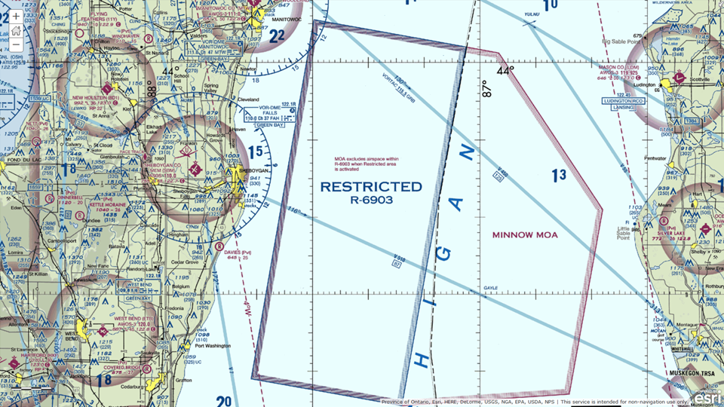
Sheboygan Air Space
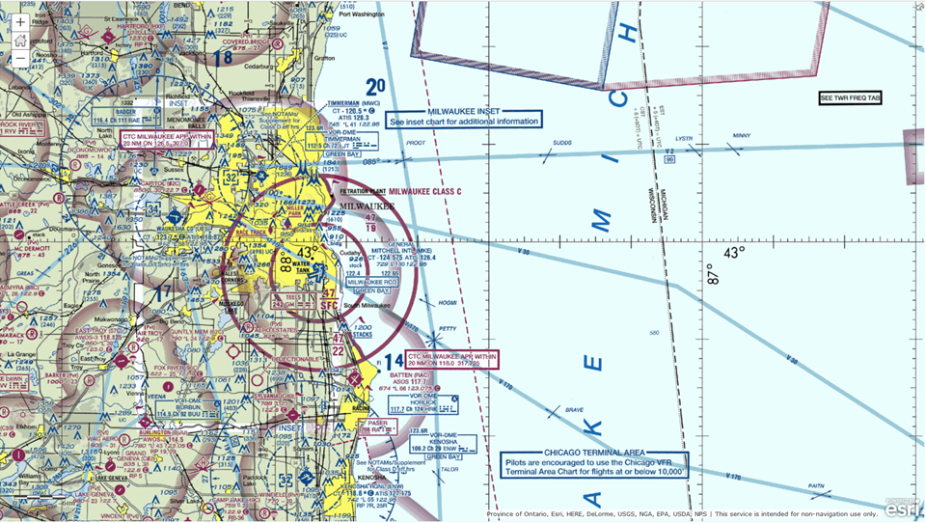
Milwaukee Air Space
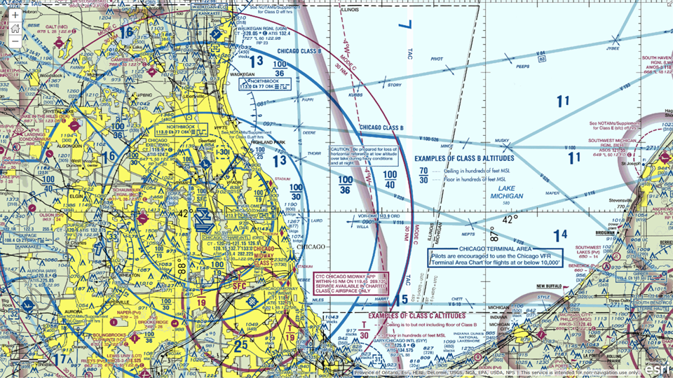
Chicago Air Space

Plan 1: Sheboygan to Zion GeoTASO Raster Flight Plan

Way Points GeoTASO 01 | Latitude | Longitude
Truax Field | 43° 8'11.27"N | 89°20'44.82"W
GeoTASO 01 Northern Raster 01 | 43°53'17.38"N | 87°56'53.68"W
GeoTASO 01 Northern Raster 02 | 43°53'14.36"N | 87°52'27.83"W
GeoTASO 01 Northern Raster 03 | 43°53'13.40"N | 87°48'1.34"W
GeoTASO 01 Northern Raster 04 | 43°53'11.06"N | 87°43'25.53"W
GeoTASO 01 Northern Raster 05 | 43°53'11.55"N | 87°38'36.28"W
GeoTASO 01 Northern Raster 06 | 43°53'10.68"N | 87°34'5.59"W
GeoTASO 01 Northern Raster 07 | 43°53'10.83"N | 87°29'32.09"W
GeoTASO 01 Southern Raster 01 | 42°24'7.18"N | 87°56'58.09"W
GeoTASO 01 Southern Raster 02 | 42°24'8.41"N | 87°52'46.45"W
GeoTASO 01 Southern Raster 03 | 42°24'4.20"N | 87°48'8.73"W
GeoTASO 01 Southern Raster 04 | 42°24'4.90"N | 87°43'44.13"W
GeoTASO 01 Southern Raster 05 | 42°24'8.23"N | 87°38'39.70"W
GeoTASO 01 Southern Raster 06 | 42°24'6.88"N | 87°34'17.34"W
GeoTASO 01 Southern Raster 07 | 42°24'7.27"N | 87°29'56.66"W

Currently 1504km total
Flight Leg | Kilometers
GeoTASO 01 Truax to Sheboygan | 141
GeoTASO 01 Sheboygan/Zion | 165x7=1155
GeoTASO 01 Northern/Southern Raster | 6x6=36
GeoTASO 01 Zion to Truax | 172

Notes:
- 1400km of linear distance at altitude (28k ft) is about 4 hours at altitude, plus about a half hour to get up and down.
- 6km lateral spacing for gapless rasters.
- Could remove Eastern most Sheboygan/Zion leg and return to Truax from Northern Raster 06 waypoint to reduce total to 1333km
- Eastern 2 Sheboygan/Zion Legs are within Sheboygan Military restricted zone
- Could move all Waypoints west by 12km to improve sampling of Milwaukee emissions

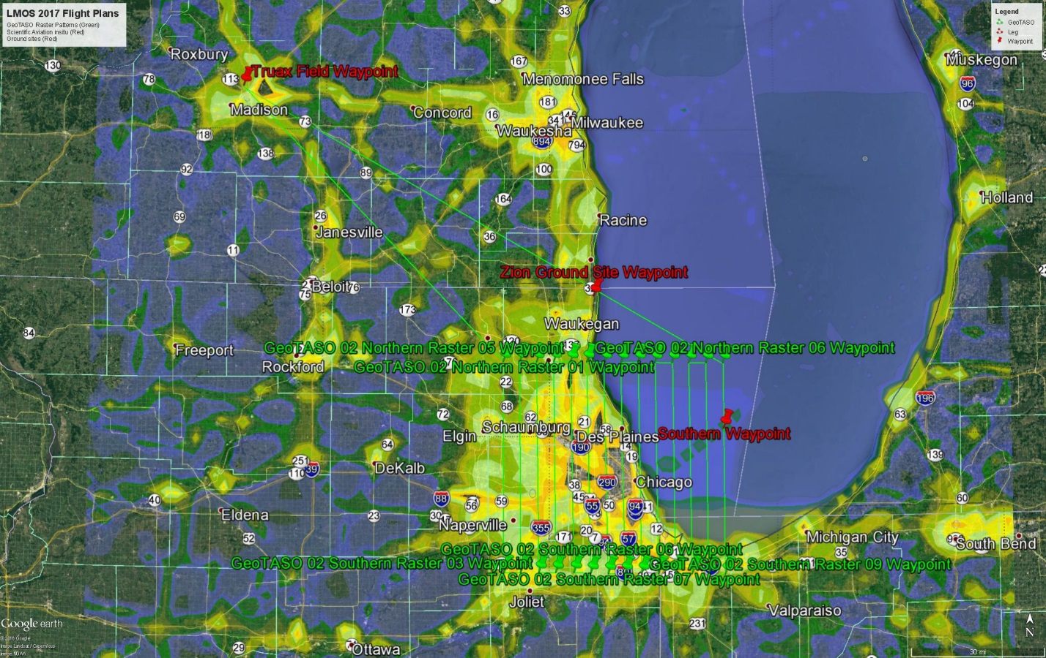
Plan 2: Chicago GeoTASO Raster Flight Plan

Way Points GeoTASO 02 | Latitude | Longitude
Truax Field | 43° 8'11.27"N | 89°20'44.82"W
GeoTASO 02 Northern Raster 01 | 42°15'28.89"N | 88°11'58.65"W
GeoTASO 02 Northern Raster 02 | 42°15'28.14"N | 88° 7'39.07"W
GeoTASO 02 Northern Raster 03 | 42°15'25.88"N | 88° 3'19.60"W
GeoTASO 02 Northern Raster 04 | 42°15'26.97"N | 87°58'55.47"W
GeoTASO 02 Northern Raster 05 | 42°15'25.39"N | 87°54'33.46"W
GeoTASO 02 Northern Raster 06 | 42°15'27.05"N | 87°50'20.29"W
GeoTASO 02 Northern Raster 07 | 42°15'22.92"N | 87°45'48.52"W
GeoTASO 02 Northern Raster 08 | 42°15'20.91"N | 87°41'27.34"W
GeoTASO 02 Northern Raster 09 | 42°15'20.44"N | 87°37'3.49"W
GeoTASO 02 Northern Raster 10 | 42°15'17.64"N | 87°32'43.88"W
GeoTASO 02 Northern Raster 11 | 42°15'17.03"N | 87°28'17.84"W
GeoTASO 02 Northern Raster 12 | 42°15'15.99"N | 87°23'56.85"W
GeoTASO 02 Northern Raster 13 | 42°15'13.64"N | 87°19'32.55"W
GeoTASO 02 Northern Raster 14 | 42°15'10.55"N | 87°15'8.43"W
GeoTASO 02 Southern Raster 01 | 41°34'56.01"N | 88°11'36.68"W
GeoTASO 02 Southern Raster 02 | 41°34'57.07"N | 88° 7'19.27"W
GeoTASO 02 Southern Raster 03 | 41°35'0.49"N | 88° 2'38.09"W
GeoTASO 02 Southern Raster 04 | 41°35'0.62"N | 87°58'16.56"W
GeoTASO 02 Southern Raster 05 | 41°35'1.81"N | 87°53'37.64"W
GeoTASO 02 Southern Raster 06 | 41°34'51.93"N | 87°49'19.02"W
GeoTASO 02 Southern Raster 07 | 41°34'45.04"N | 87°44'50.29"W
GeoTASO 02 Southern Raster 08 | 41°34'46.13"N | 87°40'33.62"W
GeoTASO 02 Southern Raster 09 | 41°34'46.22"N | 87°36'14.42"W
GeoTASO 02 Southern Raster 10 | 41°34'42.22"N | 87°31'56.11"W
GeoTASO 02 Southern Raster 11 | 41°34'39.52"N | 87°27'34.99"W
GeoTASO 02 Southern Raster 12 | 41°34'40.61"N | 87°23'17.06"W
GeoTASO 02 Southern Raster 13 | 41°34'36.66"N | 87°19'5.52"W
GeoTASO 02 Southern Raster 14 | 41°34'34.14"N | 87°14'43.52"W

Currently 1461 km total
Flight Leg | Kilometers
GeoTASO 02 Truax to Chicago Northern Raster 01 Waypoint | 135
GeoTASO 02 West to East | 75x14=1050
GeoTASO 02 Northern/Southern Raster | 6x13=78
GeoTASO 02 Northern Raster 14 Waypoint to Truax | 198

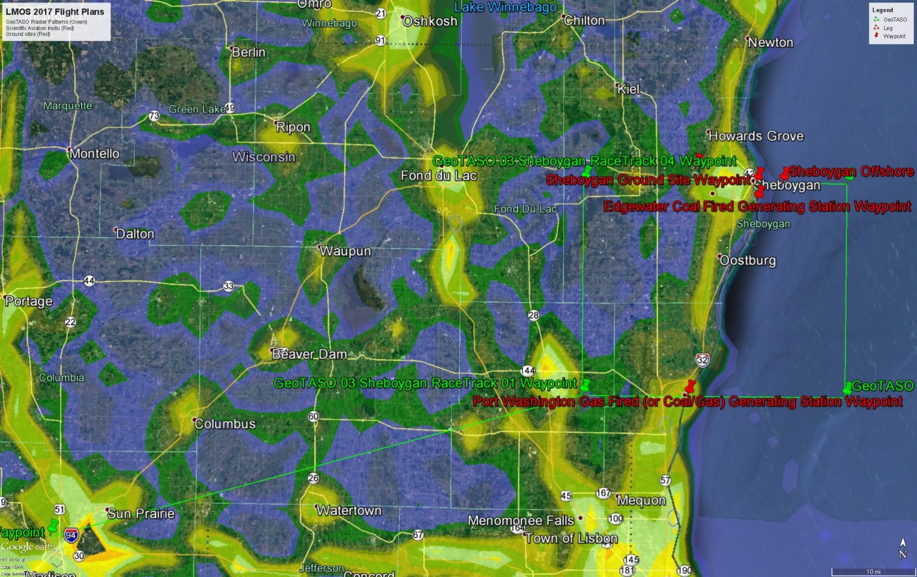
Plan 3: Sheboygan GeoTASO RaceTrack Flight Plan

Way Points GeoTASO 03 | Latitude | Longitude
Truax Field | 43° 8'11.27"N | 89°20'44.82"W
GeoTASO 03 Sheboygan RaceTrack 01 | 43°23'9.26"N | 88° 6'53.25"W
GeoTASO 03 Sheboygan RaceTrack 02 | 43°22'52.00"N | 87°29'57.91"W
GeoTASO 03 Sheboygan RaceTrack 03 | 43°44'45.49"N | 87°29'34.33"W
GeoTASO 03 Sheboygan RaceTrack 04 | 43°44'50.03"N | 88° 6'50.13"W

Currently 1468 km total (7 circuits)
Flight Leg | Kilometers
GeoTASO 03 Truax to Sheboygan RaceTrack 01 | 104
GeoTASO 03 RaceTrack | 7*(2*50+2*40)=7*180  1260
GeoTASO 03 Sheboygan RaceTrack 01 to Truax | 104
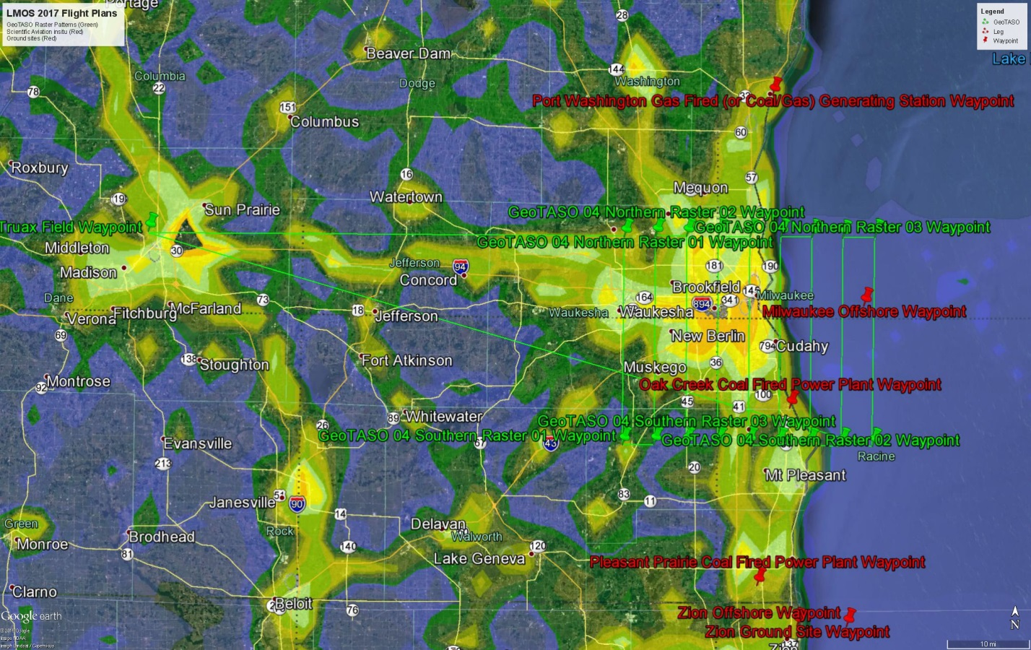
Plan 4: Milwaukee GeoTASO Raster Flight Plan

Way Points GeoTASO 04 | Latitude | Longitude
Truax Field | 43° 8'11.27"N | 89°20'44.82"W
GeoTASO 04 Northern Raster 01 | 43° 8'19.12"N | 88°13'17.74"W
GeoTASO 04 Northern Raster 02 | 43° 8'25.94"N | 88° 8'49.99"W
GeoTASO 04 Northern Raster 03 | 43° 8'24.78"N | 88° 4'25.30"W
GeoTASO 04 Northern Raster 04 | 43° 8'24.96"N | 87°59'55.13"W
GeoTASO 04 Northern Raster 05 | 43° 8'23.48"N | 87°55'22.86"W
GeoTASO 04 Northern Raster 06 | 43° 8'26.39"N | 87°51'0.27"W
GeoTASO 04 Northern Raster 07 | 43° 8'21.11"N | 87°46'33.68"W
GeoTASO 04 Northern Raster 08 | 43° 8'16.81"N | 87°42'10.23"W
GeoTASO 04 Northern Raster 09 | 43° 8'21.90"N | 87°37'34.41"W
GeoTASO 04 Southern Raster 01 | 42°46'49.53"N | 88°13'21.88"W
GeoTASO 04 Southern Raster 02 | 42°46'51.76"N | 88° 8'54.78"W
GeoTASO 04 Southern Raster 03 | 42°46'50.21"N | 88° 4'23.85"W
GeoTASO 04 Southern Raster 04 | 42°46'52.18"N | 87°59'52.90"W
GeoTASO 04 Southern Raster 05 | 42°46'51.98"N | 87°55'31.54"W
GeoTASO 04 Southern Raster 06 | 42°46'46.69"N | 87°51'16.35"W
GeoTASO 04 Southern Raster 07 | 42°46'44.20"N | 87°46'51.42"W
GeoTASO 04 Southern Raster 08 | 42°46'44.47"N | 87°42'22.55"W
GeoTASO 04 Southern Raster 09 | 42°46'42.60"N | 87°37'57.40"W

Currently 645 km total (one raster)
Flight Leg | Kilometers
GeoTASO 04 Truax to Milwaukee Northern Raster 01 Waypoint | 92
GeoTASO 04 West to East | 40x9=360
GeoTASO 04 Northern/Southern Raster | 6x8=48
GeoTASO 04 Milwaukee Southern Raster 09 Waypoint to Truax | 145

Currently 877 km total (two rasters)
Flight Leg | Kilometers
GeoTASO 04 Truax to Milwaukee Northern Raster 01 Waypoint | 92
GeoTASO 04 West to East | 40x9=360
GeoTASO 04 East to West | 40x8=320
GeoTASO 04 Northern/Southern Raster | 6x16=96
GeoTASO 04 Milwaukee Northern Raster 01 Waypoint to Truax | 92

Currently 1381 km total (three rasters)
Flight Leg | Kilometers
GeoTASO 04 Truax to Milwaukee Northern Raster 01 Waypoint | 92
GeoTASO 04 West to East | 40x9=360
GeoTASO 04 East to West | 40x8=320
GeoTASO 04 West to East | 40x8=320
GeoTASO 04 Northern/Southern Raster | 6x24=144
GeoTASO 04 Milwaukee Northern Raster 01 Waypoint to Truax | 145

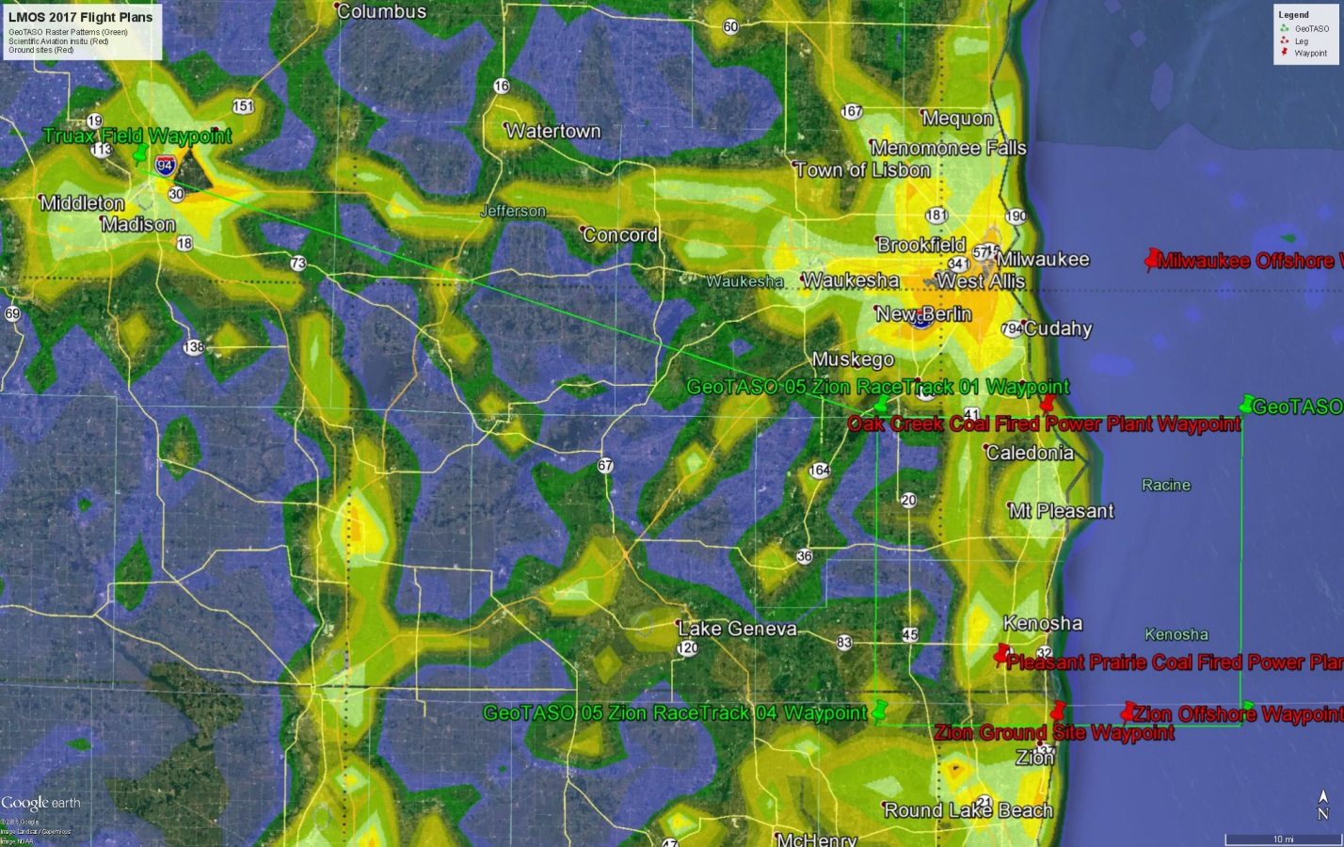
Plan 5: Zion GeoTASO RaceTrack Flight Plan

Way Points GeoTASO 03 | Latitude | Longitude
Truax Field | 43° 8'11.27"N | 89°20'44.82"W
GeoTASO 05 Zion RaceTrack 01 | 42°50'33.06"N | 88° 6'21.61"W
GeoTASO 05 Zion RaceTrack 02 | 42°50'31.56"N | 87°29'40.81"W
GeoTASO 05 Zion RaceTrack 03 | 42°28'1.25"N | 87°29'46.64"W
GeoTASO 05 Zion RaceTrack 04 | 42°28'6.22"N | 88° 6'22.23"W

Currently 1500 km total (7 circuits)
Flight Leg | Kilometers
GeoTASO 05 Truax to Zion RaceTrack 01 | 106
GeoTASO 05 RaceTrack | 7*(2*50+2*42)=7*184  1288
GeoTASO 05 Zion RaceTrack 01 to Truax | 106

