The NCEP Global Data Assimilation System / Global Forecast System porting procedures, verification metrics and results between the NOAA R&D (Vapor), JCSDA-NASA (JIBB), and JCSDA-NESDIS (S4) computers.
Editors:
James A. Jung¹
Other Contributors:

Affiliations:
¹CIMSS (Cooperative Institute for Meteorological Satellite Studies) University of Wisconsin, Madison

Table of Contents
1. Introduction 8
2. Computer Architectures 8
3. Software 9
4. Experiment Design 9
5. Verification Design and Statistics 10
5.1 Monitoring Quality Parameters and Observation Fits 11
5.2 Anomaly Correlations 22
5.3 RMSE Statistics 25
5.4 Standard Deviations of the Analyses and Forecasts. 26
5.5 Analysis and 48-hour Forecast Mean Differences 40
5.6 Precipitation Comparison 54
6. Summary 56

Table 5.1-1: Average final convergence values for S4, JIBB and Vapor for 1 December – 31 January 2011 and 1 August – 30 September 2011. 11
Table 5.1-2: Average final penalty for S4, JIBB and Vapor for 1 December – 31 January 2011 and 1 August – 30 September 2011. 12
Table 5.1-3: Average number of NOAA-19 AMSU-A radiances used by S4, JIBB and Vapor for 1 December – 31 January 2011 and 1 August – 30 September 2011. 12
Table 5.1-4: Average number of NOAA-18 MHS radiances used by S4, JIBB and Vapor for 1 December – 31 January 2011 and 1 August – 30 September 2011. 12
Table 5.1-5: Average number of METOP IASI radiances used by S4, JIBB and Vapor for 1 December – 31 January 2011 and 1 August – 30 September 2011. 12
Table 5.1-6: Average rawinsonde assimilation relative humidity statistics from S4, JIBB, and Vapor 13
Table 5.1-7: Average rawinsonde assimilation temperature statistics from S4, JIBB, and Vapor 13
Table 5.1-8: Average rawinsonde assimilation wind speed statistics from S4, JIBB and Vapor 13

List of Figures
Figure 5.1-1: Temperature bias, RMSE and observation counts of 12 & 36 (a, b, c) and 24 & 48 (d, e, f) hour forecast fit to rawinsondes (RAOBS) for S4 vs Vapor (a and d), JIBB vs Vapor (b and e) and S4 vs JIBB (c and f). These statistics are for 1 December 2010 – 31 January 2011. Units are degrees Kelvin [K]. 15
Figure 5.1-2: Temperature bias, RMSE and observation counts of 12 & 36 (a, b, c) and 24 & 48 (d, e, f) hour forecast fit to rawinsondes (RAOBS) for S4 vs Vapor (a and d), JIBB vs Vapor (b and e) and S4 vs JIBB (c and f). These statistics are for 1 August – 30 September 2011. Units are degrees Kelvin [K]. 15
Figure 5.1-3: Wind speed bias, RMSE and observation counts of 12 & 36 (a, b, c) and 24 & 48 (d, e, f) hour forecast fit to rawinsondes (RAOBS) for S4 vs Vapor (a and d), JIBB vs Vapor (b and e) and S4 vs JIBB (c and f). These statistics are for 1 December 2010 – 31 January 2011. Units are meters/second [m/s]. 16
Figure 5.1-4: Wind speed bias, RMSE and observation counts of 12 & 36 (a, b, c) and 24 & 48 (d, e, f) hour forecast fit to rawinsondes (RAOBS) for S4 vs Vapor (a and d), JIBB vs Vapor (b and e) and S4 vs JIBB (c and f). These statistics are for 1 August – 30 September 2011. Units are meters/second [m/s]. 17
Figure 5.1-5: Specific humidity bias, RMSE and observation counts of 12 & 36 (a, b, c) and 24 & 48 (d, e, f) hour forecast fit to rawinsondes (RAOBS) for S4 vs Vapor (a and d), JIBB vs Vapor (b and e) and S4 vs JIBB (c and f). These statistics are for 1 December 2010 – 31 January 2011. Units are gram/kilogram [g/Kg]. 18
Figure 5.1-6: Specific humidity bias, RMSE and observation counts of 12 & 36 (a, b, c) and 24 & 48 (d, e, f) hour forecast fit to rawinsondes (RAOBS) for S4 vs Vapor (a and d), JIBB vs Vapor (b and e) and S4 vs JIBB (c and f). These statistics are for 1 August – 30 September 2011. Units are gram/kilogram [g/Kg]. 19
Figure 5.1-7: Geopotential height humidity bias, RMSE and observation counts of 12 & 36 (a, b, c) and 24 & 48 (d, e, f) hour forecast fit to rawinsondes (RAOBS) for S4 vs Vapor (a and d), JIBB vs Vapor (b and e) and S4 vs JIBB (c and f). These statistics are for 1 December 2010 – 31 January 2011. Units are meters [m]. 20
Figure 5.1-8: Geopotential height humidity bias, RMSE and observation counts of 12 & 36 (a, b, c) and 24 & 48 (d, e, f) hour forecast fit to rawinsondes (RAOBS) for S4 vs Vapor (a and d), JIBB vs Vapor (b and e) and S4 vs JIBB (c and f). These statistics are for 1 August – 30 September 2011. Units are meters [m]. 21
Figure 5.2-1: Anomaly correlation time series from 1 December 2010 to 31 January 2011 for Northern (a and c) and Southern (b and d) Hemisphere at 500 (a and b) and 1000 (b and d) hPa. Vapor, S4 and JIBB are plotted in black, red, and green respectively. 22
Figure 5.2-2: Anomaly correlation time series from 1 August to 30 September 2010 for Northern (a and c) and Southern (b and d) Hemisphere at 500 (a and b) and 1000 (b and d) hPa. Vapor, S4 and JIBB are plotted in black, red, and green respectively. 23
Figure 5.2-3: Anomaly correlation die off curves from 1 December 2010 to 31 January 2011 for Northern (a and c) and Southern (b and d) Hemisphere at 500 (a and b) and 1000 (c and d) hPa. Vapor, S4 and JIBB are plotted in black, red, and green respectively. 24
Figure 5.2-4: Anomaly correlation die off curves from 1 August to 30 September 2011 for Northern (a and c) and Southern (b and d) Hemisphere at 500 (a and b) and 1000 (c and d) hPa. Vapor, S4 and JIBB are plotted in black, red, and green respectively. 25
Figure 5.3-1: RMSE die off curves for 1 December 2010 - 31 January 2011 (a and b) and 1 August - 30 September 2011 (c and d) at 200 (a and c) and 850 (b and d) hPa. Vapor, S4 and JIBB are plotted in black, red, and green respectively. 26
Figure 5.4-1: Standard deviation of the difference between analyses (a, b, c) and 48-hour forecasts (d, e, f) of precipitable water. Differences between S4 – Vapor (a and d), JIBB – Vapor (b and e), and S4 – JIBB (c and f) are for 1 December 2010 to 31 January 2011. Units are millimeters of water Vapor [mm]. 27
Figure 5.4-2: Standard deviation of the difference between analyses (a, b, c) and 48-hour forecasts (d, e, f) of precipitable water. Differences between S4 – Vapor (a and d), JIBB – Vapor (b and e), and S4 – JIBB (c and f) are for 1 August to 30 September 2011. Units are millimeters of water Vapor [mm]. 28
Figure 5.4-3: Standard deviation of the difference between the 6-hour forecasts (a, b, c) and 48-hour forecasts (d, e, f) for 6-hour accumulation of total precipitation. Differences between S4 – Vapor (a and d), JIBB – Vapor (b and f), and S4 – JIBB (c and e) are for 1 December 2010 to 31 January 2011. Units are millimeters of water [mm]. 29
Figure 5.4-4: Standard deviation of the difference between the 6-hour forecasts (a, b, c) and 48-hour forecasts (d, e, f) for 6-hour accumulation of total precipitation. Differences between S4 – Vapor (a and d), JIBB – Vapor (b and f), and S4 – JIBB (c and e) are for 1 August to 30 September 2011. Units are millimeters of water [mm]. 30
Figure 5.4-5: Standard deviation of the difference between the analyses (a, b, c) and 48-hour forecast (d, e, f) for 500 hPa Relative Humidity. Differences between S4 – Vapor (a and d), JIBB – Vapor (b and e), and S4 – JIBB (c and f) are for 1 December 2010 to 31 January 2011. Units are percent [%]. 31
Figure 5.4-6: Standard deviation of the difference between the analyses (a, b, c) and 48-hour forecast (d, e, f) for 500 hPa Relative Humidity. Differences between S4 – Vapor (a and d), JIBB – Vapor (b and e), and S4 – JIBB (c and f) are for 1 August to 30 September 2011. Units are percent [%]. 32
Figure 5.4-7: Standard deviation of the difference between the analyses (a, b, c) and 48-hour forecasts (d, e, f) for 500 hPa Temperature. Differences between S4 – Vapor (a and d), JIBB – Vapor (b and e), and S4 – JIBB (c and f) are for 1 December 2010 to 31 January 2011. Units are degrees Kelvin [K]. 33
Figure 5.4-8: Standard deviation of the difference between the analyses (a, b, c) and 48-hour forecasts (d, e, f) for 500 hPa Temperature. Differences between S4 – Vapor (a and d), JIBB – Vapor (b and e), and S4 – JIBB (c and f) are for 1 August to 30 September 2011. Units are degrees Kelvin [K]. 34
Figure 5.4-9: Standard deviation of the difference between the analyses (a, b, c) and 48-hour forecasts (d, e, f) for 250 hPa U component of wind. Differences between S4 – Vapor (a and d), JIBB – Vapor (b and e), and S4 – JIBB (c and f) are for 1 December 2010 to 31 January 2011. Units are meters/second [m/s]. 35
Figure 5.4-10: Standard deviation of the difference between the analyses (a, b, c) and 48-hour forecasts (d, e, f) for 250 hPa U component of wind. Differences between S4 – Vapor (a and d), JIBB – Vapor (b and e), and S4 – JIBB (c and f) are for 1 August to 30 September 2011. Units are meters/second [m/s]. 36
Figure 5.4-11: Standard deviation of the difference between the analyses (a, b, c) and 48-hour forecasts (d, e, f) for 100 hPa Geopotential Height. Differences between S4 – Vapor (a and d), JIBB – Vapor (b and e), and S4 – JIBB (c and f) are for 1 December 2010 to 31 January 2011. Units are meters/second [m/s]. 37
Figure 5.4-12: Standard deviation of the difference between the analyses (a, b, c) and 48-hour forecasts (d, e, f) for 100 hPa Geopotential Height. Differences between S4 – Vapor (a and d), JIBB – Vapor (b and e), and S4 – JIBB (c and f) are for 1 August to 30 September 2011. Units are meters/second [m/s]. 38
Figure 5.4-13: Standard deviation of the difference between the analyses (a, b, c) and 48-hour forecasts (d, e, f) for 500 hPa Geopotential Height. Differences between S4 – Vapor (a and d), JIBB – Vapor (b and e), and S4 – JIBB (c and f) are for 1 December 2010 to 31 January 2011. Units are meters/second [m/s]. 39
Figure 5.4-14: Standard deviation of the difference between the analyses (a, b, c) and 48-hour forecasts (d, e, f) for 500 hPa Geopotential Height. Differences between S4 – Vapor (a and d), JIBB – Vapor (b and e), and S4 – JIBB (c and f) are for 1 August to 30 September 2011. Units are meters/second [m/s]. 40
Figure 5.5-1: Mean difference between analyses (a, b, c) and 48-hour forecasts (d, e, f) of precipitable water. Differences between S4 – Vapor (a and d), JIBB – Vapor (b and e), and S4 – JIBB (c and f) are for 1 December 2010 to 31 January 2011. Units are millimeters of water Vapor [mm]. 41
Figure 5.5-2: Mean difference between analyses (a, b, c) and 48-hour forecasts (d, e, f) of precipitable water. Differences between S4 – Vapor (a and d), JIBB – Vapor (b and e), and S4 – JIBB (c and f) are for 1 August to 30 September 2011. Units are millimeters of water Vapor [mm]. 42
Figure 5.5-3: Mean difference between the 6-hour forecasts (a, b, c) and 48-hour forecasts (d, e, f) for 6-hour accumulation of total precipitation. Differences between S4 – Vapor (a and d), JIBB – Vapor (b and e), and S4 – JIBB (c and f) are for 1 December 2010 to 31 January 2011. Units are millimeters of water [mm]. 43
Figure 5.5-4: Mean difference between the 6-hour forecasts (a, b, c) and 48-hour forecasts (d, e, f) for 6-hour accumulation of total precipitation. Differences between S4 – Vapor (a and d), JIBB – Vapor (b and e), and S4 – JIBB (c and f) are for 1 August to 30 September 2011. Units are millimeters of water [mm]. 44
Figure 5.5-5: Mean difference between the analyses (a, b, c) and 48-hour forecast (d, e, f) for 500 hPa Relative Humidity. Differences between S4 – Vapor (a and d), JIBB – Vapor (b and e), and S4 – JIBB (c and f) are for 1 December 2010 to 31 January 2011. Units are percent [%]. 45
Figure 5.5-6: Mean difference between the analyses (a, b, c) and 48-hour forecast (d, e, f) for 500 hPa Relative Humidity. Differences between S4 – Vapor (a and d), JIBB – Vapor (b and e), and S4 – JIBB (c and f) are for 1 August to 30 September 2011. Units are percent [%]. 46
Figure 5.5-7: Mean difference between the analyses (a, b, c) and 48-hour forecasts (d, e, f) for 500 hPa Temperature. Differences between S4 – Vapor (a and d), JIBB – Vapor (b and e), and S4 – JIBB (c and f) are for 1 December 2010 to 31 January 2011. Units are degrees Kelvin [K]. 47
Figure 5.5-8: Mean difference between the analyses (a, b, c) and 48-hour forecasts (d, e, f) for 500 hPa Temperature. Differences between S4 – Vapor (a and d), JIBB – Vapor (b and e), and S4 – JIBB (c and f) are for 1 August to 30 September 2011. Units are degrees Kelvin [K]. 48
Figure 5.5-9: Mean difference between the analyses (a, b, c) and 48-hour forecasts (d, e, f) for 250 hPa U component of wind. Differences between S4 – Vapor (a and d), JIBB – Vapor (b and e), and S4 – JIBB (c and f) are for 1 December 2010 to 31 January 2011. Units are meters/second [m/s]. 49
Figure 5.5-10: Mean difference between the analyses (a, b, c) and 48-hour forecasts (d, e, f) for 250 hPa U component of wind. Differences between S4 – Vapor (a and d), JIBB – Vapor (b and e), and S4 – JIBB (c and f) are for 1 August to 30 September 2011. Units are meters/second [m/s]. 50
Figure 5.5-11: Mean difference between the analyses (a, b, c) and 48-hour forecasts (d, e, f) for 100 hPa Geopotential Height. Differences between S4 – Vapor (a and d), JIBB – Vapor (b and e), and S4 – JIBB (c and f) are for 1 December 2010 to 31 January 2011. Units are meters/second [m/s]. 51
Figure 5.5-12: Mean difference between the analyses (a, b, c) and 48-hour forecasts (d, e, f) for 100 hPa Geopotential Height. Differences between S4 – Vapor (a and d), JIBB – Vapor (b and e), and S4 – JIBB (c and f) are for 1 August to 30 September 2011. Units are meters/second [m/s]. 52
Figure 5.5-13: Mean difference between the analyses (a, b, c) and 48-hour forecasts (d, e, f) for 500 hPa Geopotential Height. Differences between S4 – Vapor (a and d), JIBB – Vapor (b and e), and S4 – JIBB (c and f) are for 1 December 2010 to 31 January 2011. Units are meters/second [m/s]. 53
Figure 5.5-14: Mean difference between the analyses (a, b, c) and 48-hour forecasts (d, e, f) for 500 hPa Geopotential Height. Differences between S4 – Vapor (a and d), JIBB – Vapor (b and e), and S4 – JIBB (c and f) are for 1 August to 30 September 2011. Units are meters/second [m/s]. 54
Figure 5.6-1: Precipitation statistics (equitable threat scores and precipitation bias) for 1 December 2010 – 31 January 2011 (a, b, c) and 1 August – 30 September 2011 (d, e, f). Panels a and b are 12 – 36 hour accumulations, panels c and d are 36 – 60 hour accumulations and panels e and f are 60 – 84 hour accumulations. Units are millimeters/day [mm/24hr]. 55

Introduction

Two of the Joint Center for Satellite Data Assimilation (JCSDA) partners, the National Aeronautics and Space Administration (NASA) and the National Oceanic and Atmospheric Administration (NOAA) National Environmental Satellite, Data and Information Service (NESDIS), each purchased new computers in FY2011. These computers will be used to conduct satellite data assimilation research and aid in the transition of data assimilation technologies into the NOAA National Centers for Environmental Prediction (NCEP) weather models. In the past, the research and development computers used by the JCSDA were of similar architecture to the NCEP operational computers. Software management and verification/validation procedures were much easier with these similar computers as bit identical answers were expected. The two new computers purchased by the JCSDA partners are both Linux clusters but are of different architecture. Bit identical answers are not expected. We attempt to quantify some of the similarities and differences in the hardware and software here. [Add statement about how this document defines a minimum set of diagnostics necessary to establish a viable port to a new machine.]

Computer Architectures

The current NOAA research and development computer (Vapor) is an IBM-P6, a RISC architecture and uses IBM-AIX for an operating system. It has 48 nodes which have 32 real and 32 virtual cores. Other notable properties include: 120 GB of memory per core, FORTRAN compiler version V12.1, IBM loadleveler job submission software. The JCSDA-NOAA/NESDIS computer (Supercomputer for Satellite Simulations and data assimilation Studies, S4) is Linux cluster with Advanced Micro Devices (AMD) Opteron processors. It has 64 nodes with 48 cores per node. Other notable properties include: 100 GB of memory per node, Intel compiler suite V12.0 and Sun Grid Engine job submission software. The JCSDA-NASA computer (Joint center In a Big Box, JIBB) is a Linux cluster with Intel processors. It has 280 nodes with 12 cores per node. Notable properties include: 48 GB of memory per node, Intel FORTRAN compiler V12.0 and Portable batch system job submission software.
The RISC architecture has the first byte as most significant or big Endian. The Intel and AMD processors have the first byte as least significant or little Endian. This is a fundamental difference in the chip architecture requiring significant changes to the software routines that do byte level manipulations or binary reads. These routines must be compatible with the machine architecture. Several FORTRAN subroutines and libraries used by the GDAS/GFS do either byte manipulation or binary reads. The read routines were able to be changed with compiler flags. The byte manipulation subroutines, like w3lib, must be re-written.

Software

The May 2011 version of the National Centers for Environmental Prediction (NCEP) Global Data Assimilation System / Global Forecast System (GFS) was installed on the National Oceanic and Atmospheric Administration (NOAA) Research and Development computer vapor.rdhpcs.noaa.gov by NCEP Central Operations (NCO). The GDAS/GFS source code and executables were copied from the NCEP operational computer to vapor. The NESDIS Software Integration Team also started with the GDAS/GFS source code from the NCEP operational computer and copied it to JIBB and S4.
Not all of the GDAS/GFS libraries have current little Endian equivalents. Some older library versions do have little Endian equivalents. The equivalent little Endian libraries were used when available to minimize transition costs. This means some of the libraries are from previous versions of the GDAS/GFS. The libraries that didn’t have little Endian equivalents were re-written. Differences in results between the three computers may have been introduced from not using identical libraries.

Experiment Design

The experimental design for this comparison was to run as close to NCEP operations as possible. However, differences with NCEP operations were necessary. Due to computational time on Vapor, the 7day forecast was run only at 00Z. Also, a lower T382L64 resolution was required vice the operational T574L64. All of the data files used were from the NCEP operations database. This database was developed in real time and has the real time data cutoff requirements incorporated. All data used by the operational system, except the restricted data, were used. The GDAS/GFS was started with the same initial files on each machine. The GDAS/GFS then used its previous forecast as the background field for the next cycle’s analysis on each machine. This allowed compiler and machine round off differences to influence each step of the GDAS cycles. At each 00Z cycle, the 7-day forecast was spawned and was consistent with the NCO early data cutoff times. This is commonly referred to as the GFS portion of the GDAS/GFS. The case studies chosen consist of ~45-day periods during December 2010 – January 2011 and August – September 2011.
The NCEP operational GDAS/GFS uses several types of restricted data. They include: surface ship, Tropospheric Airborne Meteorological Data Reporting (TAMDAR), Aircraft Communications Addressing and Reporting System (ACARS), Aircraft Meteorological Data Relay (AMDAR) and Mesonet data. Both JIBB and S4 do not meet the security requirements to use restricted data. For this initial inter-comparison, the restricted data were removed from the dataset used by all three computers. After 48 hours the restrictions are relaxed for some of the data types (ACARS, AMDAR, and TAMDAR). The ship data requires the ID be changed for the restrictions to be removed. These data will eventually be added to the daily archive on JIBB and S4 to be used by future experiments.
There are seven steps to each 6 hour cycle of the GDAS/GFS, the prep, anal, angu, fcst, post, vrfy, and arch. The prep step prepares the data for use in the analysis (including quality control, non-radiance bias corrections and assignment of conventional data errors). The prep step uses grid information, generated by the previous fcst and post step, for quality control purposes. The anal step runs the data assimilation software, currently the Gridpoint Statistical Interpolation (GSI) code. The angu step updates the angle dependent bias correction for all satellite radiance data used by the GSI. The fcst step runs the current version of the global weather forecast model. The post step converts the analysis and forecast fields to World Meteorological Organization (WMO) standard GRIdded Binary or General Regularly-distributed Information in Binary form (GRIB) format grids for a pre-described set of meteorological parameters and resolutions used by forecasters, researchers and etc. The vrfy step generates the output used by external verification packages to quantify model performance. [Define arch step]
Six of the seven steps within a cycle were ported to JIBB and S4. Due to its complexity, the prep step was not included in this initial setup. The file generated by the prep step (prepqc) was obtained from NCEP’s production run. Prepqc was copied to JIBB and S4 along with the other operational observations used by the anal step. The restricted data within the prepqc file were removed consistent with the other observation files. Removing the prep step creates dependencies that would be unique to the specific GDAS/GFS build (the accept/reject criteria in the prep is based on a different resolution of the GDAS/GFS on a different machine). [Need to clarify here that the QC done in the prep step only applies to conventional data, not satellite data. Otherwise the discussion below about # of satellite observations used is confusing.]
Several comparisons with the NCEP operational GDAS/GFS were conducted. The purpose was to make sure the scripts and the various steps were correct. Direct bit comparisons were not possible because of differences in machine architecture, compilers, resolution and data. Each step generates an output file typically know as the dayfile. These dayfiles were directly compared to the NCEP operational dayfiles to make sure the script follows the same logic, the same parameters were sent to the executable and similar output was achieved.

Verification Design and Statistics

There are several parts to the GDAS/GFS performance verification. The initial file generation is done after each post step. These initial files are used by other software packages which generate longer term statistics. There are four parts to the verification step: anomaly correlations, precipitation threat scores, hurricane track and intensity values and analysis/forecast fits to observations.
The main verification package used for this inter-comparison is the Verification Statistics Data Base (VSDB). VSDB uses the files generated by the vrfy step to generate and plot time series, 1D and 2D fields, and long term average statistics of various parameters. These parameters include anomaly correlations, RMSE, precipitation threat scores and others as explained in http://www.emc.ncep.noaa.gov/gmb/wx24fy/doc/RMSE_decomposition.pdf.
Other statistics were also generated for comparison including standard deviation and mean differences between analyses and selected forecast times. These plots were generated using the post processor constant-pressure-GRIB (PGB) files. Interpolation and round off errors are known to exist in these files but should be minimal compared to other differences.
Several types of verification statistics were used to quantify differences and similarities in the analyses and forecasts between S4, JIBB and Vapor. Parameters for monitoring the performance of the GDAS include the final values of the convergence (gnorm) and the penalty. Parameters used for determining model performance include fits to observations, anomaly correlations, RMSE with respect to its own analysis, and precipitation threat scores.
To identify regions where computer differences are occurring, within the analyses and short term forecasts, we generated various 2-D fields of standard deviation and mean difference. These fields were calculated using the 1ºX1º lat/lon PGB files generated by the post processor. Round-off errors in generating the PGB files from the sigma files is expected but should be similar for each computer. Statistics are generated for both seasons (1 December 2010 – 31 January 2011 and 1 August -30 September 2011). Fields of precipitable water, total accumulated rainfall, 500 hPa relative humidity, 500 hPa temperature, 250 hPa U-component of wind, 100 hPa geopotential heights and 500 hPa geopotential heights are displayed for both seasons for both seasons.

Monitoring Quality Parameters and Observation Fits
Two common quality parameters that are monitored within the GSI are convergence and the penalty. The convergence should decrease with each inner loop iteration. The value that is monitored, called gnorm, is a normalized value which is defined by the first inner loop iteration. It is expected that the final convergence values, shown in table 6.1-1, would be similar for each computer. The convergence values are slightly larger for S4 and JIBB but are reasonable. The final penalty should also be similar between the three computers. As shown in table 6.1-2, the final penalty values for S4 and JIBB are slightly larger but still reasonable. [The percentage difference between the final convergence values are quite abit larger then the percentage differences between the final penalty values, should indicate what an acceptable level of convergence value is so that these differences can be put into perspective.]
Table 5.1-1: Average final convergence values for S4, JIBB and Vapor for 1 December – 31 January 2011 and 1 August – 30 September 2011.
 | S4 | JIBB | Vapor
1 Dec – 31 Jan | 9.56E-06 | 9.44E-06 | 6.33E-06
1Aug – 30 Sep | 4.78E-06 | 5.08E-06 | 3.16E-06

Table 5.1-2: Average final penalty for S4, JIBB and Vapor for 1 December – 31 January 2011 and 1 August – 30 September 2011.
 | S4 | JIBB | Vapor
1 Dec – 31 Jan | 827378.8 | 827996.5 | 824529.2
1Aug – 30 Sep | 852811.1 | 852785.3 | 853702.5

Because the GDAS/GFS was cycled, differences in the analyses and forecasts between the three computers will propagate and cause the quality control to accept/reject some different observations. [If you used the prepqc file obtained from NCEP’s production run then the QC has already been applied according to your discussion above. Need to clarify what additional QC is done following the prep step.] A simple way to monitor differences on each computer is to track changes in the number of satellite radiances used. Although all of the different satellite sensors are monitored, we chose to only include three of them here. Shown in tables 6.1-3 to 6.1-5 are the Advanced Microwave Sounding Unit (AMSU-A) from NOAA-19, the Microwave Humidity Sensor (MHS) from NOAA-18 and the Infrared Atmospheric Sounding Interferometer (IASI) from MetOp-A respectively. On average, there are slightly less AMSU-A radiances but slightly more MHS and IASI radiances used by S4 and JIBB than Vapor for both seasons. [May want to quantify “slightly less” with percentage differences.]
Table 5.1-3: Average number of NOAA-19 AMSU-A radiances used by S4, JIBB and Vapor for 1 December – 31 January 2011 and 1 August – 30 September 2011.
NOAA-19 AMSU-A | S4 | JIBB | Vapor
1 Dec – 31 Jan | 141529 | 141559 | 141599
1Aug – 30 Sep | 144227 | 144250 | 144564

Table 5.1-4: Average number of NOAA-18 MHS radiances used by S4, JIBB and Vapor for 1 December – 31 January 2011 and 1 August – 30 September 2011.
NOAA-18 MHS | S4 | JIBB | Vapor
1 Dec – 31 Jan | 46921 | 47058 | 46918
1Aug – 30 Sep | 46793 | 46869 | 46769

Table 5.1-5: Average number of METOP IASI radiances used by S4, JIBB and Vapor for 1 December – 31 January 2011 and 1 August – 30 September 2011.
MetOp-A IASI | S4 | JIBB | Vapor
1 Dec – 31 Jan | 1184840 | 1184915 | 1183640
1Aug – 30 Sep | 1211321 | 1211143 | 1208847

The conventional data quality control procedures and assimilation weights are defined in the prep step. Since the prep step was not used in this comparison, the quality control and assimilation weights were defined by the NCEP operational GDAS. These prepqc files were copied from NCEP’s operational GDAS to the three computers after removing the restricted data.
Identical counts and very similar bias and RMS statistics for the conventional data are expected for the three computers because their assimilation parameters were fixed. The total column statistics of the rawinsonde specific humidity, temperature and wind speed during both seasons are shown in tables 6.1-6 – 6.1-8. As expected, the rawinsonde assimilation statistics between S4, JIBB and Vapor are similar.
Table 5.1-6: Average rawinsonde assimilation relative humidity statistics from S4, JIBB, and Vapor
Rawinsonde RH |  | S4 | JIBB | Vapor
1 Dec – 31 Jan | Count | 12444 | 12444 | 12444
 | Bias | -.72137 | -.74242 | -.74129
 | RMS | 14.43315 | 14.43742 | 14.39081
1Aug – 30 Sep | Count | 13981 | 13981 | 13981
 | Bias | -1.17 | -1.1832 | -1.1459
 | RMS | 13.47631 | 13.47443 | 13.44082

Table 5.1-7: Average rawinsonde assimilation temperature statistics from S4, JIBB, and Vapor
Rawinsonde T |  | S4 | JIBB | Vapor
1 Dec – 31 Jan | Count | 27811 | 27811 | 27811
 | Bias | .003468 | .004435 | -.00315
 | RMS | 1.402097 | 1.402177 | 1.402661
1Aug – 30 Sep | Count | 28707 | 28707 | 28707
 | Bias | .049672 | .050984 | .034754
 | RMS | 1.193934 | 1.193607 | 1.192782

Table 5.1-8: Average rawinsonde assimilation wind speed statistics from S4, JIBB and Vapor
Rawinsonde uv |  | S4 | JIBB | Vapor
1 Dec – 31 Jan | Count | 31412 | 31412 | 31411
 | Bias | .404839 | .404355 | .40371
 | RMS | 3.700403 | 3.699839 | 3.704597
1Aug – 30 Sep | Count | 34658 | 34658 | 34658
 | Bias | .507131 | .506885 | .40918
 | RMS | 3.367705 | 3.367623 | 3.373361

Computing forecast fit statistics to various types of conventional observations is part of the VSDB package. The widely used comparison parameters are temperature, wind speed, specific humidity and geopotential heights with rawinsondes. Both season comparisons of temperature, wind speed, specific humidity and geopotential heights to rawinsondes are shown in figures 5.1-1 – 5.1.8 respectively. The VSDB package calculates fits to rawinsondes for the 12-, 24-, 36-, and 48-hour forecasts. The 12- and 36-hour forecast comparisons are combined in panels a, b and c for S4-Vapor, JIBB-Vapor and JIBB-S4 respectively. The 24- and 48-hour forecast comparisons are combined in panels d, e, f again, for S4-Vapor, JIBB-Vapor and JIBB-S4 respectively. Almost all of the differences in temperature, wind, and moisture are not detectable in the various plots. The only parameter having a noticeable difference is geopotential height. These differences reflect integrated differences in temperature and moister and therefore increase with altitude and are largest near the tropopause.
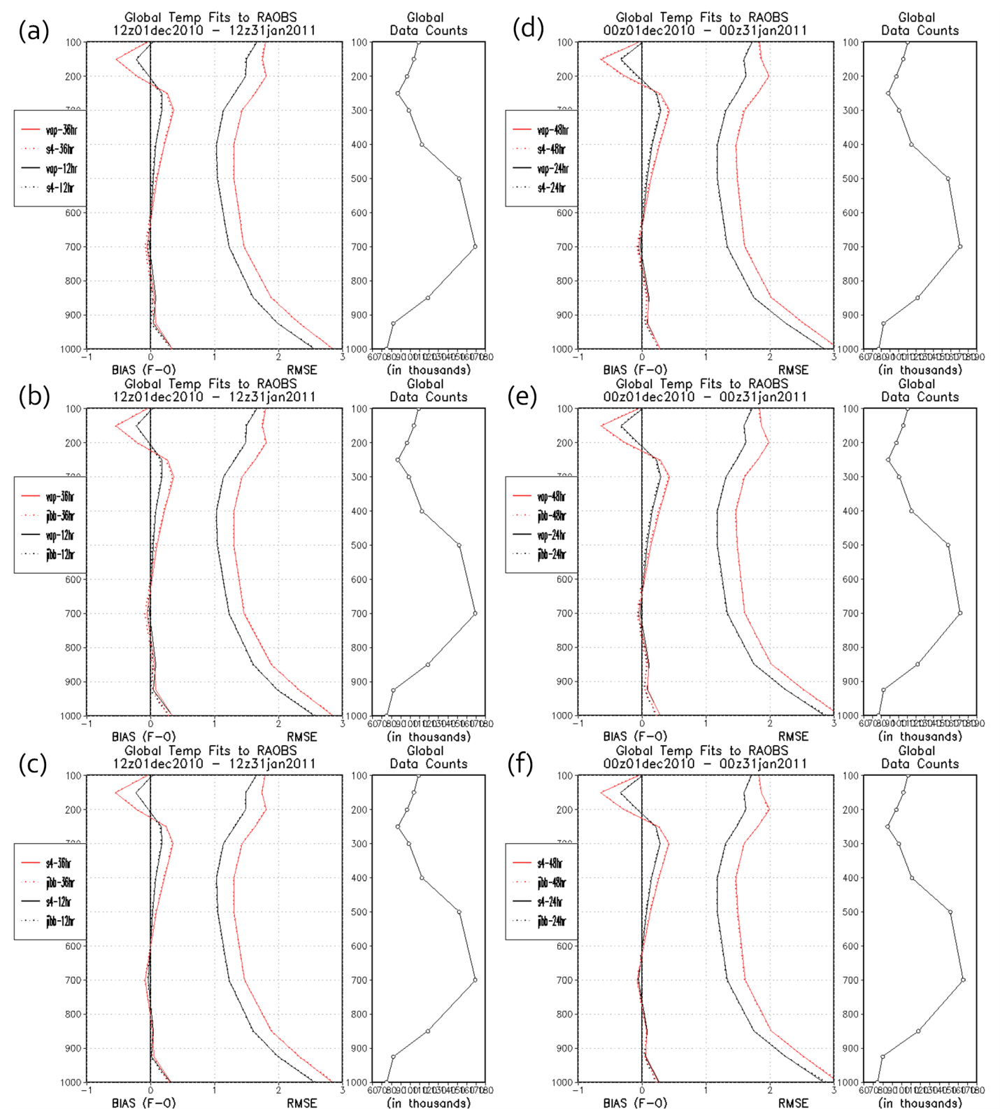
Figure 5.1-1: Temperature bias, RMSE and observation counts of 12 & 36 (a, b, c) and 24 & 48 (d, e, f) hour forecast fit to rawinsondes (RAOBS) for S4 vs. Vapor (a and d), JIBB vs. Vapor (b and e) and S4 vs. JIBB (c and f). These statistics are for 1 December 2010 – 31 January 2011. Units are degrees Kelvin [K].

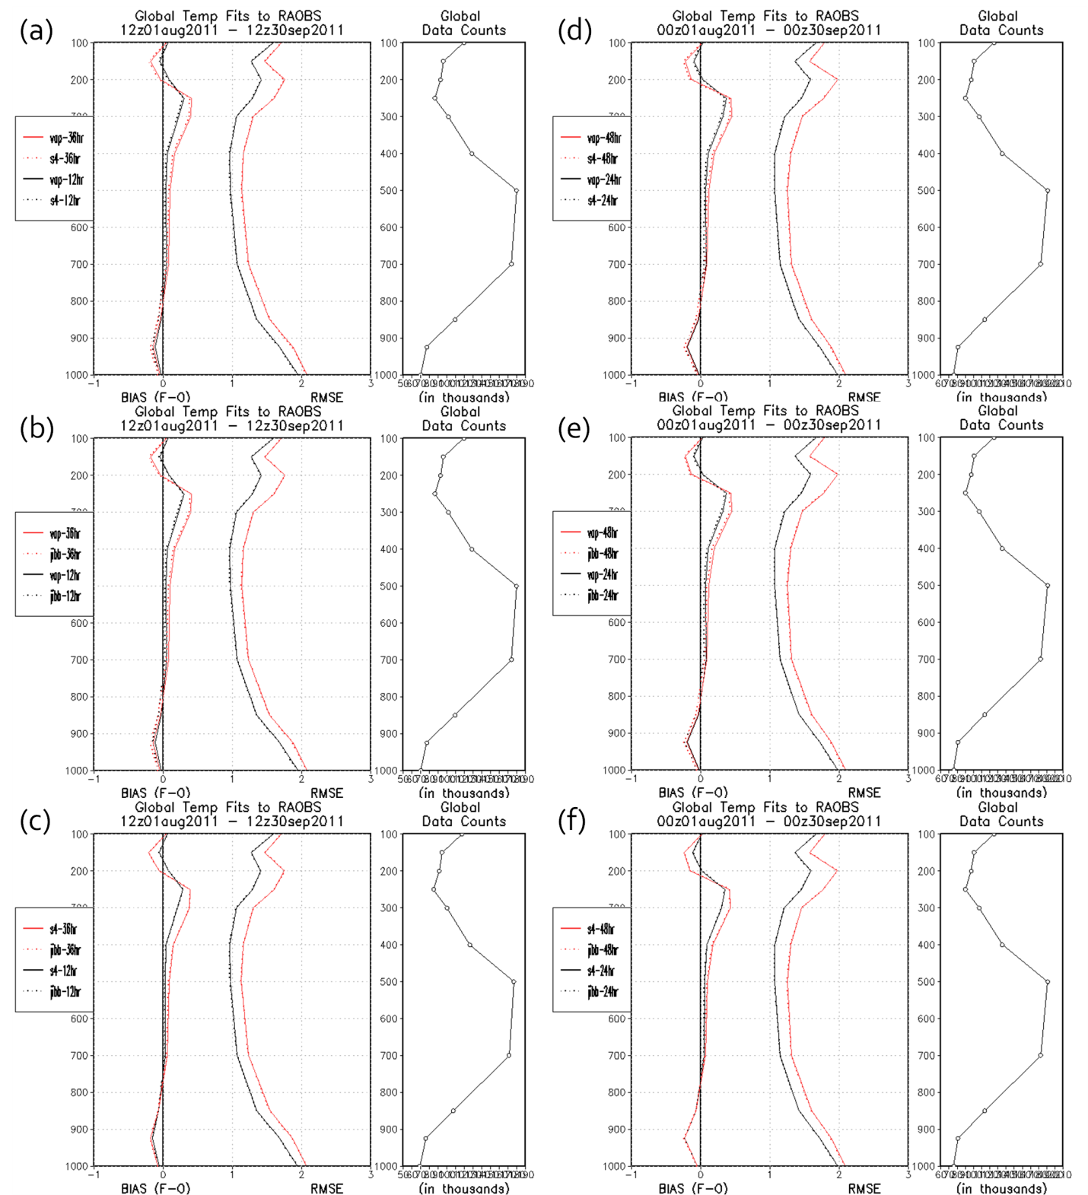
Figure 5.1-2: Temperature bias, RMSE and observation counts of 12 & 36 (a, b, c) and 24 & 48 (d, e, f) hour forecast fit to rawinsondes (RAOBS) for S4 vs. Vapor (a and d), JIBB vs. Vapor (b and e) and S4 vs. JIBB (c and f). These statistics are for 1 August – 30 September 2011. Units are degrees Kelvin [K].

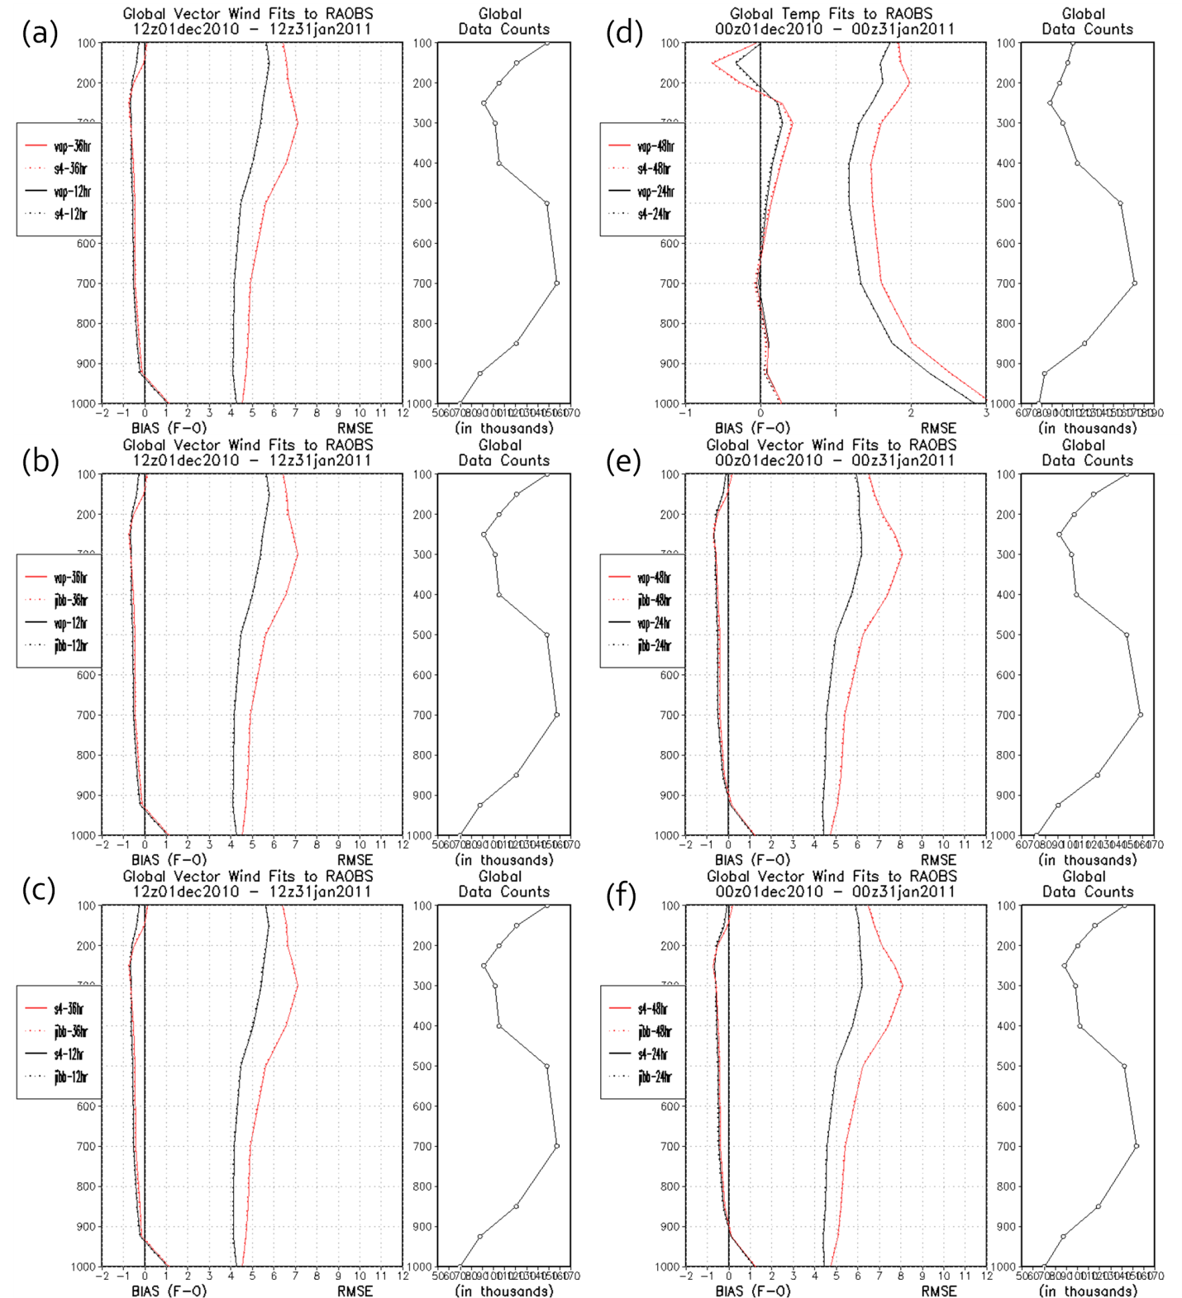
Figure 5.1-3: Wind speed bias, RMSE and observation counts of 12 & 36 (a, b, c) and 24 & 48 (d, e, f) hour forecast fit to rawinsondes (RAOBS) for S4 vs. Vapor (a and d), JIBB vs. Vapor (b and e) and S4 vs. JIBB (c and f). These statistics are for 1 December 2010 – 31 January 2011. Units are meters/second [m/s].
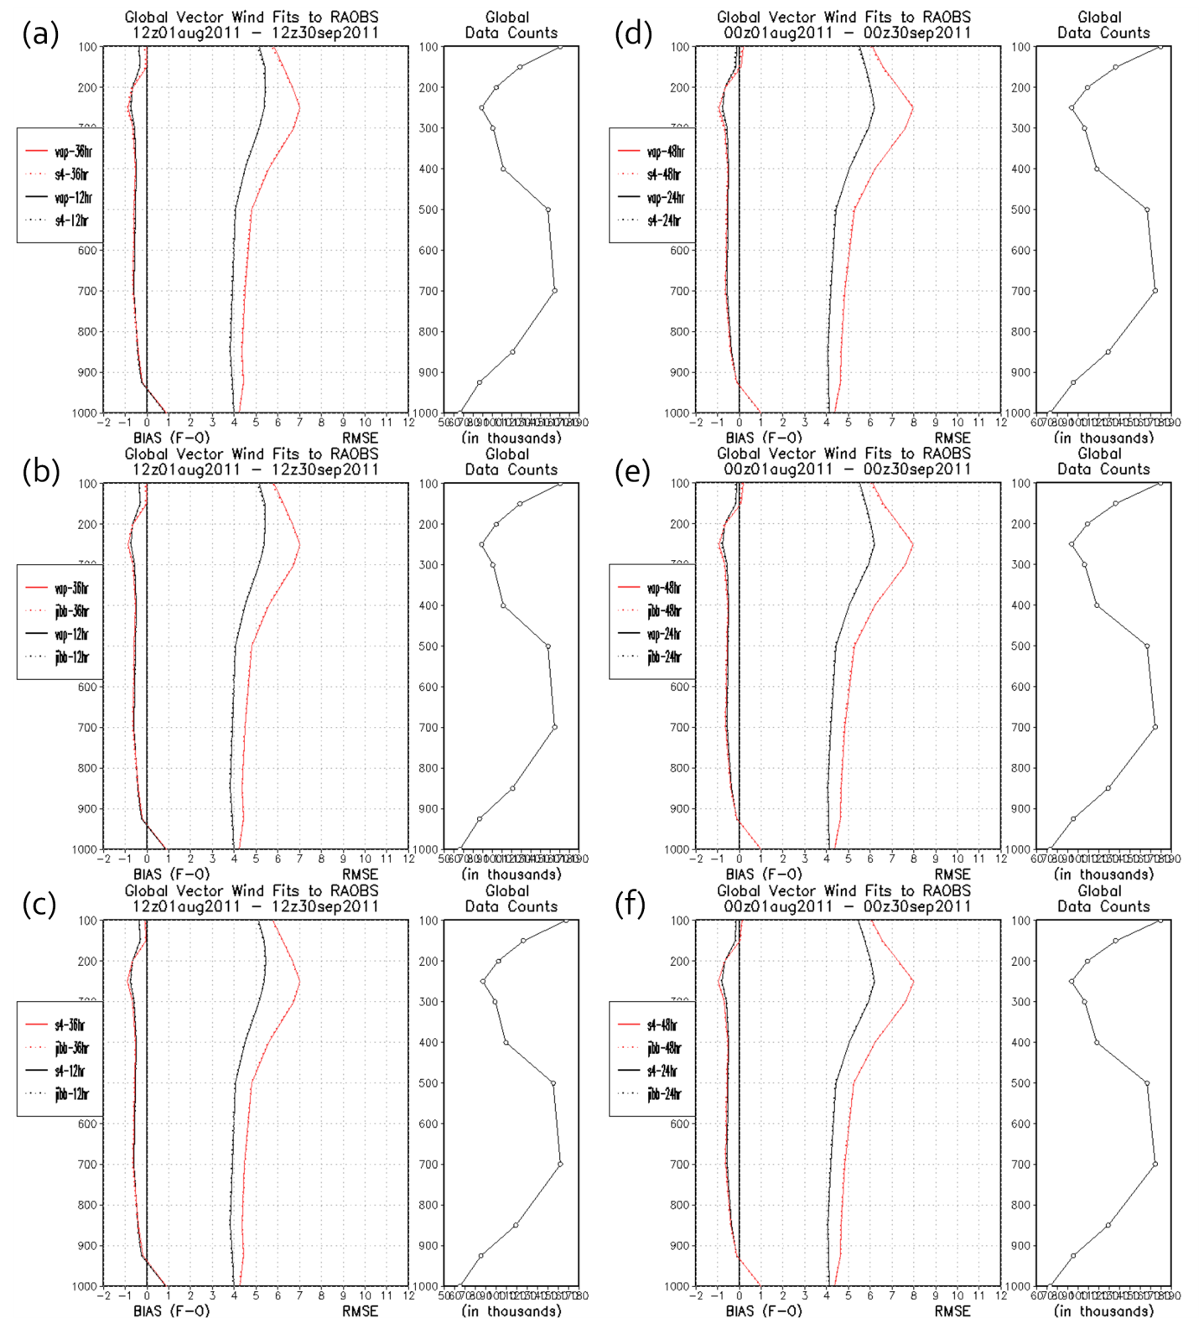
Figure 5.1-4: Wind speed bias, RMSE and observation counts of 12 & 36 (a, b, c) and 24 & 48 (d, e, f) hour forecast fit to rawinsondes (RAOBS) for S4 vs. Vapor (a and d), JIBB vs. Vapor (b and e) and S4 vs. JIBB (c and f). These statistics are for 1 August – 30 September 2011. Units are meters/second [m/s].

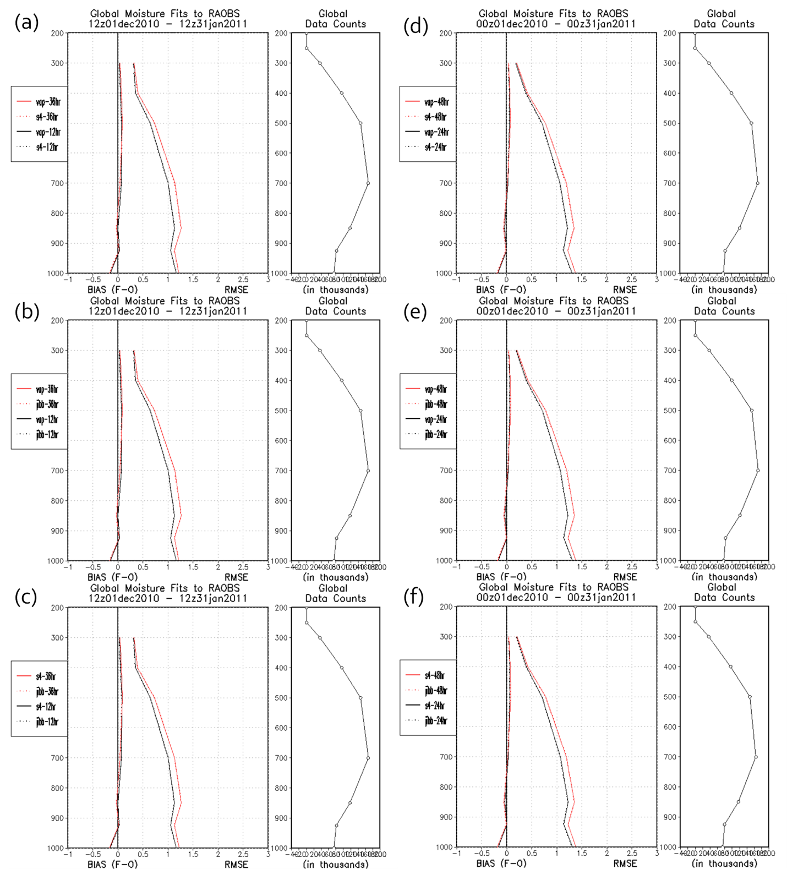
Figure 5.1-5: Specific humidity bias, RMSE and observation counts of 12 & 36 (a, b, c) and 24 & 48 (d, e, f) hour forecast fit to rawinsondes (RAOBS) for S4 vs. Vapor (a and d), JIBB vs. Vapor (b and e) and S4 vs. JIBB (c and f). These statistics are for 1 December 2010 – 31 January 2011. Units are gram/kilogram [g/Kg].
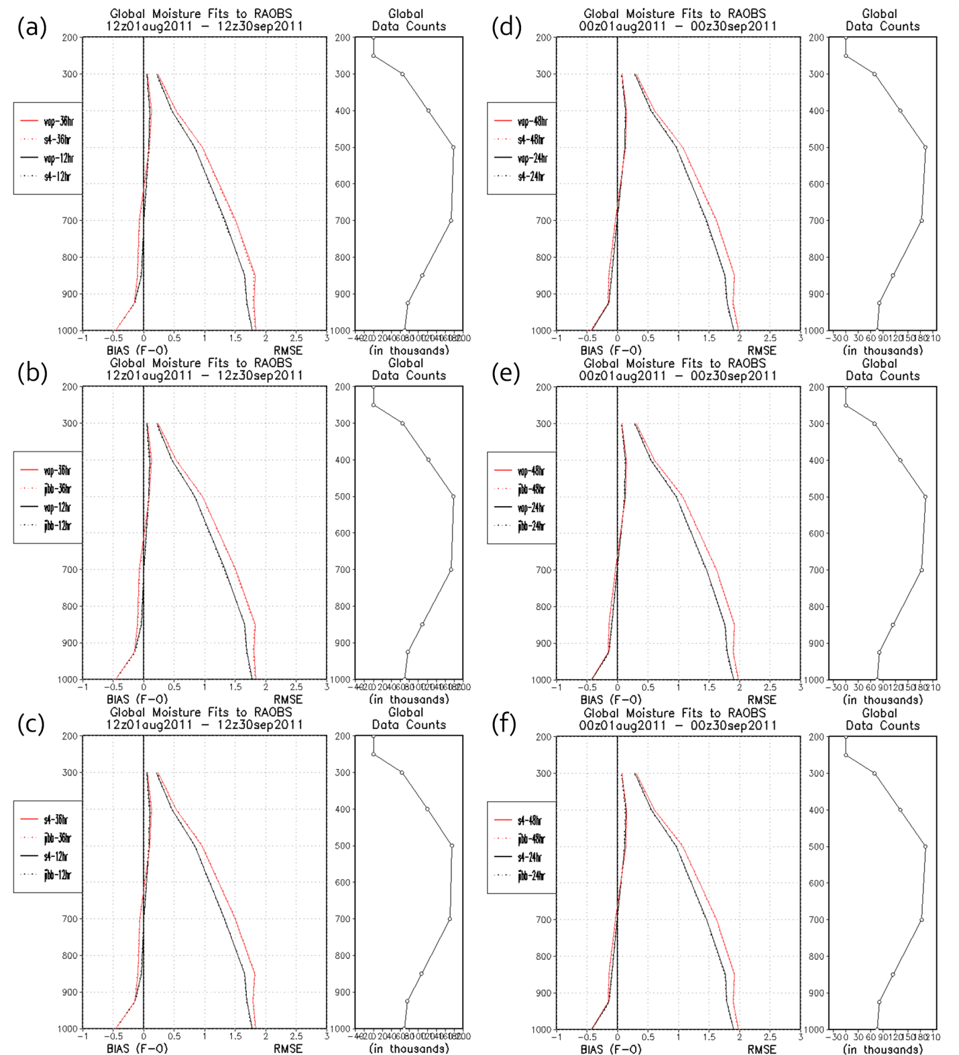
Figure 5.1-6: Specific humidity bias, RMSE and observation counts of 12 & 36 (a, b, c) and 24 & 48 (d, e, f) hour forecast fit to rawinsondes (RAOBS) for S4 vs. Vapor (a and d), JIBB vs. Vapor (b and e) and S4 vs. JIBB (c and f). These statistics are for 1 August – 30 September 2011. Units are gram/kilogram [g/Kg].

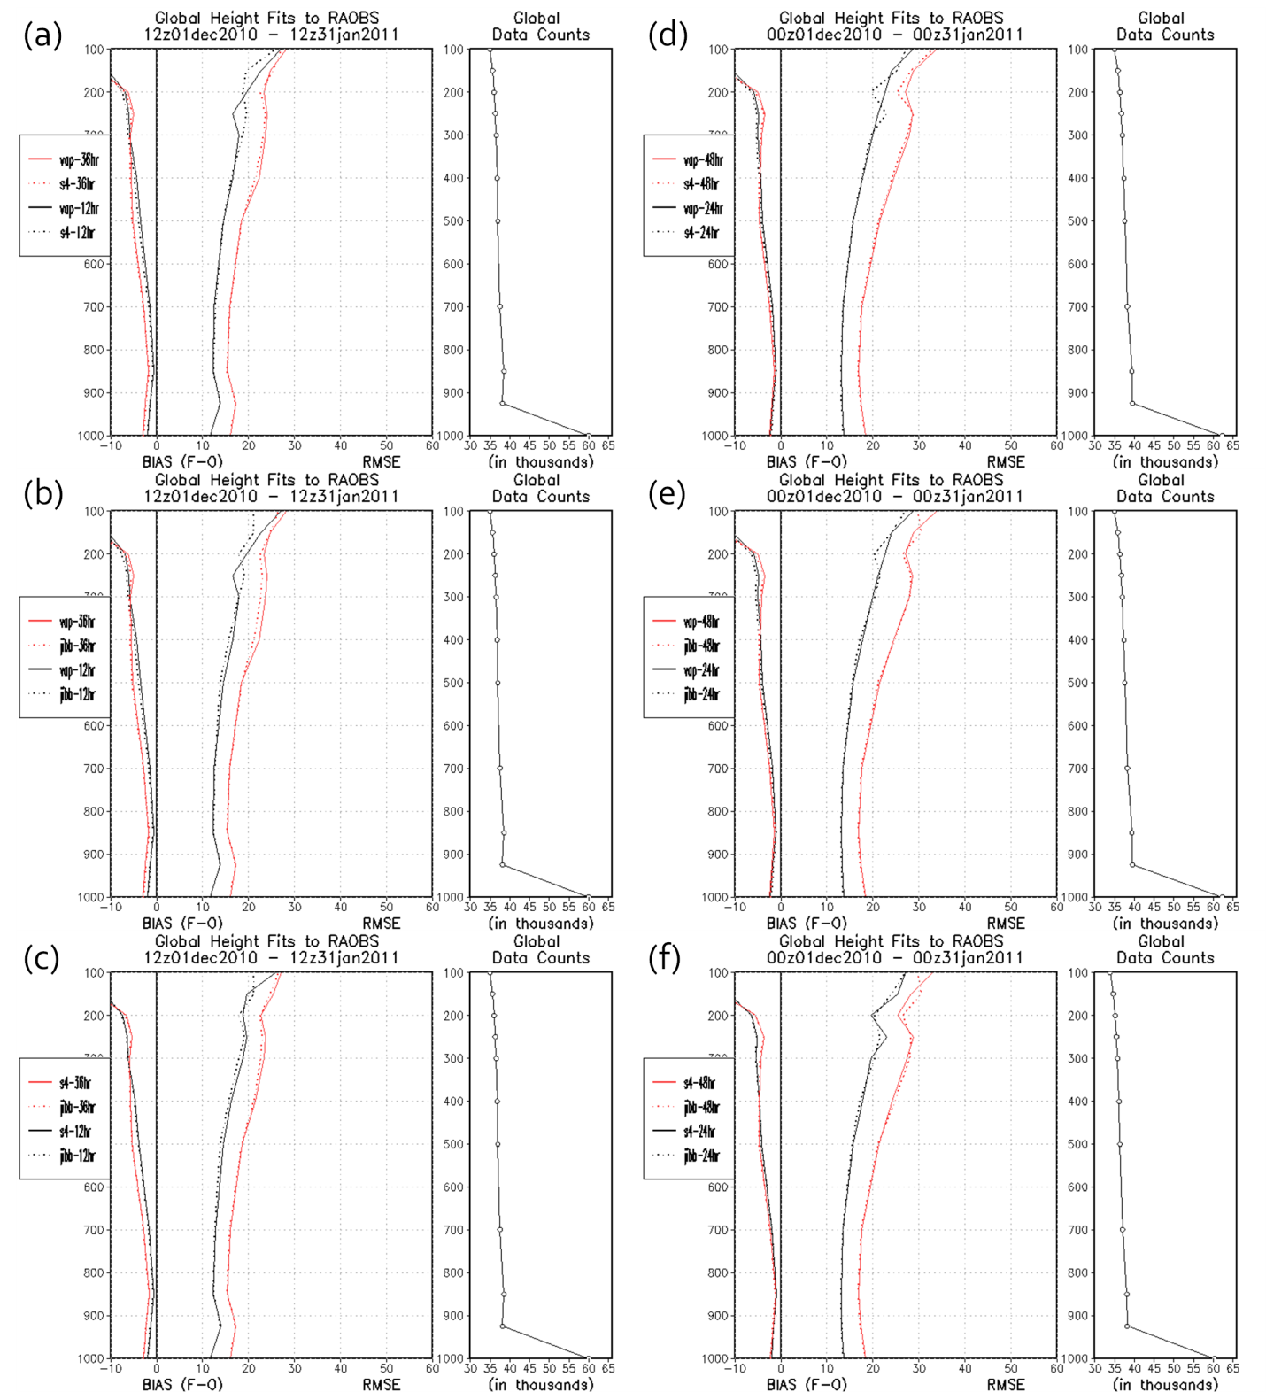
Figure 5.1-7: Geopotential height humidity bias, RMSE and observation counts of 12 & 36 (a, b, c) and 24 & 48 (d, e, f) hour forecast fit to rawinsondes (RAOBS) for S4 vs. Vapor (a and d), JIBB vs. Vapor (b and e) and S4 vs. JIBB (c and f). These statistics are for 1 December 2010 – 31 January 2011. Units are meters [m].

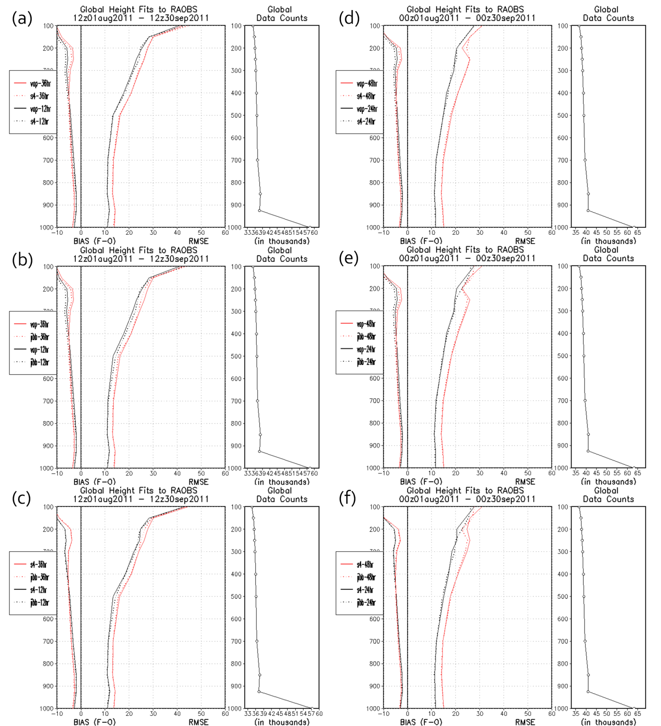
Figure 5.1-8: Geopotential height humidity bias, RMSE and observation counts of 12 & 36 (a, b, c) and 24 & 48 (d, e, f) hour forecast fit to rawinsondes (RAOBS) for S4 vs. Vapor (a and d), JIBB vs. Vapor (b and e) and S4 vs. JIBB (c and f). These statistics are for 1 August – 30 September 2011. Units are meters [m].

Anomaly Correlations
The most common weather forecast model performance benchmarks are the mid-latitude (20-80º N/S) anomaly correlations. The VSDB package generates two types of anomaly correlation plots, the time series and die-off curves. The 500 and 1000 hPa anomaly correlation time series plots at forecast day 5 for 1 December 2010 – 1 January 2011 and 1 August – 30 September 2011 are shown in figure 5.2-1 and 5.2-2 respectively. The day-to-day variation in these plots is typical. Obtaining almost the same value each day on the Vapor, JIBB and S4 computers suggests the day-to-day forecast skill is very similar. The 500 and 1000 hPa die-off curves in figures 5.2-3 and 5.2-4 confirm that these forecast skill trends are consistent through all seven forecast days and both seasons. Most of the forecast differences are not significant at the 95% level suggesting the three computers are generating similar forecasts.
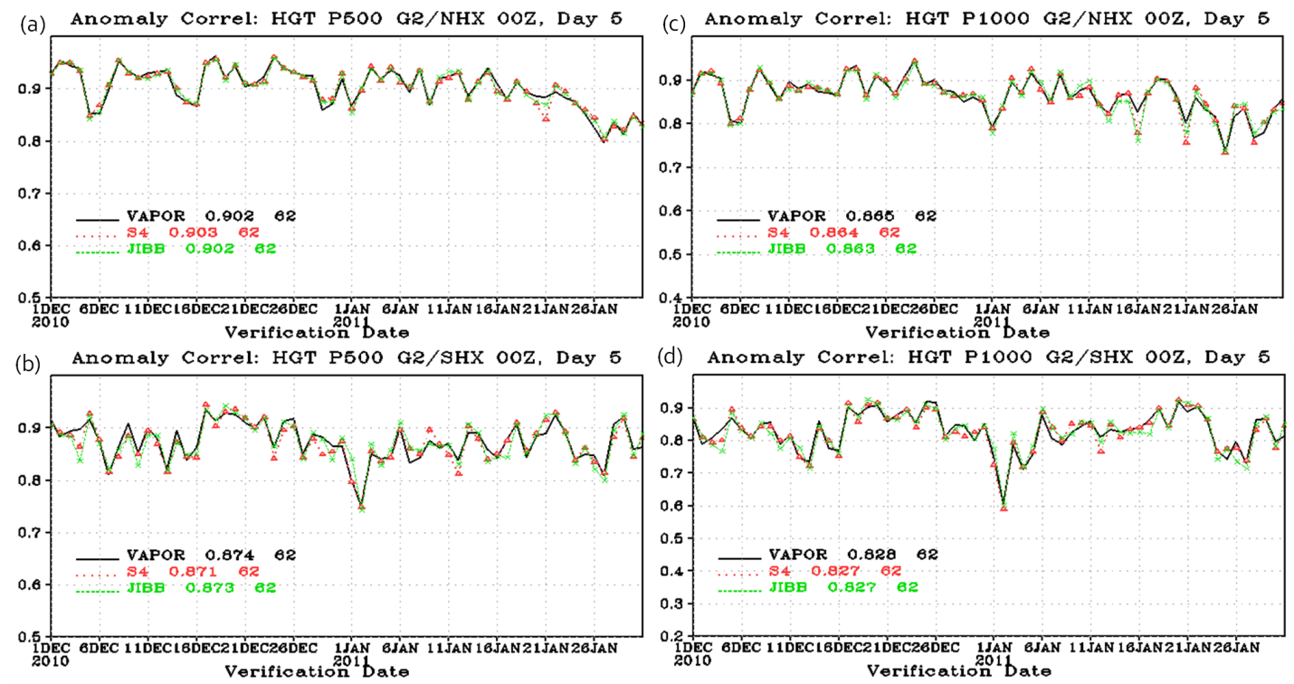
Figure 5.2-9: Anomaly correlation time series from 1 December 2010 to 31 January 2011 for Northern (a and c) and Southern (b and d) Hemisphere at 500 (a and b) and 1000 (b and d) hPa. Vapor, S4 and JIBB are plotted in black, red, and green respectively.

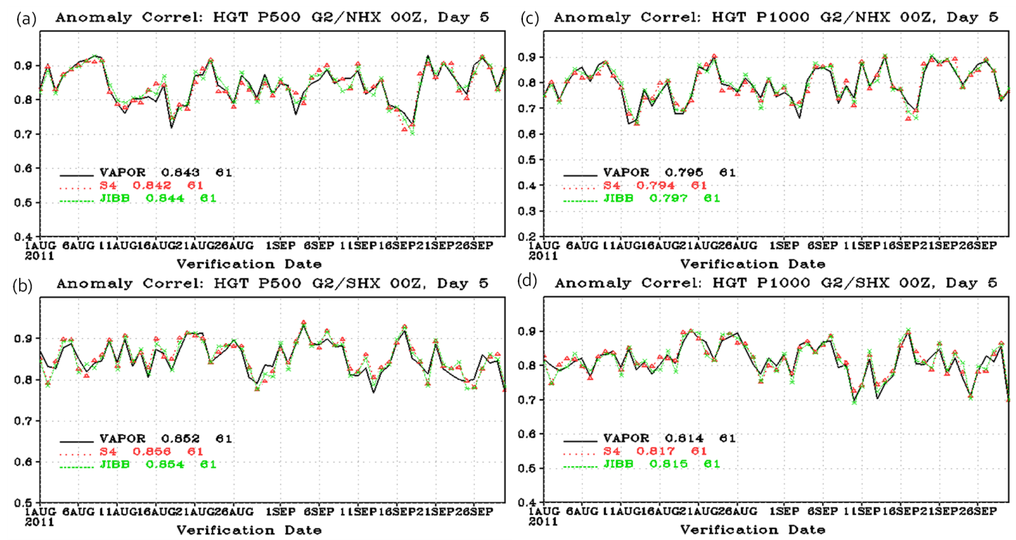
Figure 5.2-10: Anomaly correlation time series from 1 August to 30 September 2010 for Northern (a and c) and Southern (b and d) Hemisphere at 500 (a and b) and 1000 (b and d) hPa. Vapor, S4 and JIBB are plotted in black, red, and green respectively.

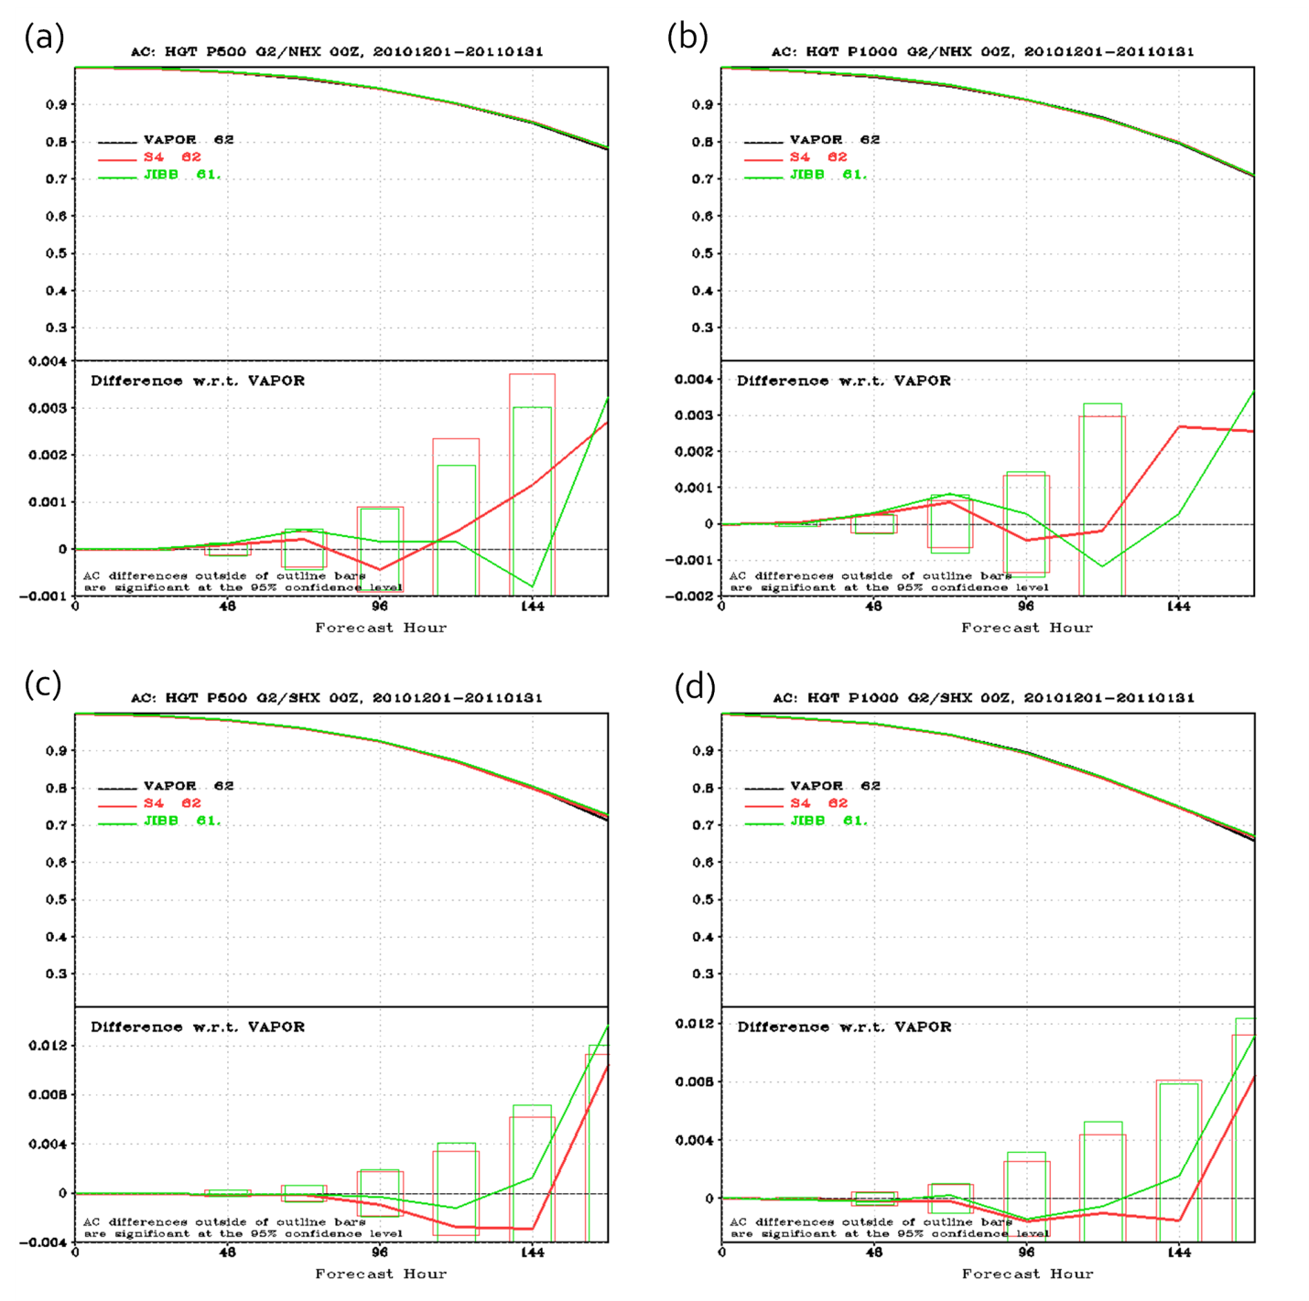
Figure 5.2-11: Anomaly correlation die off curves from 1 December 2010 to 31 January 2011 for Northern (a and c) and Southern (b and d) Hemisphere at 500 (a and b) and 1000 (c and d) hPa. Vapor, S4 and JIBB are plotted in black, red, and green respectively.

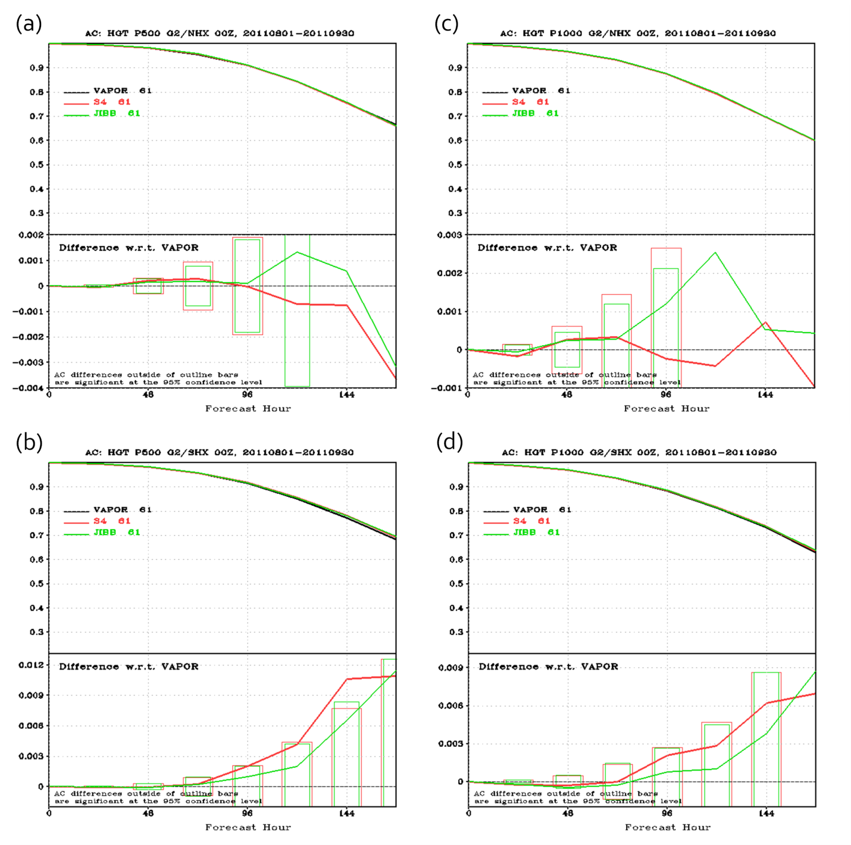
Figure 5.2-12: Anomaly correlation die off curves from 1 August to 30 September 2011 for Northern (a and c) and Southern (b and d) Hemisphere at 500 (a and b) and 1000 (c and d) hPa. Vapor, S4 and JIBB are plotted in black, red, and green respectively.

RMSE Statistics
Since the geopotential heights have small variations in the tropics, vector wind RMSE is typically used to measure forecast skill. Tropical vector wind RMSE can also be problematic due to fast error growth and being verified against its own analysis. The vector wind RMSE is compared at 200 and 850 hPa for both seasons in figure 5.3-1. In general, the differences are not significant at the 95% confidence level. The only significant difference is at 850 hPa vector wind during 1Dec – 31 Jan 2011 (panel b) where S4 and JIBB have a significantly better tropical wind forecast than Vapor. The differences between S4 and JIBB in panel b are not significant.
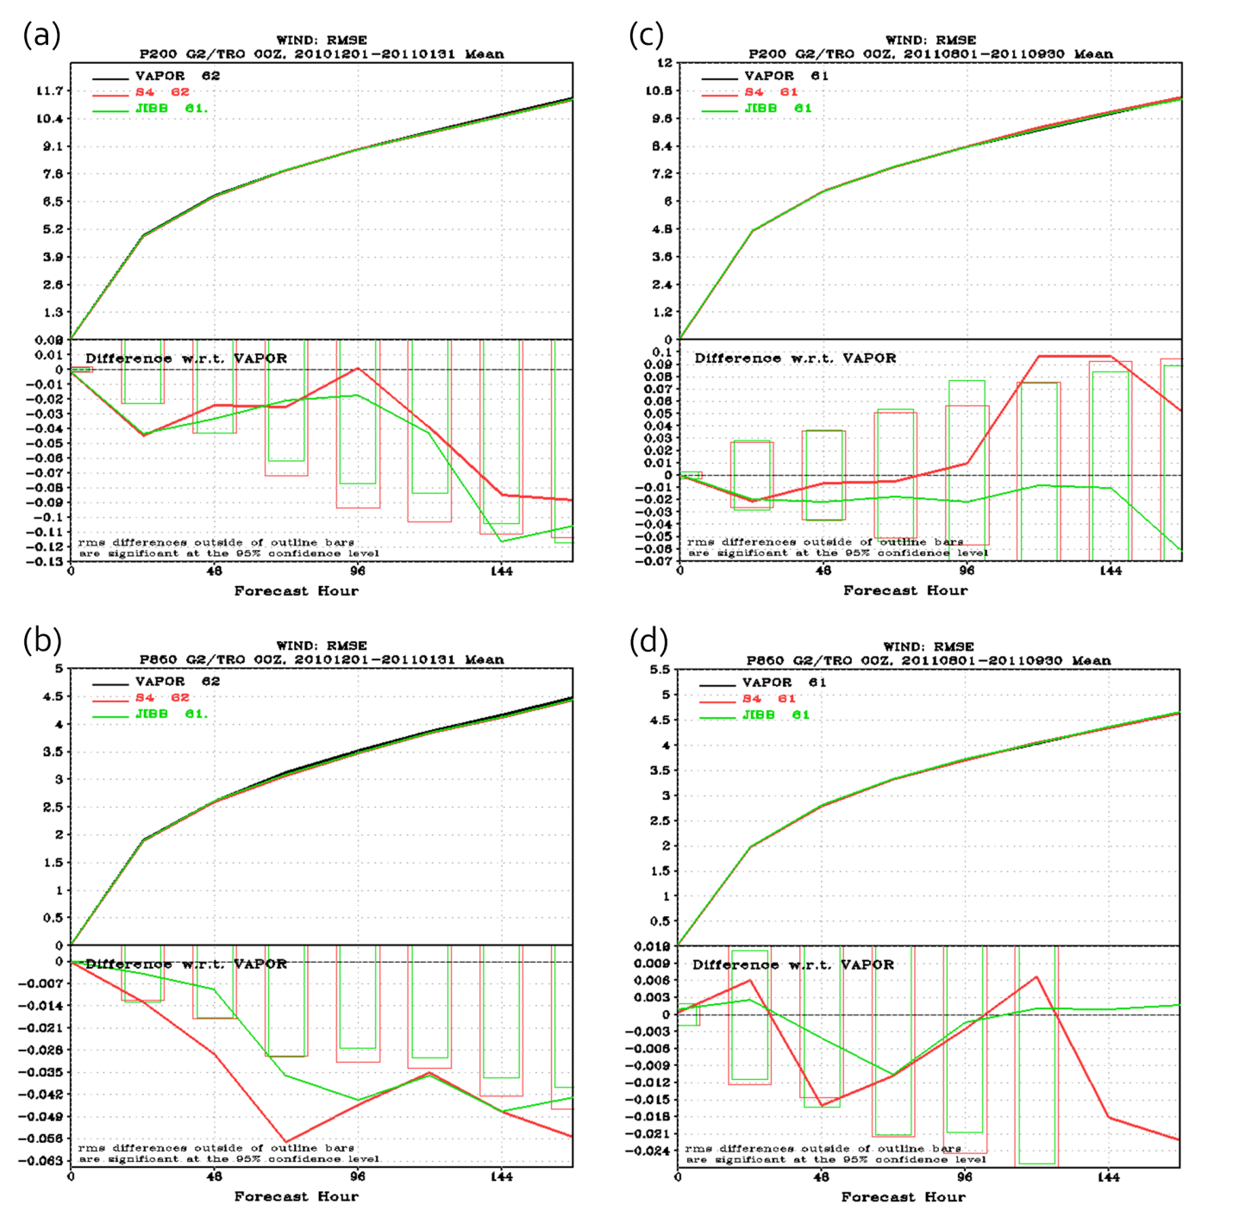
Figure 5.3-13: RMSE die off curves for 1 December 2010 - 31 January 2011 (a and b) and 1 August - 30 September 2011 (c and d) at 200 (a and c) and 850 (b and d) hPa. Vapor, S4 and JIBB are plotted in black, red, and green respectively. Note: Smaller RMSE values are better forecasts, a forecast improvement will be a negative difference.

Standard Deviations of the Analyses and Forecasts.

[The standard deviation fields concern me since they have a systematic geographical structure and it appears that the magnitude of the standard deviations are pretty large. For example, precipitable water appears to be upto 5% of a nominal mean. It would be good to be able to put these in perspective by showing the mean distributions as well. Also discuss the issue with the binary/stochastic nature of the model convection and how this can potentially lead to geographically systematic changes in moisture, diabatic heating, and subsequently large scale circulation patterns. ] Standard deviation fields of precipitable water, total accumulated rainfall, 500 hPa relative humidity, 500 hPa temperature, 250 hPa U-component of wind, 100 hPa geopotential heights and 500 hPa geopotential heights are displayed for both seasons in figures 5.4-1 through 5.4-14 for both seasons respectively. The standard deviations are displayed for the analysis (panels a, b, and c) and the 48-hour forecast (panels d, e, f). Since the analysis PGB files do not contain precipitation, the 6-hour forecast was used in figures 5.4-3 and 5.4-4. Differences are displayed with respect to each computer combination. Panels a and d are S4 – Vapor differences, panels b and e are JIBB – Vapor and differences and panels c and f are S4 – JIBB differences.
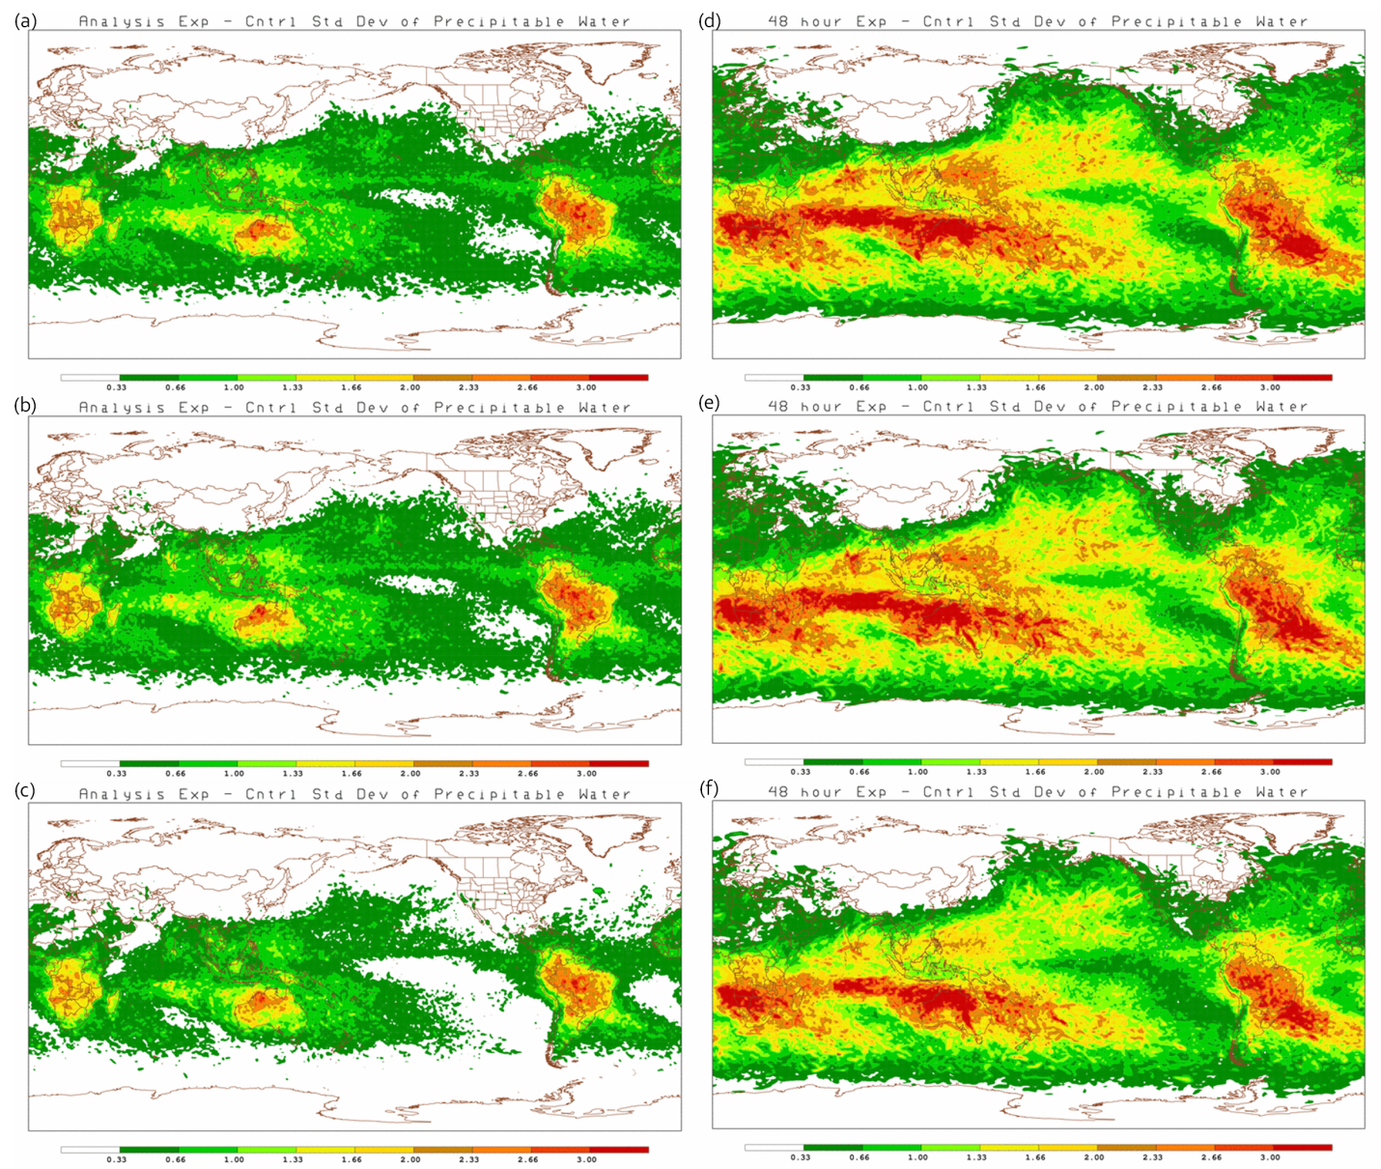
Figure 5.4-14: Standard deviation of the difference between analyses (a, b, c) and 48-hour forecasts (d, e, f) of precipitable water. Differences between S4 – Vapor (a and d), JIBB – Vapor (b and e), and S4 – JIBB (c and f) are for 1 December 2010 to 31 January 2011. Units are millimeters of water Vapor [mm].
Several regions (Southern Africa, Australia and Northern South America) show increased variability for all three computer combinations during 1 December 2010 – 31 January 2011 in figure 5.4-1. This seems to translate into increased variability for the same regions in the 48-hour forecast. During the period of 1 August – 30 September 2011 in figure 5.4-2, the regions of greatest variability has shifted northward. This suggests the increased variability is related to the summer season hemisphere.
In a qualitative sense, the variability seems to be consistent in the same regions in all of the parameters shown and for all the computers. There seems to be a little less variability in panel c and e suggesting that S4 and JIBB may be more consistent with each other than with Vapor.
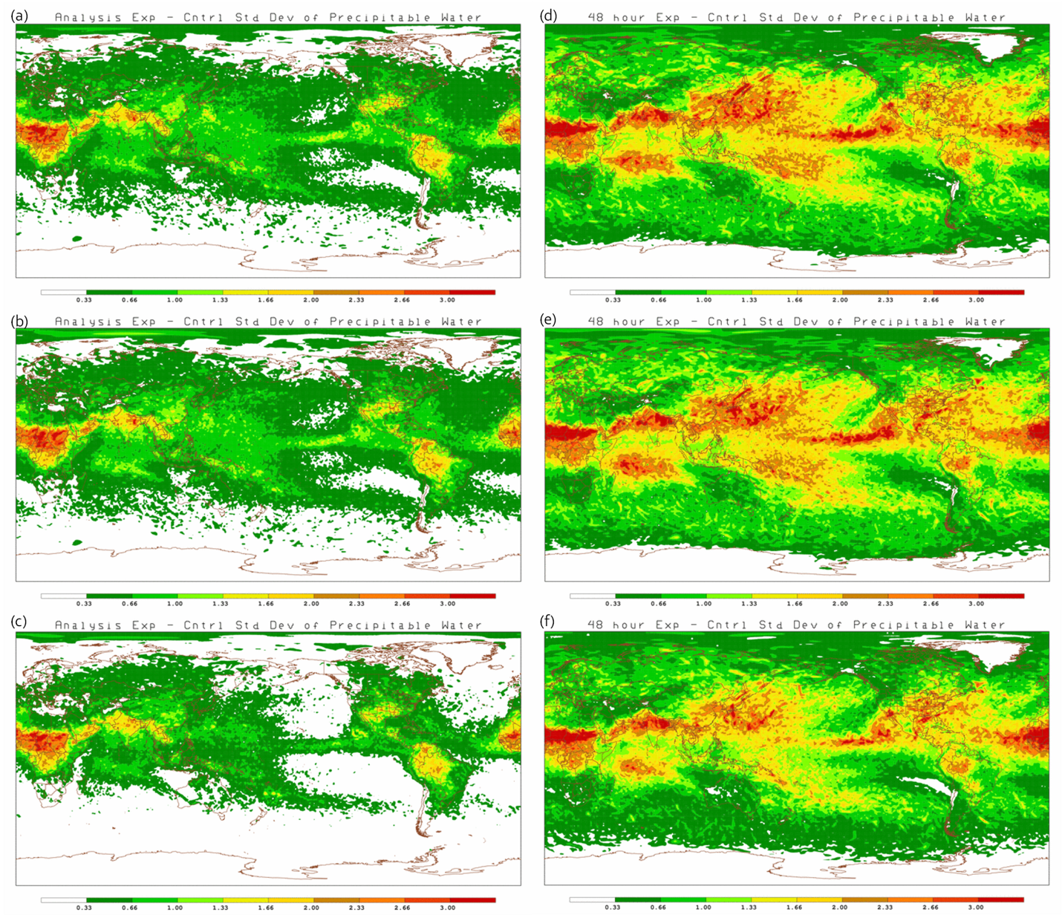
Figure 5.4-15: Standard deviation of the difference between analyses (a, b, c) and 48-hour forecasts (d, e, f) of precipitable water. Differences between S4 – Vapor (a and d), JIBB – Vapor (b and e), and S4 – JIBB (c and f) are for 1 August to 30 September 2011. Units are millimeters of water Vapor [mm].
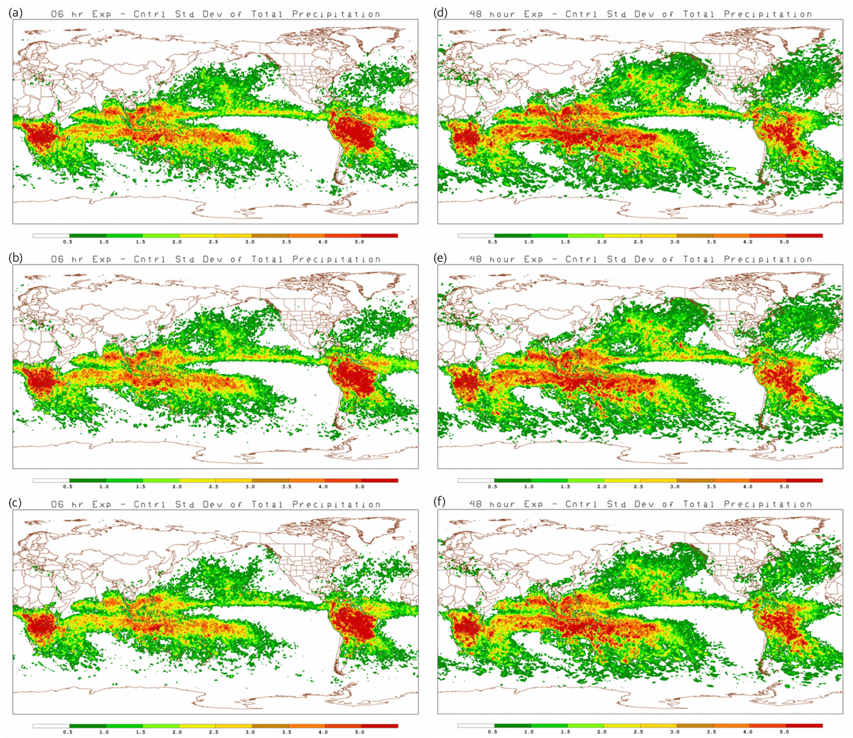
Figure 5.4-16: Standard deviation of the difference between the 6-hour forecasts (a, b, c) and 48-hour forecasts (d, e, f) for 6-hour accumulation of total precipitation. Differences between S4 – Vapor (a and d), JIBB – Vapor (b and f), and S4 – JIBB (c and e) are for 1 December 2010 to 31 January 2011. Units are millimeters of water [mm].
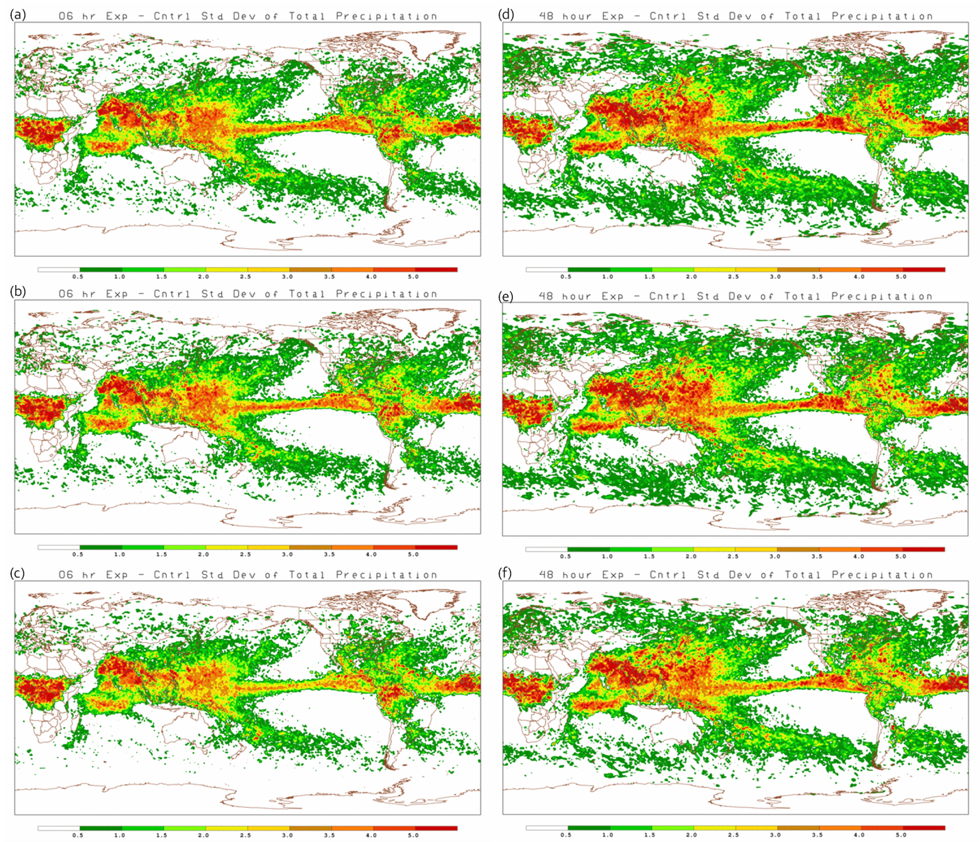
Figure 5.4-17: Standard deviation of the difference between the 6-hour forecasts (a, b, c) and 48-hour forecasts (d, e, f) for 6-hour accumulation of total precipitation. Differences between S4 – Vapor (a and d), JIBB – Vapor (b and f), and S4 – JIBB (c and e) are for 1 August to 30 September 2011. Units are millimeters of water [mm].
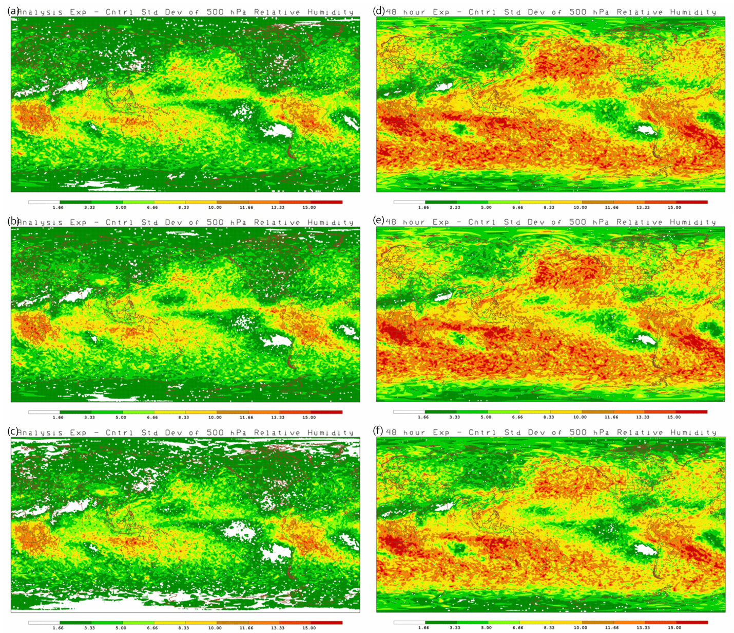
Figure 5.4-18: Standard deviation of the difference between the analyses (a, b, c) and 48-hour forecast (d, e, f) for 500 hPa Relative Humidity. Differences between S4 – Vapor (a and d), JIBB – Vapor (b and e), and S4 – JIBB (c and f) are for 1 December 2010 to 31 January 2011. Units are percent [%].
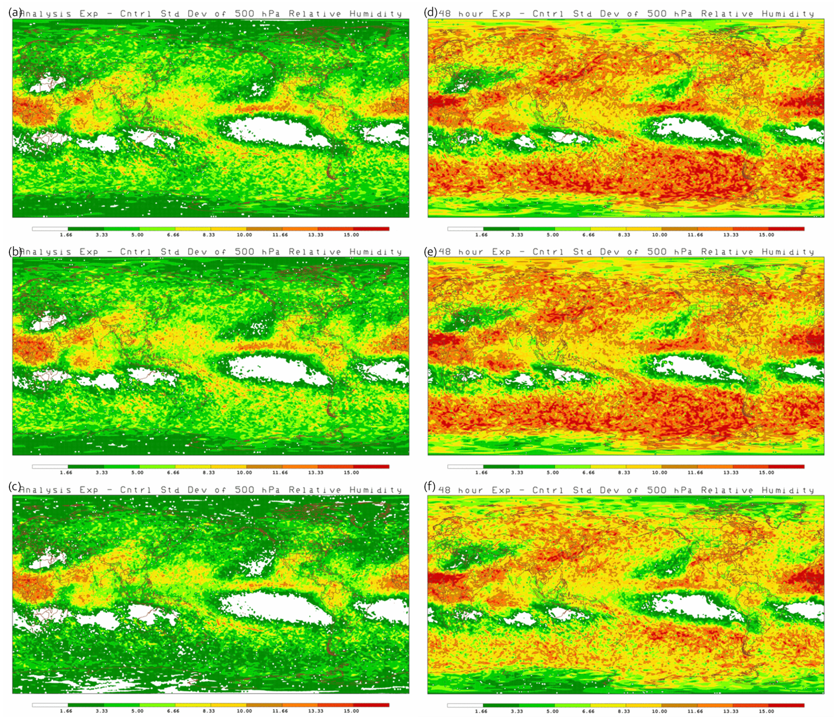
Figure 5.4-19: Standard deviation of the difference between the analyses (a, b, c) and 48-hour forecast (d, e, f) for 500 hPa Relative Humidity. Differences between S4 – Vapor (a and d), JIBB – Vapor (b and e), and S4 – JIBB (c and f) are for 1 August to 30 September 2011. Units are percent [%].
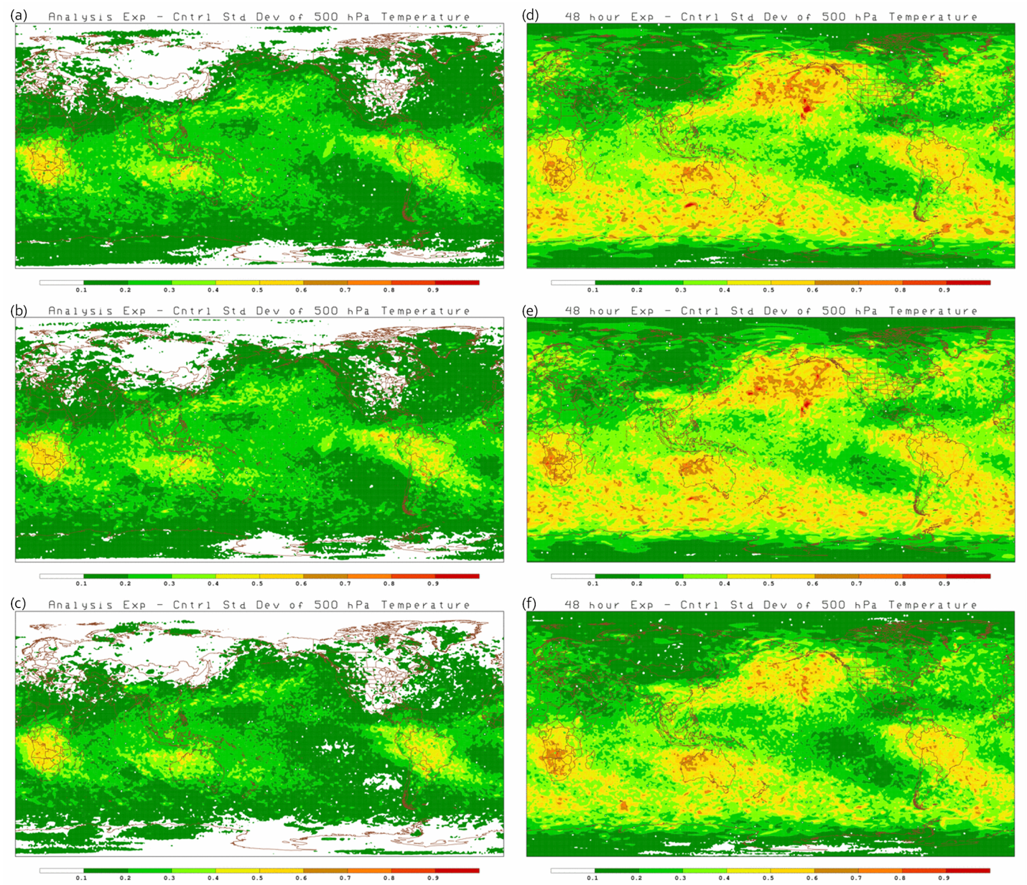
Figure 5.4-20: Standard deviation of the difference between the analyses (a, b, c) and 48-hour forecasts (d, e, f) for 500 hPa Temperature. Differences between S4 – Vapor (a and d), JIBB – Vapor (b and e), and S4 – JIBB (c and f) are for 1 December 2010 to 31 January 2011. Units are degrees Kelvin [K].
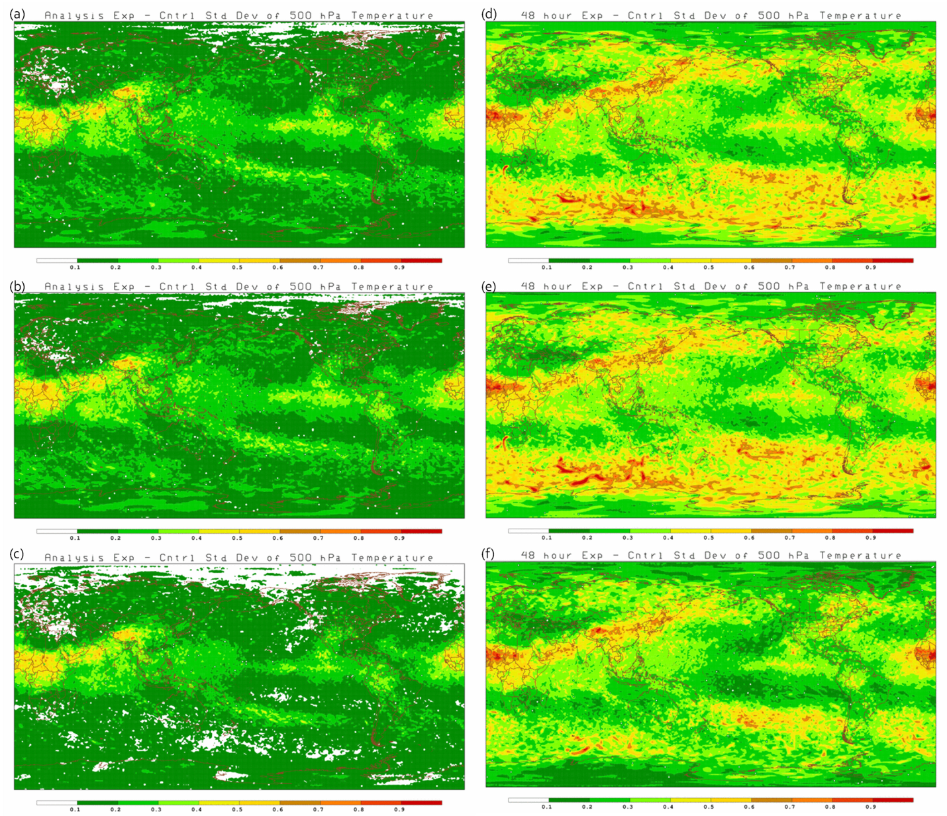
Figure 5.4-21: Standard deviation of the difference between the analyses (a, b, c) and 48-hour forecasts (d, e, f) for 500 hPa Temperature. Differences between S4 – Vapor (a and d), JIBB – Vapor (b and e), and S4 – JIBB (c and f) are for 1 August to 30 September 2011. Units are degrees Kelvin [K].
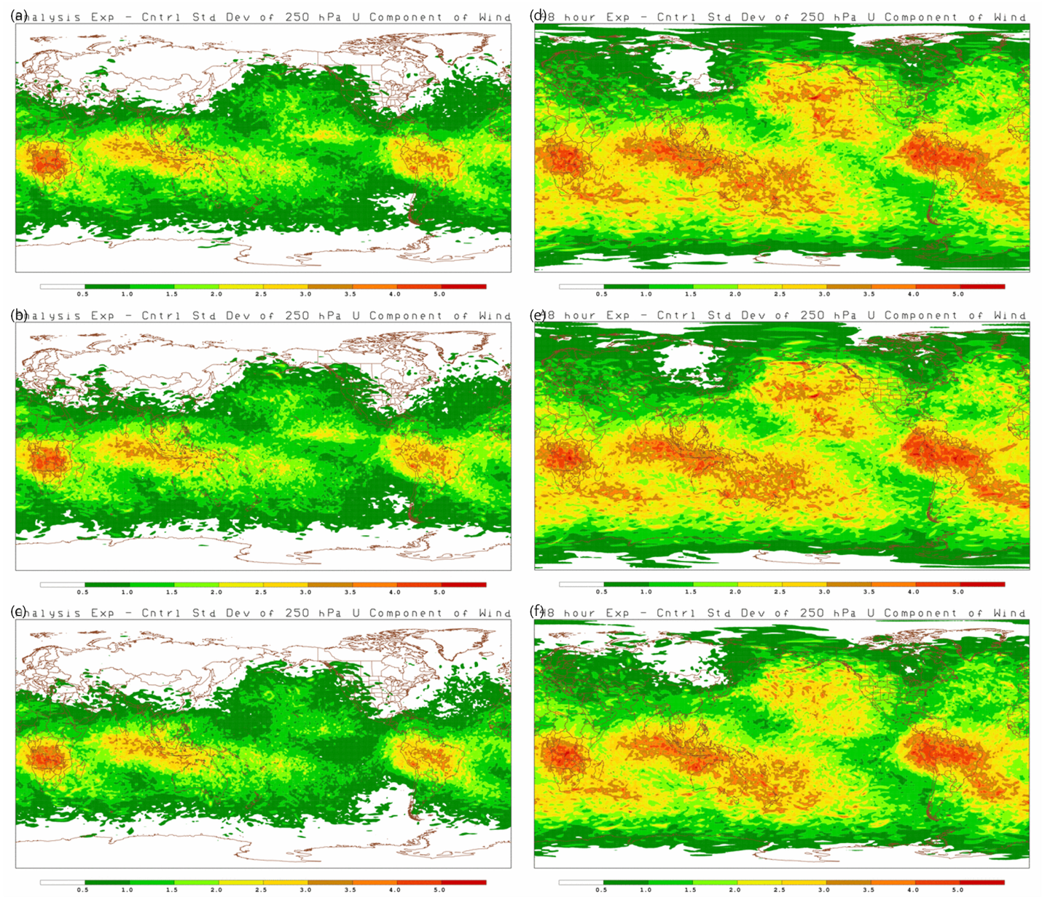
Figure 5.4-22: Standard deviation of the difference between the analyses (a, b, c) and 48-hour forecasts (d, e, f) for 250 hPa U component of wind. Differences between S4 – Vapor (a and d), JIBB – Vapor (b and e), and S4 – JIBB (c and f) are for 1 December 2010 to 31 January 2011. Units are meters/second [m/s].
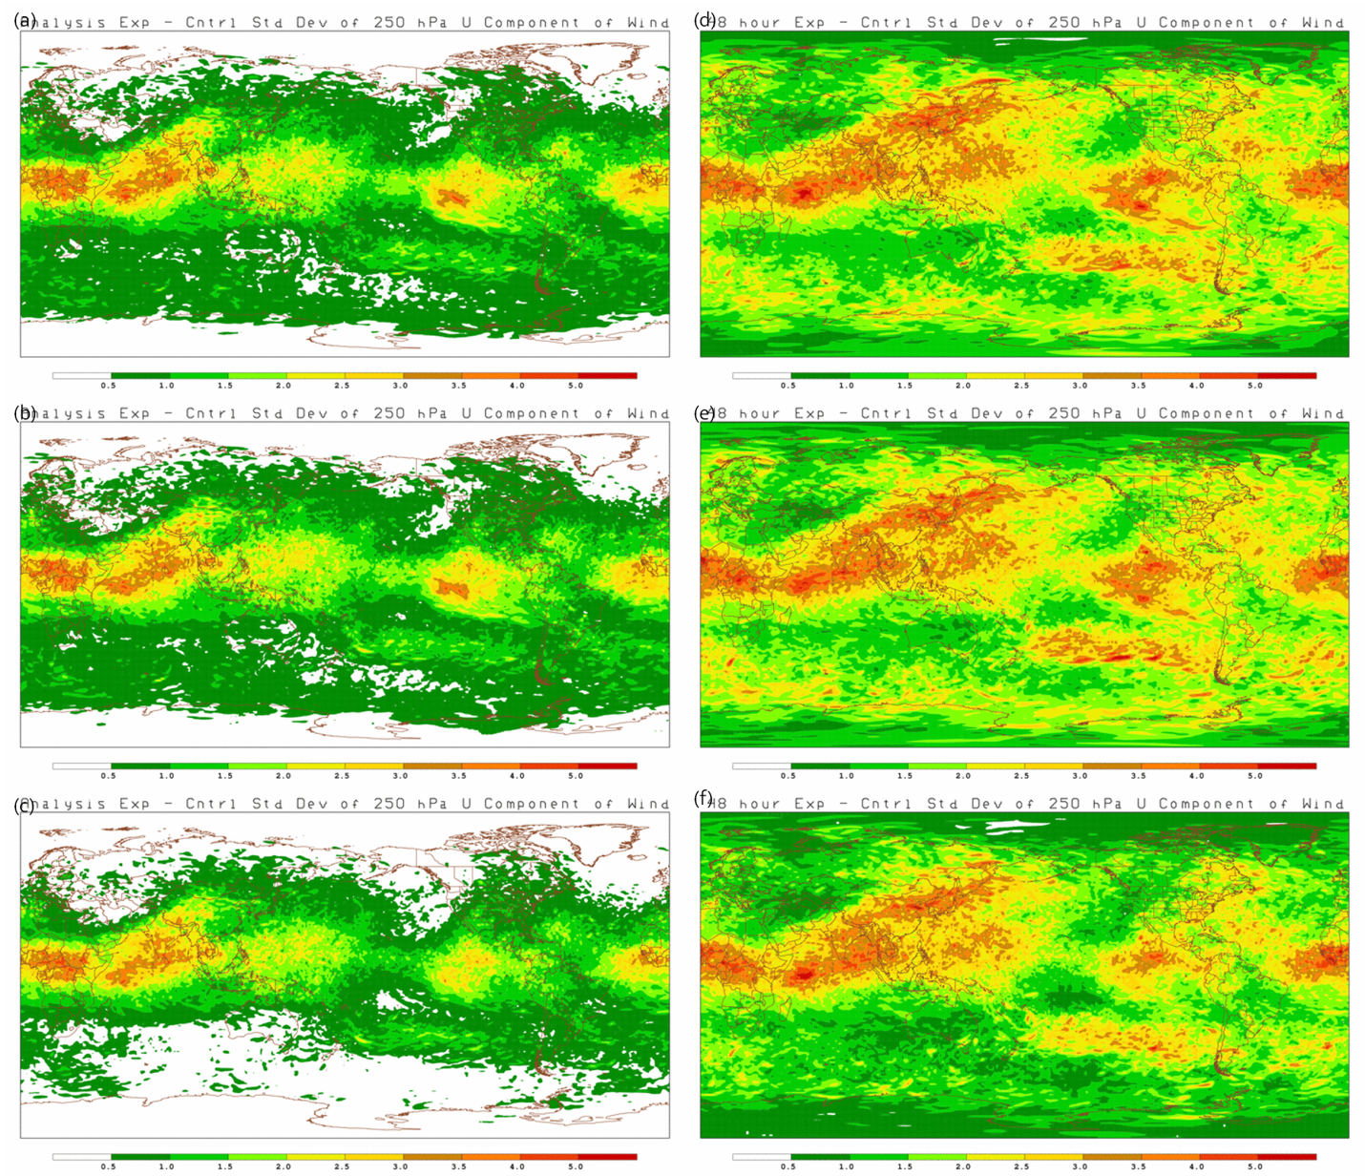
Figure 5.4-23: Standard deviation of the difference between the analyses (a, b, c) and 48-hour forecasts (d, e, f) for 250 hPa U component of wind. Differences between S4 – Vapor (a and d), JIBB – Vapor (b and e), and S4 – JIBB (c and f) are for 1 August to 30 September 2011. Units are meters/second [m/s].
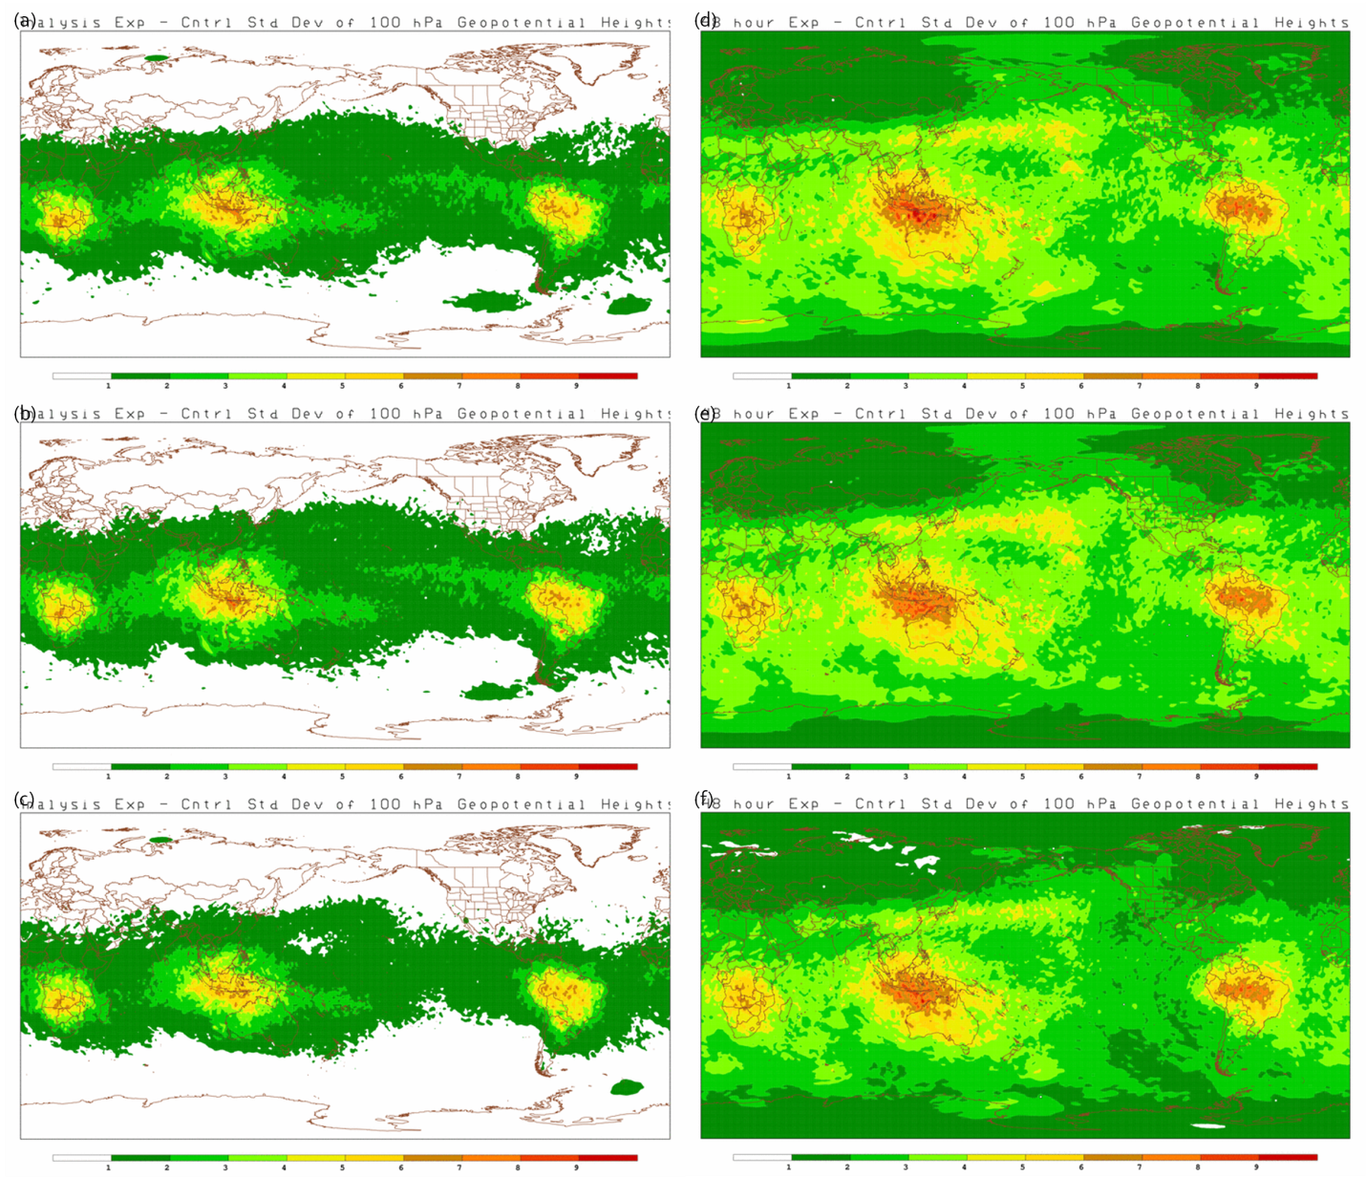
Figure 5.4-24: Standard deviation of the difference between the analyses (a, b, c) and 48-hour forecasts (d, e, f) for 100 hPa Geopotential Height. Differences between S4 – Vapor (a and d), JIBB – Vapor (b and e), and S4 – JIBB (c and f) are for 1 December 2010 to 31 January 2011. Units are meters/second [m/s].
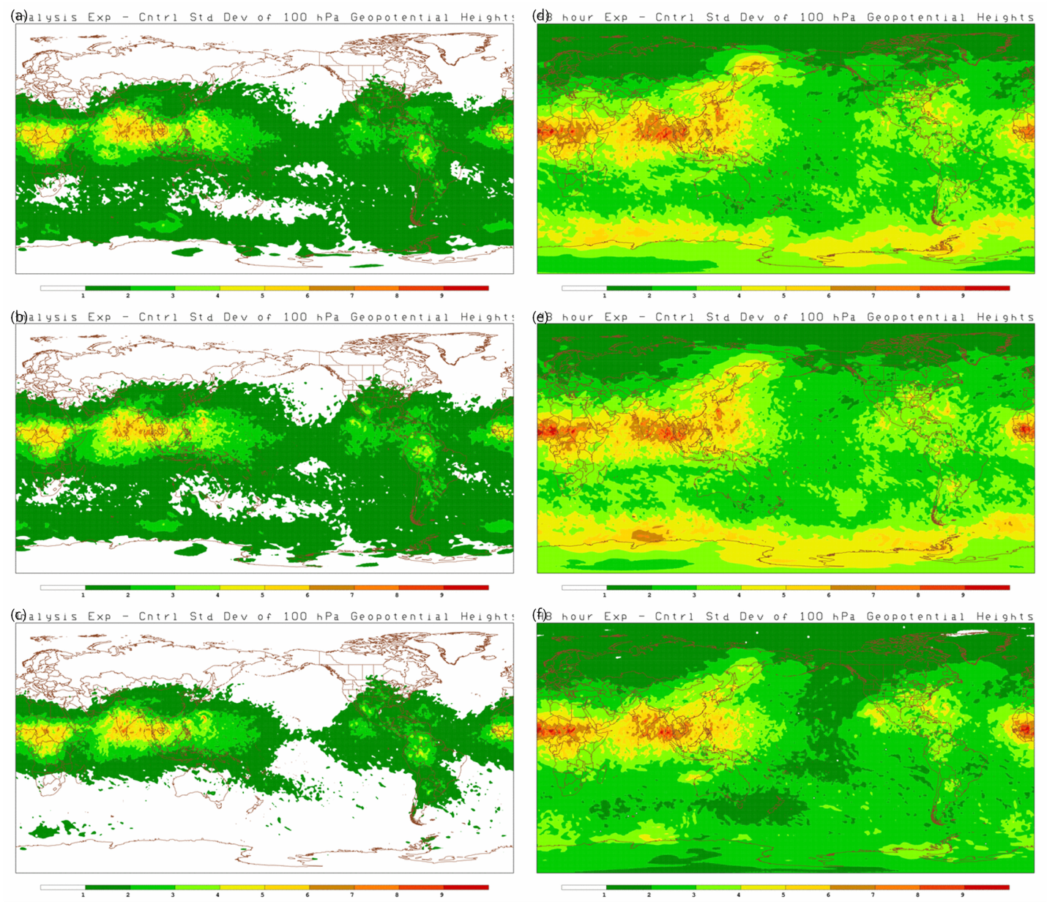
Figure 5.4-25: Standard deviation of the difference between the analyses (a, b, c) and 48-hour forecasts (d, e, f) for 100 hPa Geopotential Height. Differences between S4 – Vapor (a and d), JIBB – Vapor (b and e), and S4 – JIBB (c and f) are for 1 August to 30 September 2011. Units are meters/second [m/s].
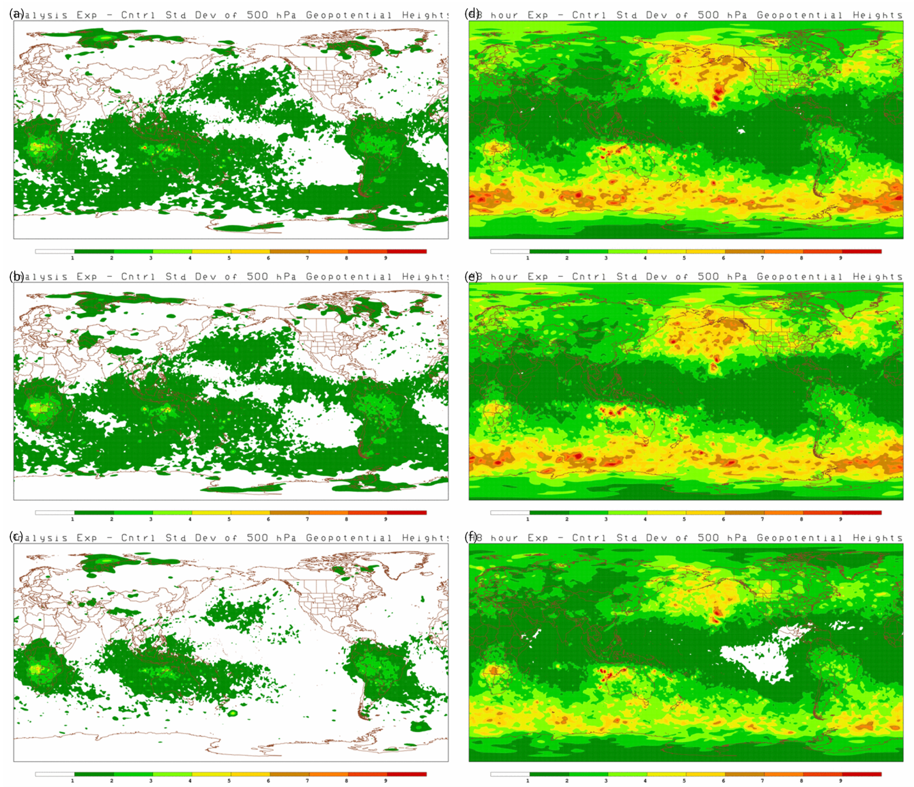
Figure 5.4-26: Standard deviation of the difference between the analyses (a, b, c) and 48-hour forecasts (d, e, f) for 500 hPa Geopotential Height. Differences between S4 – Vapor (a and d), JIBB – Vapor (b and e), and S4 – JIBB (c and f) are for 1 December 2010 to 31 January 2011. Units are meters/second [m/s].
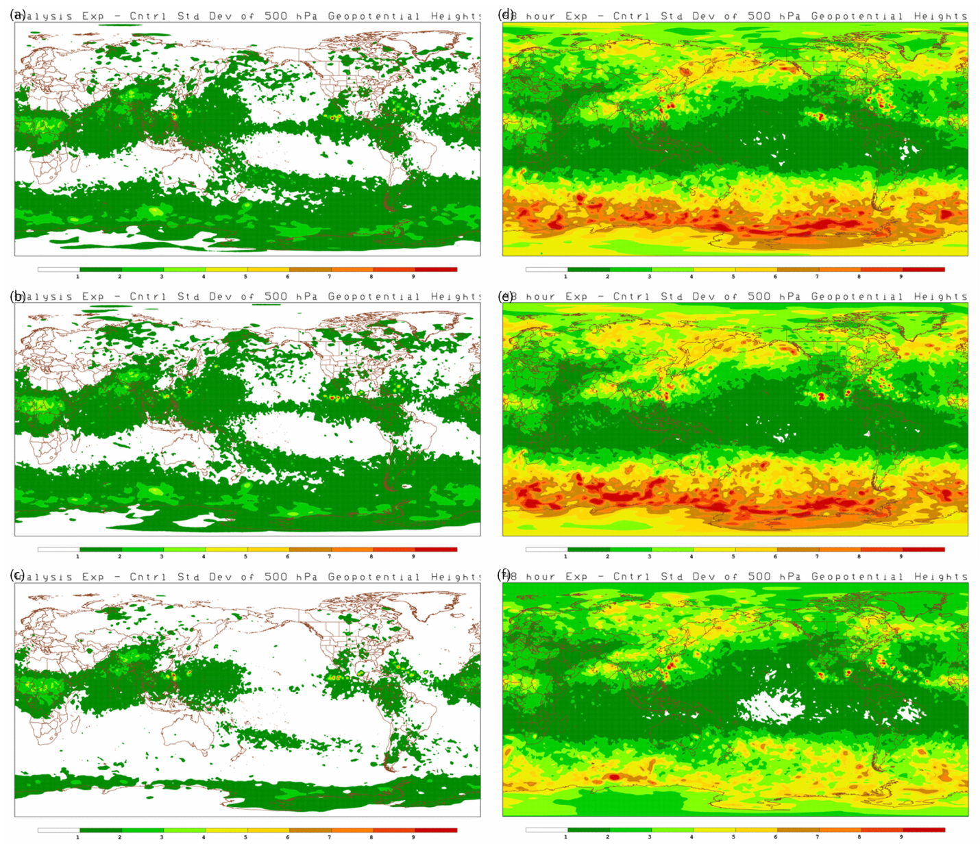
Figure 5.4-27: Standard deviation of the difference between the analyses (a, b, c) and 48-hour forecasts (d, e, f) for 500 hPa Geopotential Height. Differences between S4 – Vapor (a and d), JIBB – Vapor (b and e), and S4 – JIBB (c and f) are for 1 August to 30 September 2011. Units are meters/second [m/s].

Analysis and 48-hour Forecast Mean Differences
[The geographical structure of the mean differences are also a concern. Why is the precipitable water consistently lower over land and higher over ocean in the S4 and JIBB runs then Vapor?] Mean difference fields of precipitable water, total accumulated rainfall, 500 hPa relative humidity, 500 hPa temperature, 250 hPa U-component of wind, 100 hPa geopotential heights and 500 hPa geopotential heights are displayed for both seasons in figures 5.5-1 through 5.5-14. The mean differences are displayed for the analysis (panels a, b, and c) and the 48-hour forecast (panels d, e, f). Since the analysis GRIB files do not contain precipitation, the 6-hour forecast was used in figures 5.5-3 and 5.5-4. Differences are displayed with respect to each computer combination. Panels a and d are S4 – Vapor differences, panels b and e are JIBB – Vapor differences, and panels c and e are S4 – JIBB differences.
The mean differences of precipitable water (figures 5.5-1 and 5.5-2) are most evident in the summer hemisphere where more water vapor is expected. In general, S4 and JIBB seem to be wetter over ocean and dryer over land in the analysis than Vapor. By 48 hours the differences are mostly random with no discernible pattern. The precipitable water differences between S4 and JIBB seem to be less (panels c and e in figures 5.5-1 and 5.5-2) than comparisons with Vapor suggesting that S4 and JIBB may be wetter and more consistent with each other than with Vapor.

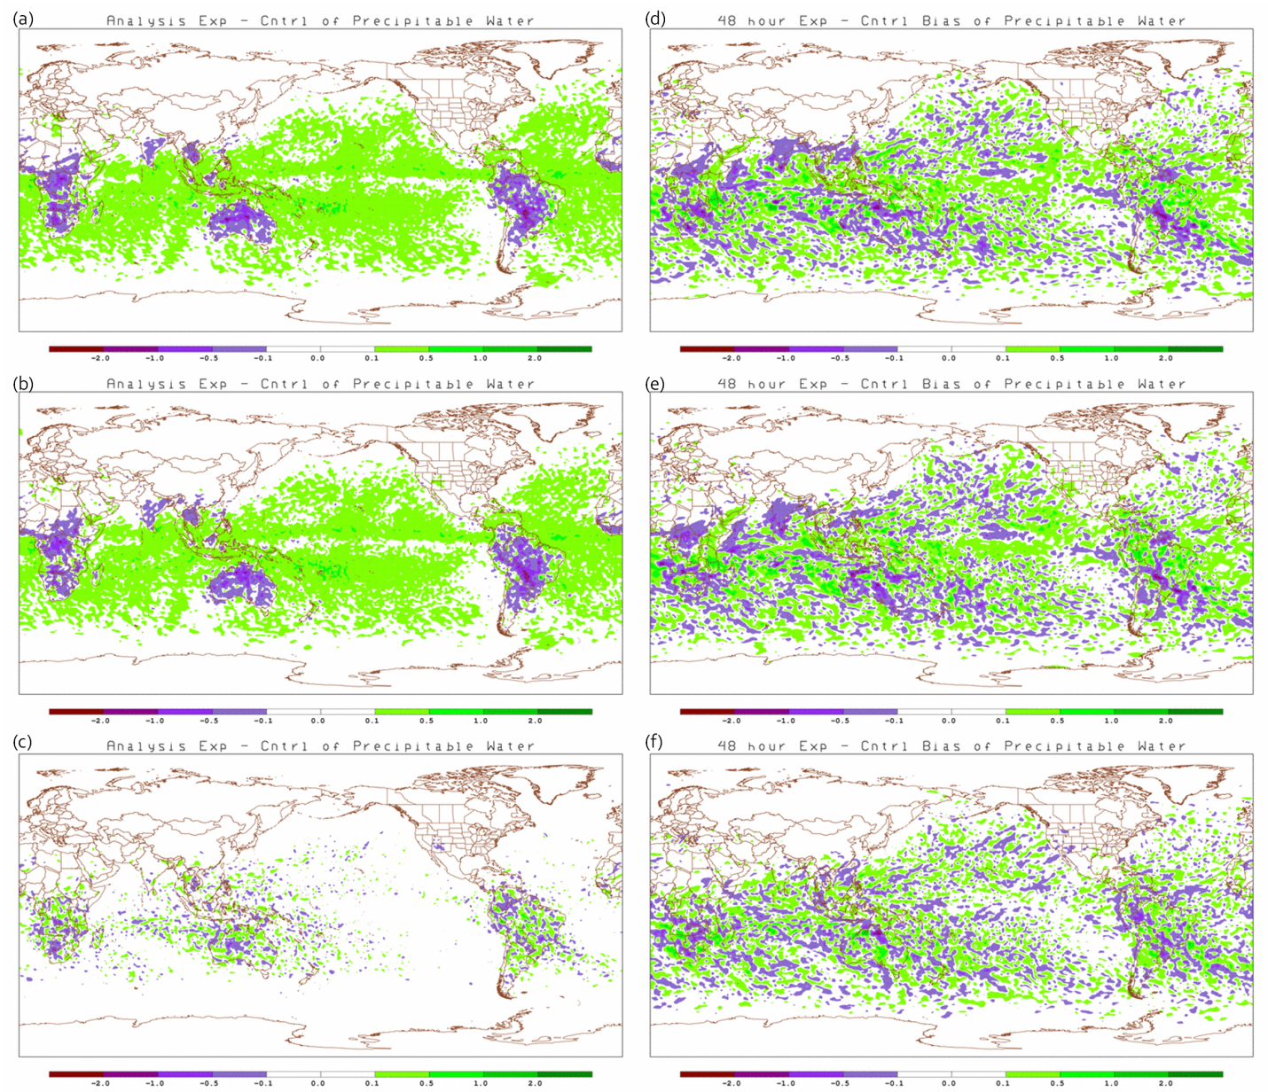
Figure 5.5-28: Mean difference between analyses (a, b, c) and 48-hour forecasts (d, e, f) of precipitable water. Differences between S4 – Vapor (a and d), JIBB – Vapor (b and e), and S4 – JIBB (c and f) are for 1 December 2010 to 31 January 2011. Units are millimeters of water Vapor [mm].

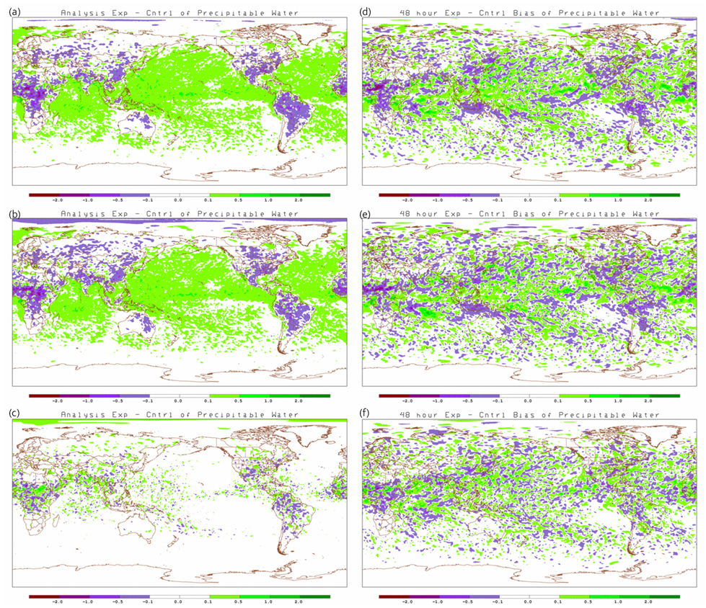
Figure 5.5-29: Mean difference between analyses (a, b, c) and 48-hour forecasts (d, e, f) of precipitable water. Differences between S4 – Vapor (a and d), JIBB – Vapor (b and e), and S4 – JIBB (c and f) are for 1 August to 30 September 2011. Units are millimeters of water Vapor [mm].
The differences in precipitation are consistent with the differences in precipitable water. Panels a and b in figures 5.5-3 and 5.5-4 suggest that S4 and JIBB have more precipitation in the first 6 hours and summer season than Vapor, especially along the Inter-Tropical Convergence Zone (ITCZ). Mean differences in the first 6 hours between S4 and JIBB (panel c of figures 5.5-3 and 5.5-3) appear to be mostly random with no clear trend. By 48 hours, the precipitation fields look mostly random for the three scenarios.
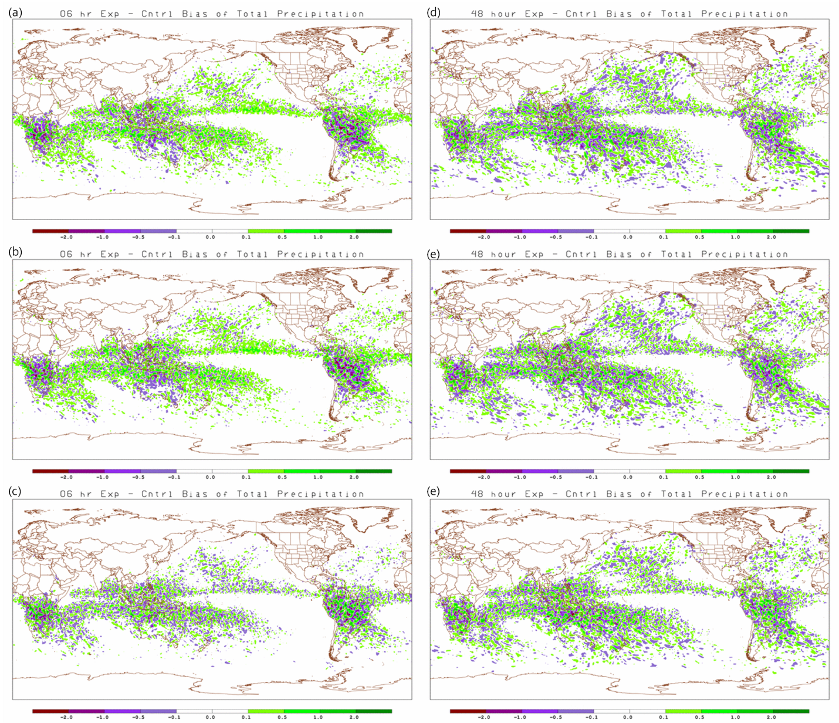
Figure 5.5-30: Mean difference between the 6-hour forecasts (a, b, c) and 48-hour forecasts (d, e, f) for 6-hour accumulation of total precipitation. Differences between S4 – Vapor (a and d), JIBB – Vapor (b and e), and S4 – JIBB (c and f) are for 1 December 2010 to 31 January 2011. Units are millimeters of water [mm].

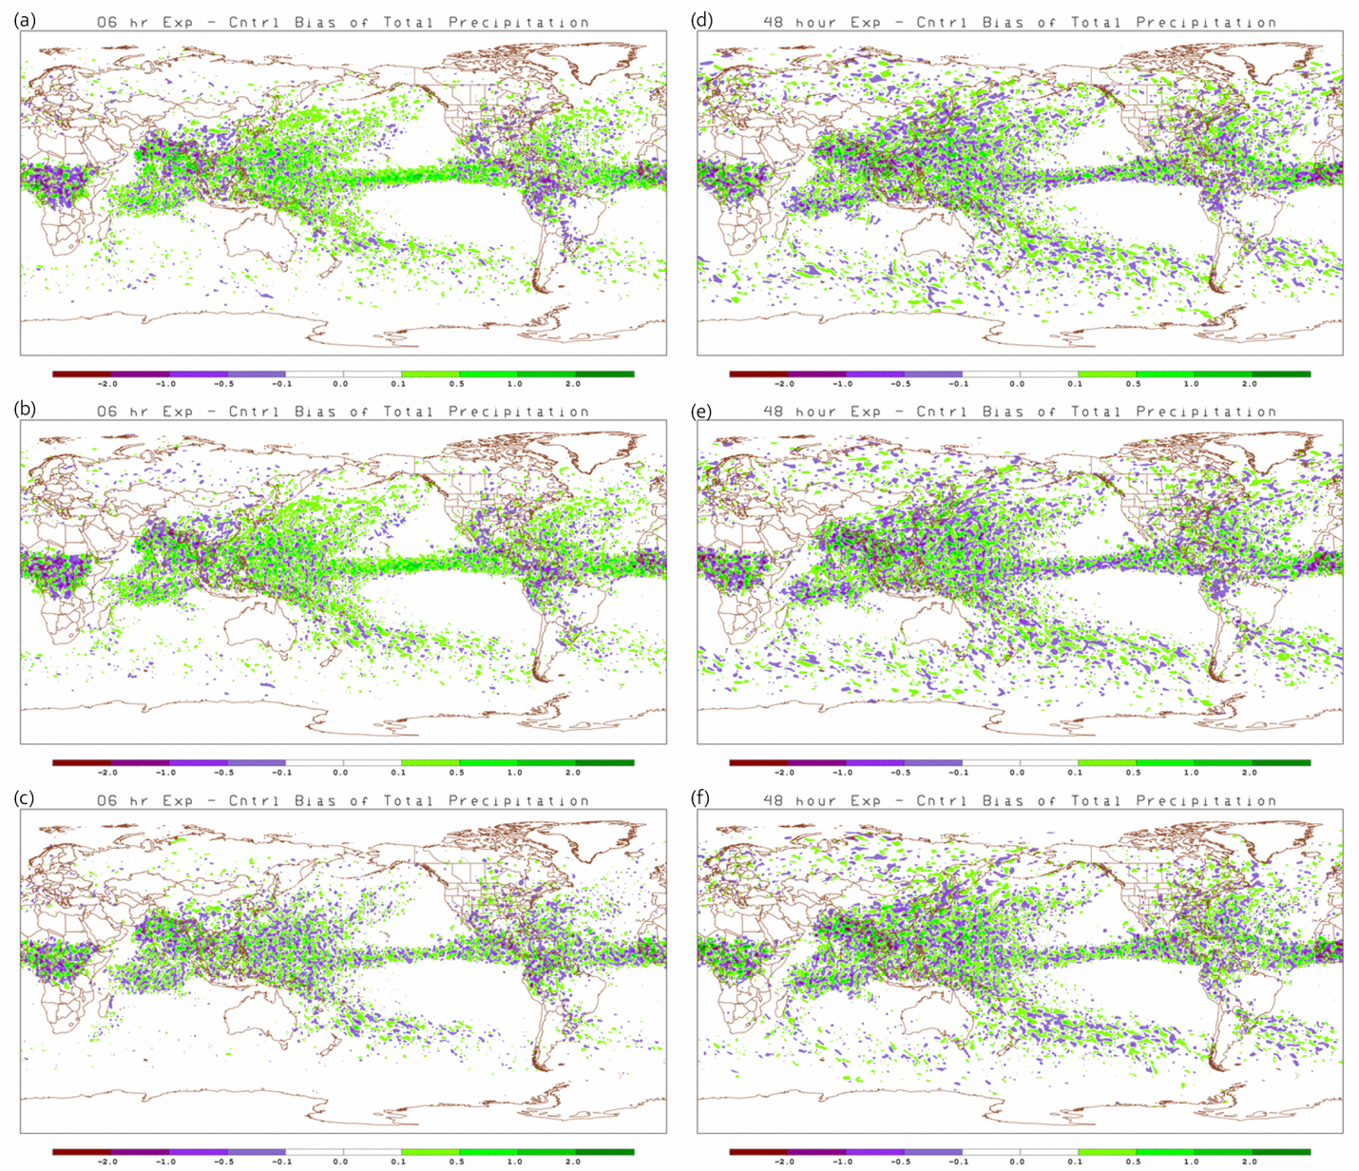
Figure 5.5-31: Mean difference between the 6-hour forecasts (a, b, c) and 48-hour forecasts (d, e, f) for 6-hour accumulation of total precipitation. Differences between S4 – Vapor (a and d), JIBB – Vapor (b and e), and S4 – JIBB (c and f) are for 1 August to 30 September 2011. Units are millimeters of water [mm].
There does not seem to be any discernible trends in the mean differences of relative humidity at 500 hPa between the three computers (figures 5.5-5 and 5.5-6). Other levels were examined and show similar results thus are not shown here. As expected, there is more variability in the relative humidity fields in the 48 hour forecast.
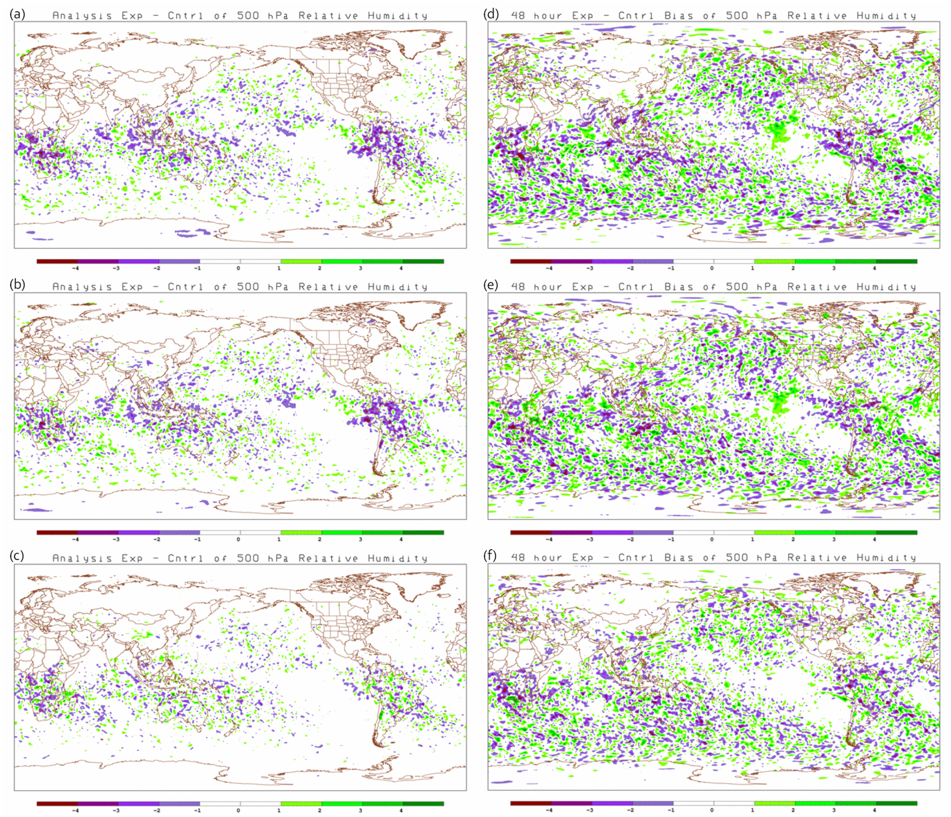
Figure 5.5-32: Mean difference between the analyses (a, b, c) and 48-hour forecast (d, e, f) for 500 hPa Relative Humidity. Differences between S4 – Vapor (a and d), JIBB – Vapor (b and e), and S4 – JIBB (c and f) are for 1 December 2010 to 31 January 2011. Units are percent [%].
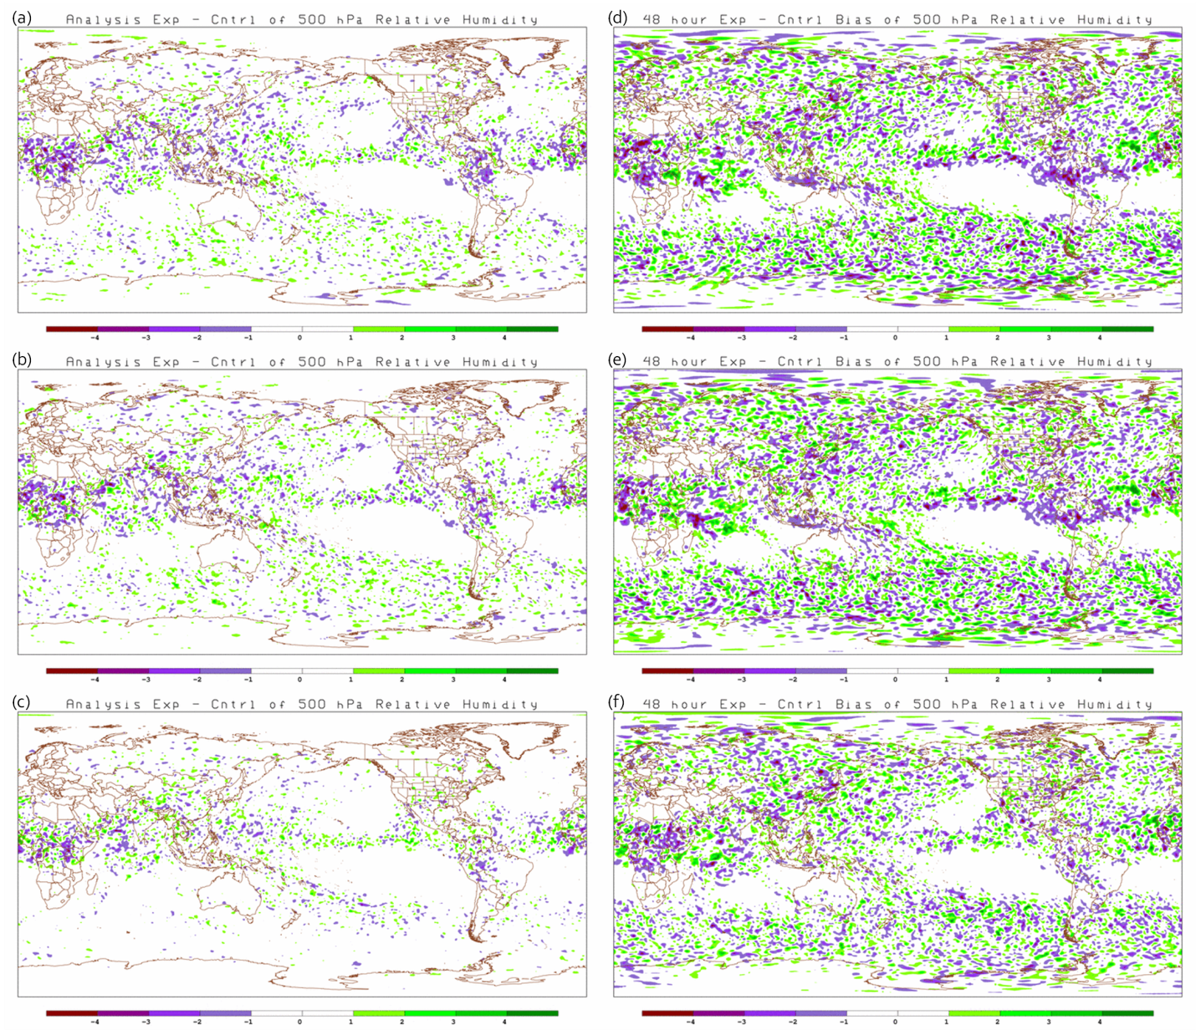
Figure 5.5-33: Mean difference between the analyses (a, b, c) and 48-hour forecast (d, e, f) for 500 hPa Relative Humidity. Differences between S4 – Vapor (a and d), JIBB – Vapor (b and e), and S4 – JIBB (c and f) are for 1 August to 30 September 2011. Units are percent [%].
The 500 hPa analysis mean temperature differences in figures 5.5-7 (a-c) and 5.5-8 (a-c) suggest that S4 and JIBB is warmer in the tropics and cooler at higher latitudes than Vapor. The warming trend continues in the tropics through the 48 hour forecast. Again, S4 and JIBB differences are smaller with each other than with Vapor.
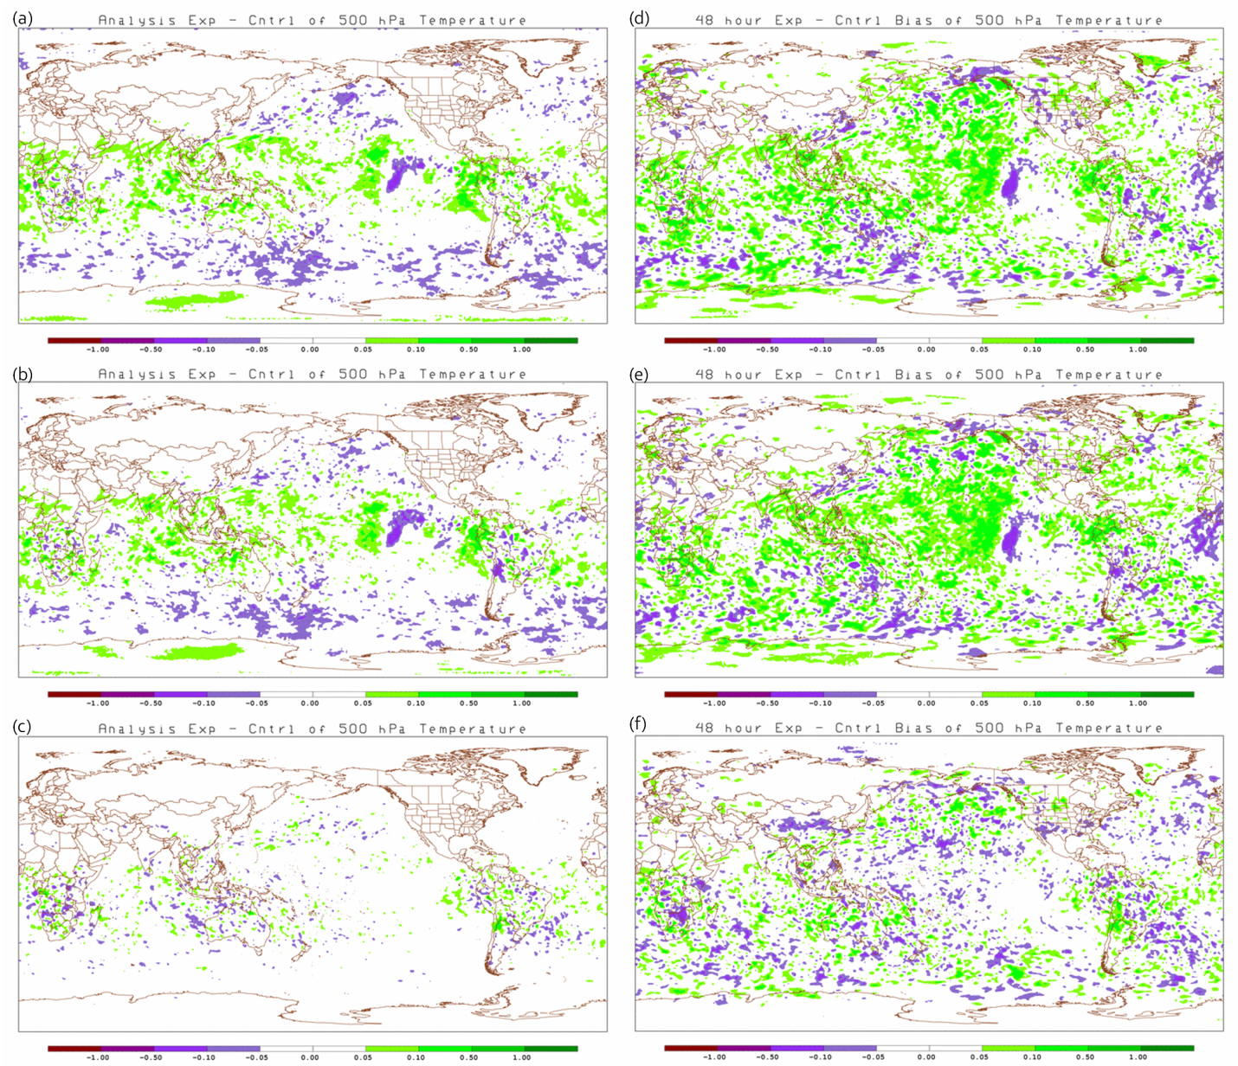
Figure 5.5-34: Mean difference between the analyses (a, b, c) and 48-hour forecasts (d, e, f) for 500 hPa Temperature. Differences between S4 – Vapor (a and d), JIBB – Vapor (b and e), and S4 – JIBB (c and f) are for 1 December 2010 to 31 January 2011. Units are degrees Kelvin [K].

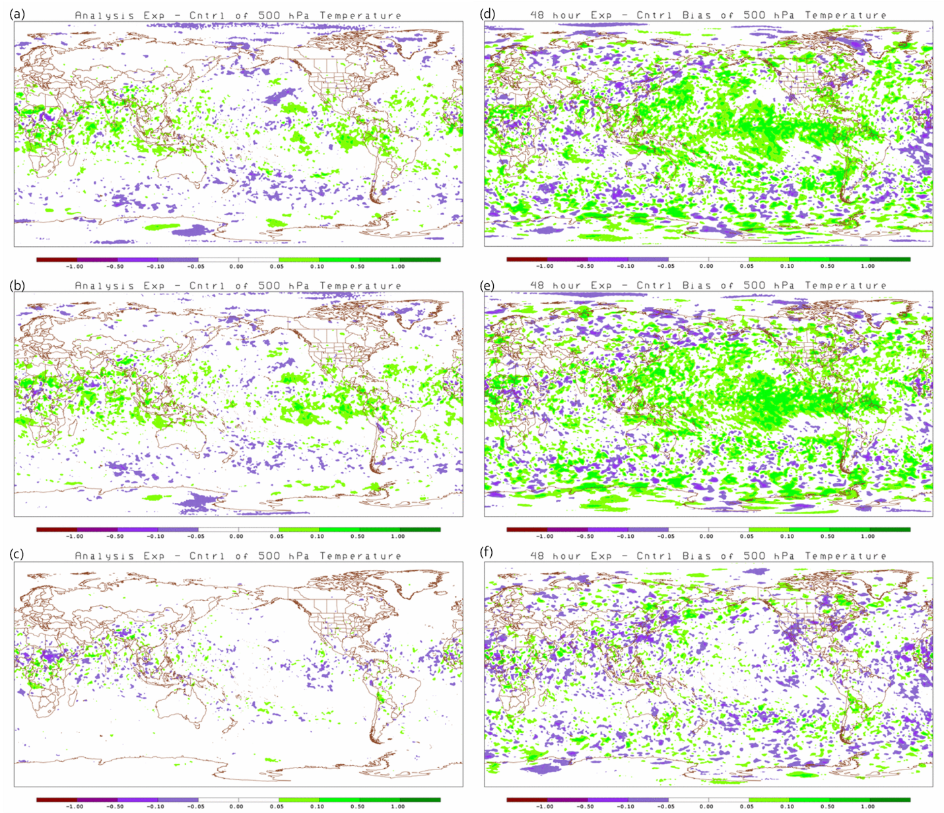
Figure 5.5-35: Mean difference between the analyses (a, b, c) and 48-hour forecasts (d, e, f) for 500 hPa Temperature. Differences between S4 – Vapor (a and d), JIBB – Vapor (b and e), and S4 – JIBB (c and f) are for 1 August to 30 September 2011. Units are degrees Kelvin [K].
The 250 hPa analysis mean U component of wind differences in figures 5.5-9 (a-c) and 5.5-10 (a-c) suggest that S4 and JIBB have greater positive (westerly) U component winds in the tropical pacific region than Vapor. This greater positive U component is apparent from about 500 hPa to 100 hPa (not shown). The greater westerly trend continues in the tropics through the 48 hour forecast (figures 5.5-9(d-f) and 5.5-10(d-f)). Similar to the previous results, S4 and JIBB differences are smaller with each other than with Vapor.

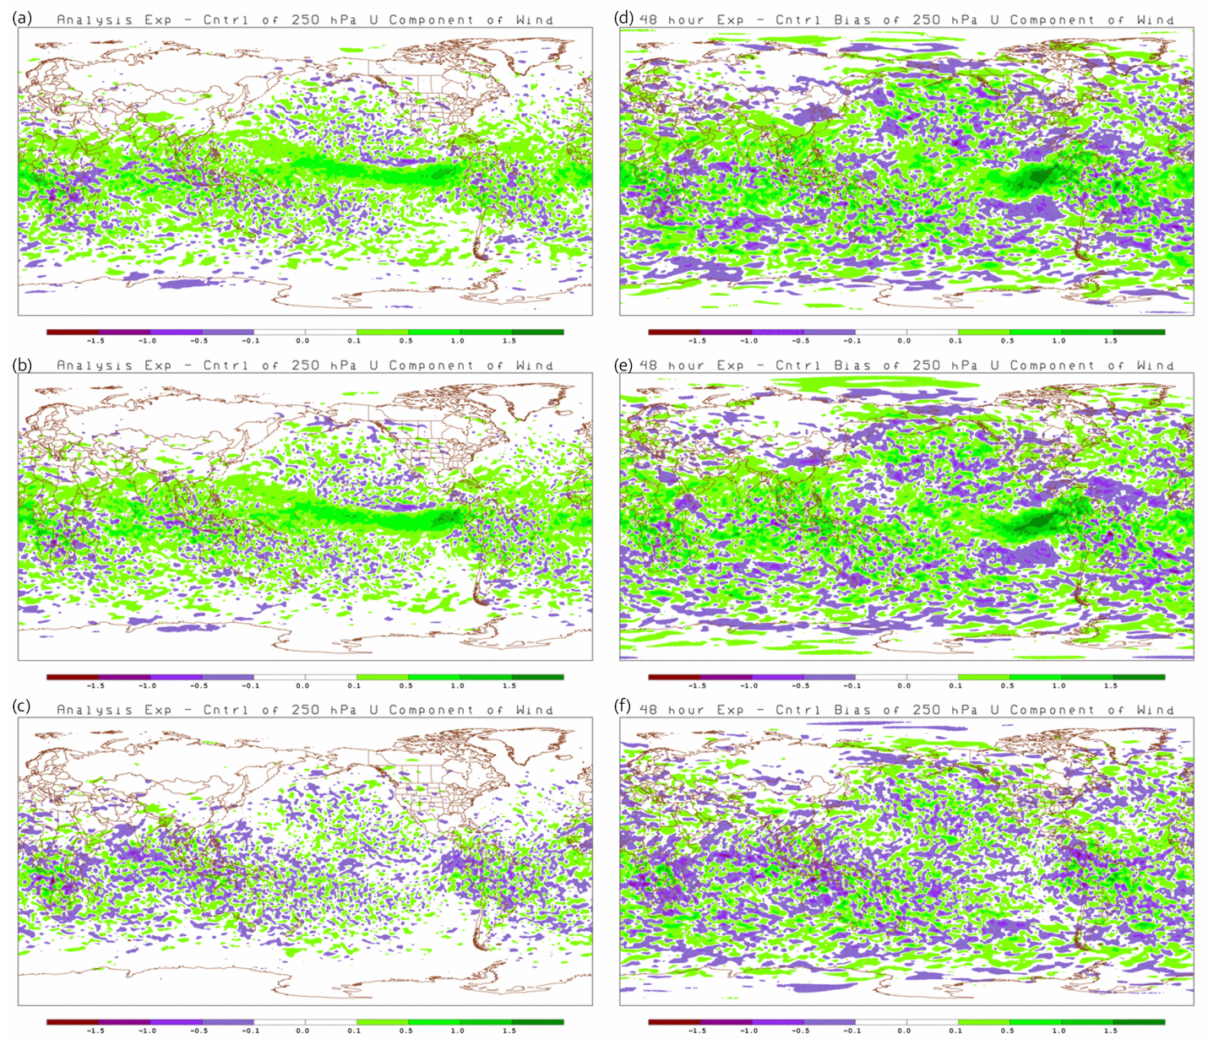
Figure 5.5-36: Mean difference between the analyses (a, b, c) and 48-hour forecasts (d, e, f) for 250 hPa U component of wind. Differences between S4 – Vapor (a and d), JIBB – Vapor (b and e), and S4 – JIBB (c and f) are for 1 December 2010 to 31 January 2011. Units are meters/second [m/s].
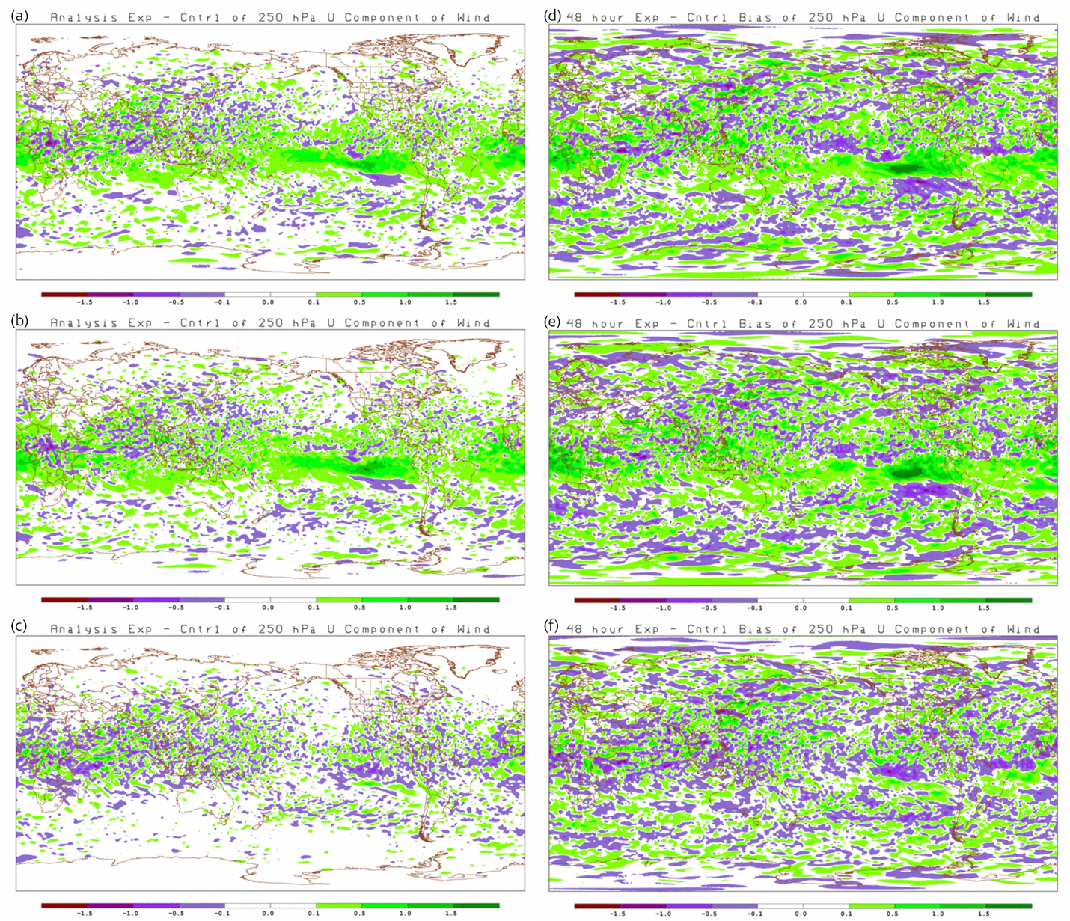
Figure 5.5-37: Mean difference between the analyses (a, b, c) and 48-hour forecasts (d, e, f) for 250 hPa U component of wind. Differences between S4 – Vapor (a and d), JIBB – Vapor (b and e), and S4 – JIBB (c and f) are for 1 August to 30 September 2011. Units are meters/second [m/s].
Consistent with the higher temperatures in the tropics on S4 and JIBB, the 100 hPa mean differences in heights are also greater (higher) in the tropical region as shown in figures 5.5-11 and 5.5-12. The height differences in the analysis (panels a-c) also show that S4 and JIBB are relatively consistent with each other. The 48 hour forecasts (panels d-f) suggest that either the heights are decreasing with time on Vapor or increasing with time on S4 and JIBB. Panel (f) also suggests that the forecast heights on JIBB are slightly higher than S4.

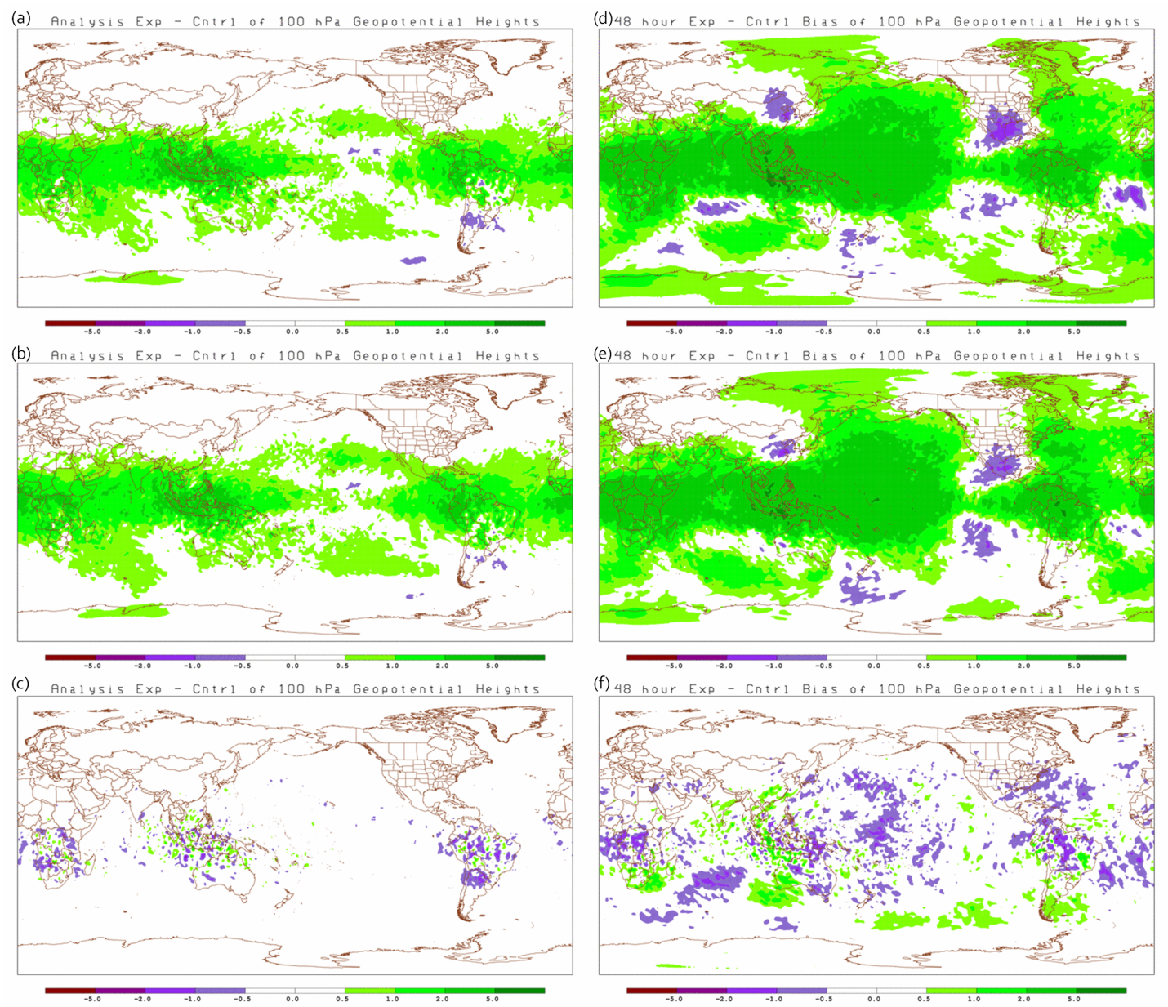
Figure 5.5-38: Mean difference between the analyses (a, b, c) and 48-hour forecasts (d, e, f) for 100 hPa Geopotential Height. Differences between S4 – Vapor (a and d), JIBB – Vapor (b and e), and S4 – JIBB (c and f) are for 1 December 2010 to 31 January 2011. Units are meters/second [m/s].

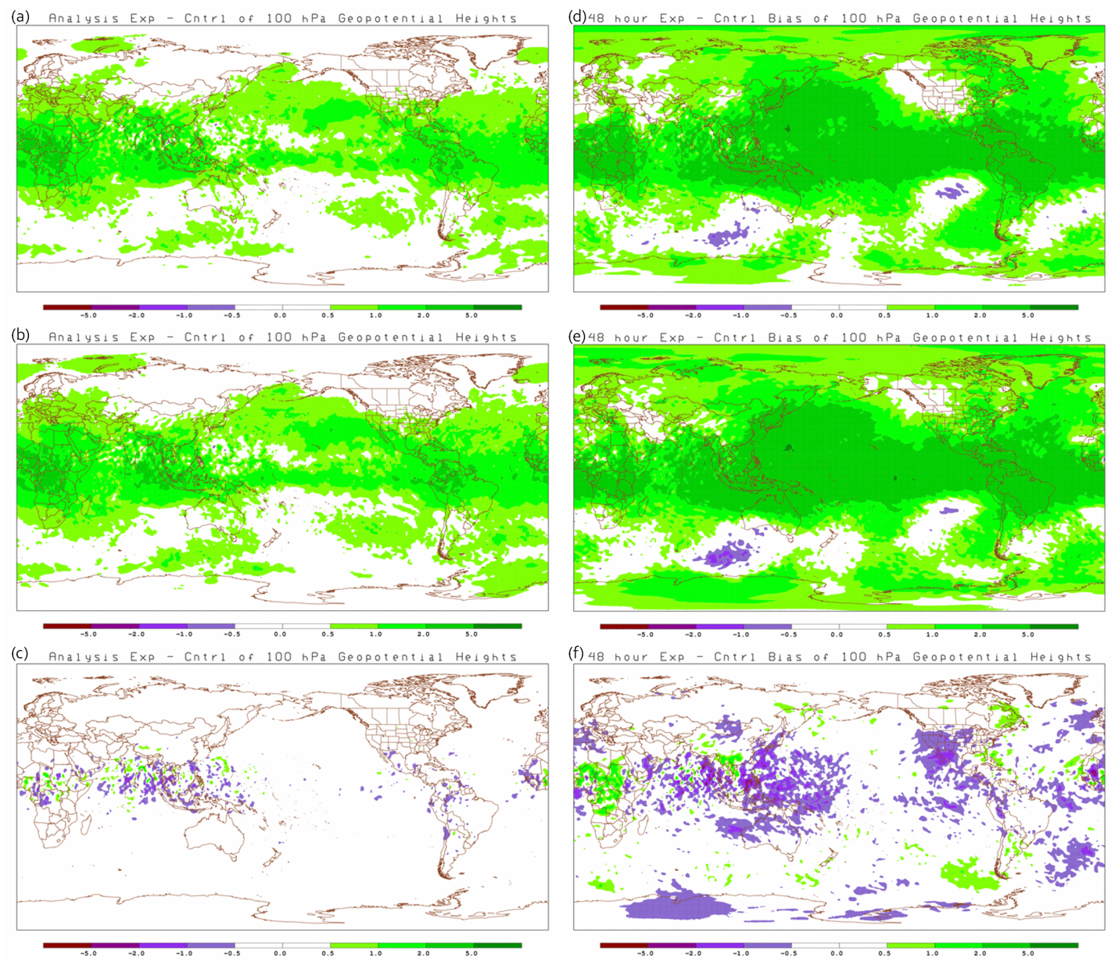
Figure 5.5-39: Mean difference between the analyses (a, b, c) and 48-hour forecasts (d, e, f) for 100 hPa Geopotential Height. Differences between S4 – Vapor (a and d), JIBB – Vapor (b and e), and S4 – JIBB (c and f) are for 1 August to 30 September 2011. Units are meters/second [m/s].
The 500 hPa geopotential heights on S4 and JIBB are generally higher over the globe than Vapor but are still consistent with each other as shown in figures 5.5-13 and 5.5-14. Unlike the 100 hPa heights, the 500 hPa heights only show greater amplitudes in the mean differences with time.

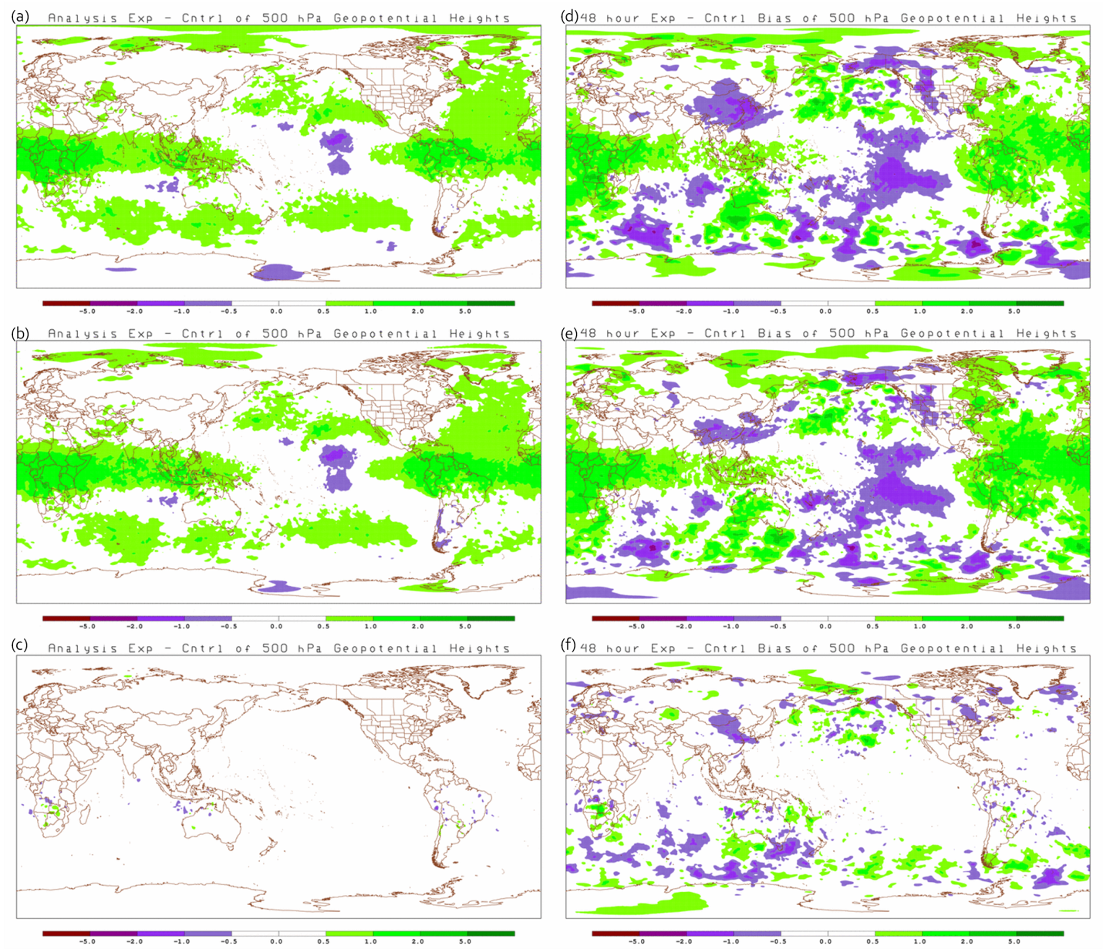
Figure 5.5-40: Mean difference between the analyses (a, b, c) and 48-hour forecasts (d, e, f) for 500 hPa Geopotential Height. Differences between S4 – Vapor (a and d), JIBB – Vapor (b and e), and S4 – JIBB (c and f) are for 1 December 2010 to 31 January 2011. Units are meters/second [m/s].

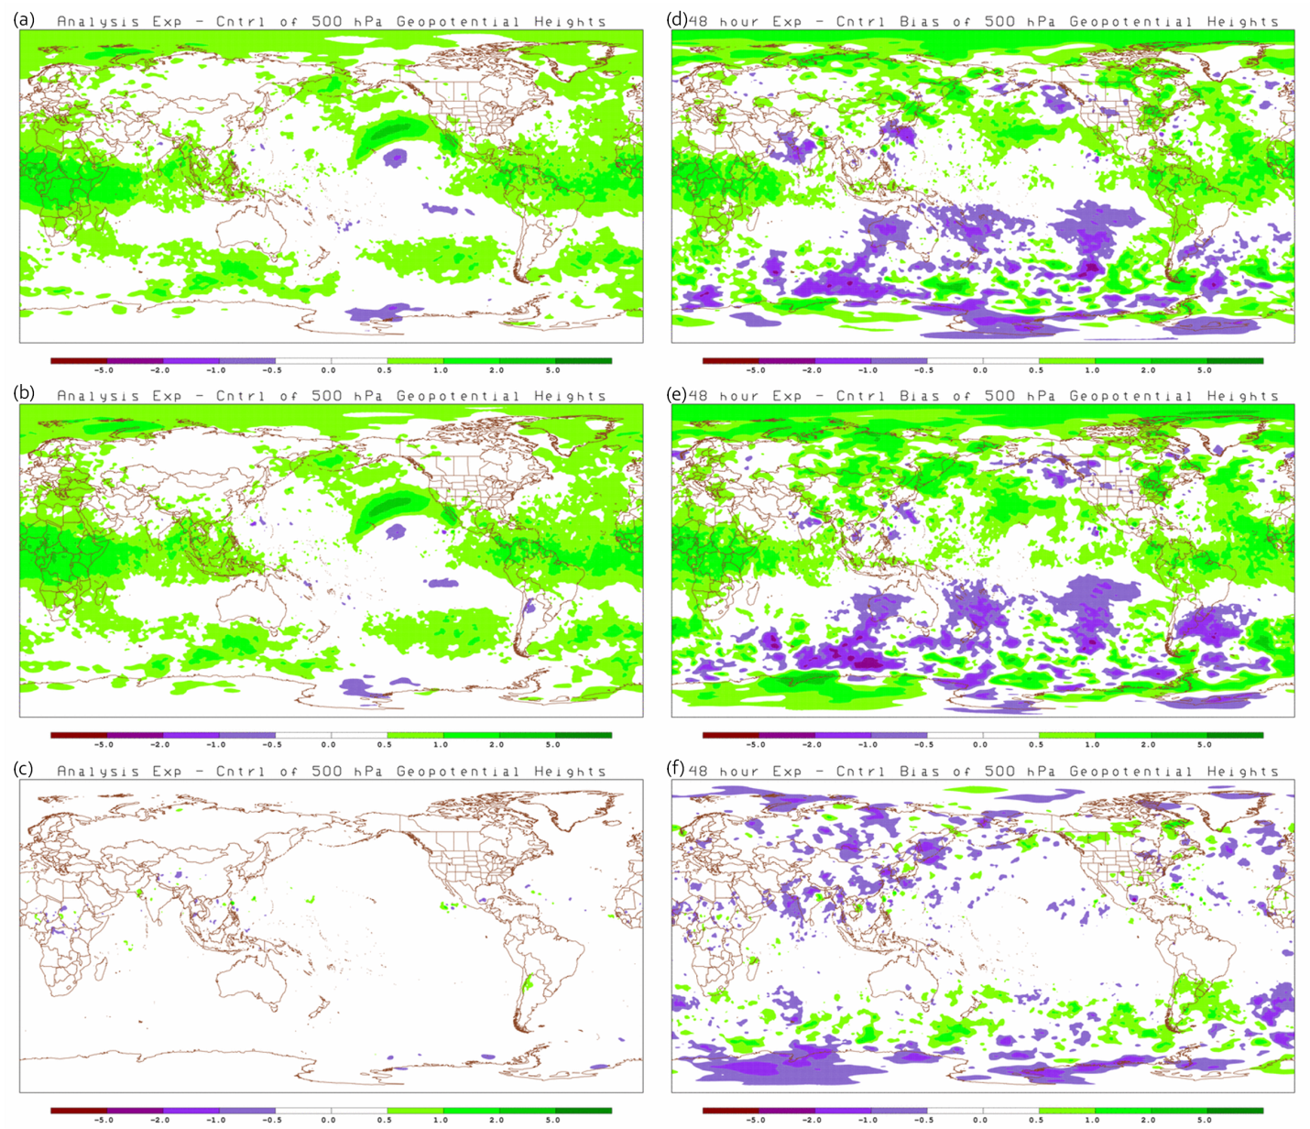
Figure 5.5-41: Mean difference between the analyses (a, b, c) and 48-hour forecasts (d, e, f) for 500 hPa Geopotential Height. Differences between S4 – Vapor (a and d), JIBB – Vapor (b and e), and S4 – JIBB (c and f) are for 1 August to 30 September 2011. Units are meters/second [m/s].

Precipitation Comparison
The precipitation verification is over the Continental United States (CONUS) only. For the global model this is a very limited domain. Most of the more active regions (tropics) are not part of these statistics. The regions of greatest differences shown in figures 5.5-3 and 5.5-4 are not covered in this verification. Most of the Equitable Threat Scores (ETS) shown in figure 5.6-1 are generally neutral except for the 1 December – 31 January ETS verified at 60-84 hours (figure 5.6-1panel c) where the S4 and JIBB improvements are determined to be significant. Further examination of the time series valid for the 25 and 36 mm threshold show the improvements occur on only one day. Since all of the shorter term precipitation threat scores are neutral, it is determined that panel c is not indicative of a trend.
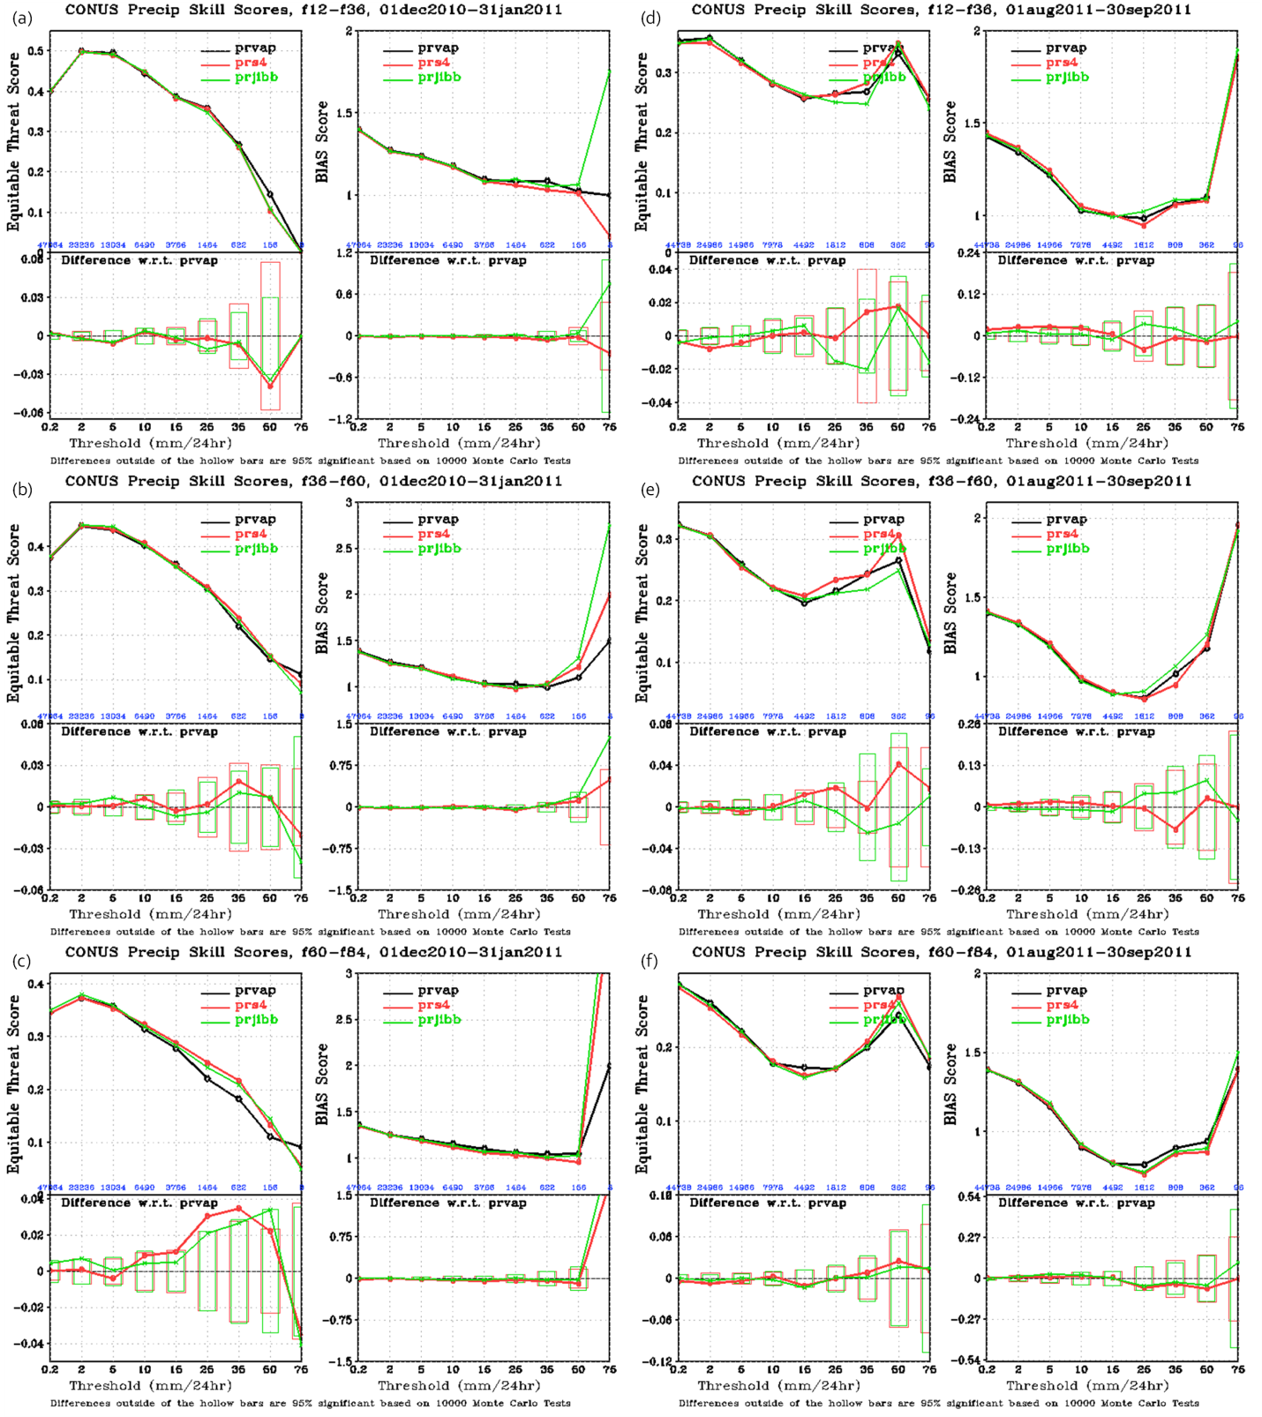
Figure 5.6-42: Precipitation statistics (Equitable Threat Scores and precipitation bias) for 1 December 2010 – 31 January 2011 (a, b, c) and 1 August – 30 September 2011 (d, e, f). Panels a and b are 12 – 36 hour accumulations, panels c and d are 36 – 60 hour accumulations and panels e and f are 60 – 84 hour accumulations. Units are millimeters/day [mm/24hr].

Summary

[Need strong statement about geographically coherent differences and how these may be due to binary/stochastic nature of the convective physics parameterization.] If everything were identical with this comparison, we would get bit identical answers from each computer. Due to the various computer hardware and software differences, bit identical answers are not possible. The differences and similarities are documented and explained in the previous sections.
Several types of verification statistics were used to quantify differences and similarities in the analyses and forecasts between S4, JIBB and Vapor. Parameters for monitoring the performance of the GDAS include the final values of the convergence (gnorm) and the penalty. Parameters used for determining model performance include fits to observations, anomaly correlations, RMSE with respect to its own analysis, and precipitation threat scores.
Two quality parameters that are monitored within the GSI are convergence and the penalty. The convergence should decrease during each inner loop iteration. The value that is monitored, called gnorm, is a normalized value which is defined by the first inner loop iteration. It is expected that the final convergence values and penalty would be similar for each computer. Both the convergence and penalty values are slightly larger for S4 and JIBB than Vapor but are reasonable.
Because the GDAS/GFS was cycled, differences in the analyses and forecasts between the three computers will propagate and cause the quality control to accept/reject some different observations. A simple way to monitor differences on each computer is to track changes in the number of observations (conventional data and satellite radiances) used. Identical counts and very similar bias and RMS statistics for the conventional data are expected for the three computers because the assimilation parameters were fixed. The total column forecast statistics of the rawinsonde temperature, specific humidity, wind and geopotential heights during both seasons are shown and, as expected, these rawinsonde statistics on S4, JIBB and Vapor are very similar. Almost all of the differences in temperature, wind, and moisture are not detectable in the various plots. The only parameter having a noticeable difference is geopotential height. These differences are mostly near the tropopause. Although all of the different satellite sensors are monitored, we chose to only include three of them here, the AMSU-A from NOAA-19, the MHS from NOAA-18 and the IASI from MetOp-A. On average, there are slightly less AMSU-A radiances but slightly more MHS and IASI radiances used by S4 and JIBB than Vapor for both seasons.
The most commonly used weather forecast model performance benchmarks are the mid-latitude (20-80º N/S) anomaly correlations. The 500 and 1000 hPa anomaly correlation time series plots at forecast day 5 for 1 December 2010 – 1 January 2011 and 1 August – 30 September 2011 The day-to-day variation in the 500 and 1000 hPa anomaly correlation plots is typical. Obtaining almost the same value each day on the Vapor, JIBB and S4 computers suggests the day-to-day forecast skill is very similar. The 500 and 1000 hPa die-off curves confirm that these forecast skill trends are consistent through all seven forecast days and both seasons. Most of the forecast differences are not significant at the 95% level suggesting the three computers are generating similar forecasts.
Since the geopotential heights have small variations in the tropics, vector wind RMSE is typically used to measure forecast skill but tropical vector wind RMSE can also be problematic due to fast error growth and being verified against its own analysis. In this study, the vector wind RMSE is compared at 200 and 850 hPa for both seasons. In general, the differences are not significant at the 95% confidence level. The only significant difference is at 850 hPa vector wind during 1Dec – 31 Jan 2011 where S4 and JIBB have a significantly better tropical wind forecast than vapor. The differences wind RMS differences between S4 and JIBB are not significant.
To identify regions where computer differences are occurring within the analyses and short term forecasts, we generated various 2-D fields of standard deviation and mean difference. These fields were calculated using the 1ºX1º lat/lon PGB files generated by the NCEP post processor. Round-off errors in generating the PGB files from the native sigma files is expected but should be similar for each computer. Standard deviation and mean difference fields of precipitable water, total accumulated rainfall, 500 hPa relative humidity, 500 hPa temperature, 250 hPa U-component of wind, 100 hPa geopotential heights and 500 hPa geopotential heights are displayed for both seasons.
Several regions (Southern Africa, Australia and Northern South America) show increased variability [isn’t this standard deviation of the errors, not variability?] for all three computer combinations during 1 December 2010 – 31 January 2011. This seems to translate into increased variability for the same regions in the 48-hour forecast. During the period of 1 August – 30 September 2011, the regions of greatest variability has shifted northward. This suggests the increased variability is related to the summer season hemisphere. In a qualitative sense, the variability seems to be consistent in the same regions in all of the parameters shown and for all the computers. There seems to be a little less variability between S4 and JIBB suggesting that S4 and JIBB may be more consistent with each other than with Vapor.
The mean differences of precipitable water are most evident in the summer hemisphere where more water vapor is expected. In general, S4 and JIBB seem to be wetter over ocean and dryer over land in the analysis than Vapor. By 48 hours the differences are mostly random with no discernible pattern. The precipitable water differences between S4 and JIBB seem to be less than comparisons with Vapor suggesting that S4 and JIBB may be wetter and more consistent with each other than with Vapor.

The differences in precipitation are consistent with the differences in precipitable water suggesting that S4 and JIBB have more precipitation in the first 6 hours and summer season than Vapor, especially along the Inter-Tropical Convergence Zone (ITCZ). Mean differences in the first 6 hours between S4 and JIBB appear to be mostly random with no clear trend. By 48 hours, the precipitation fields look mostly random for the three computers.
There does not seem to be any discernible trends in the mean differences of relative humidity between the three computers. As expected, there is more variability in the relative humidity fields in the 48 hour forecast.
The 500 hPa analysis mean temperature differences suggests that S4 and JIBB are warmer in the tropics and cooler at higher latitudes than Vapor. The warming trend continues in the tropics through the 48 hour forecast. Again, S4 and JIBB differences are smaller with each other than with Vapor.
The 250 hPa analysis mean U component of wind differences suggests that S4 and JIBB have greater positive (westerly) U component winds in the tropical pacific region than Vapor. This greater positive U component is apparent from about 500 hPa to 100 hPa. The greater westerly trend continues in the tropics through the 48 hour forecast. Similar to the previous results, S4 and JIBB differences are smaller with each other than with Vapor.
Consistent with the higher temperatures in the tropics on S4 and JIBB, the 100 hPa mean differences in heights are also greater (higher) in the tropical region. The height differences in the analysis also show that S4 and JIBB are relatively consistent with each other. The 48 hour forecasts suggest that either the heights are decreasing with time on Vapor or increasing with time on S4 and JIBB. The forecast heights on JIBB are slightly higher than S4. The 500 hPa geopotential heights on S4 and JIBB are generally higher over the globe than Vapor but are still consistent with each other. Unlike the 100 hPa heights, the 500 hPa heights only show greater amplitudes in the mean differences with time.
Most of the Equitable Threat Scores (ETS) are generally neutral except for the 1 December – 31 January ETS verified at 60-84 hours where the S4 and JIBB improvements are determined to be significant. Further examination of the time series valid for the 25 and 36 mm threshold show the improvements occur on only one day. Since all of the shorter term precipitation threat scores are neutral, it is determined that this trend is probably not real.

