GOES-R ABI Fact Sheet Band 8 (The “upper-level water vapor” infrared band)
The “need to know” Advanced Baseline Imager reference guide for the NWS forecaster

Front page – Maintain general layout

No changes needed to header banner (GOES-R satellite); title as above
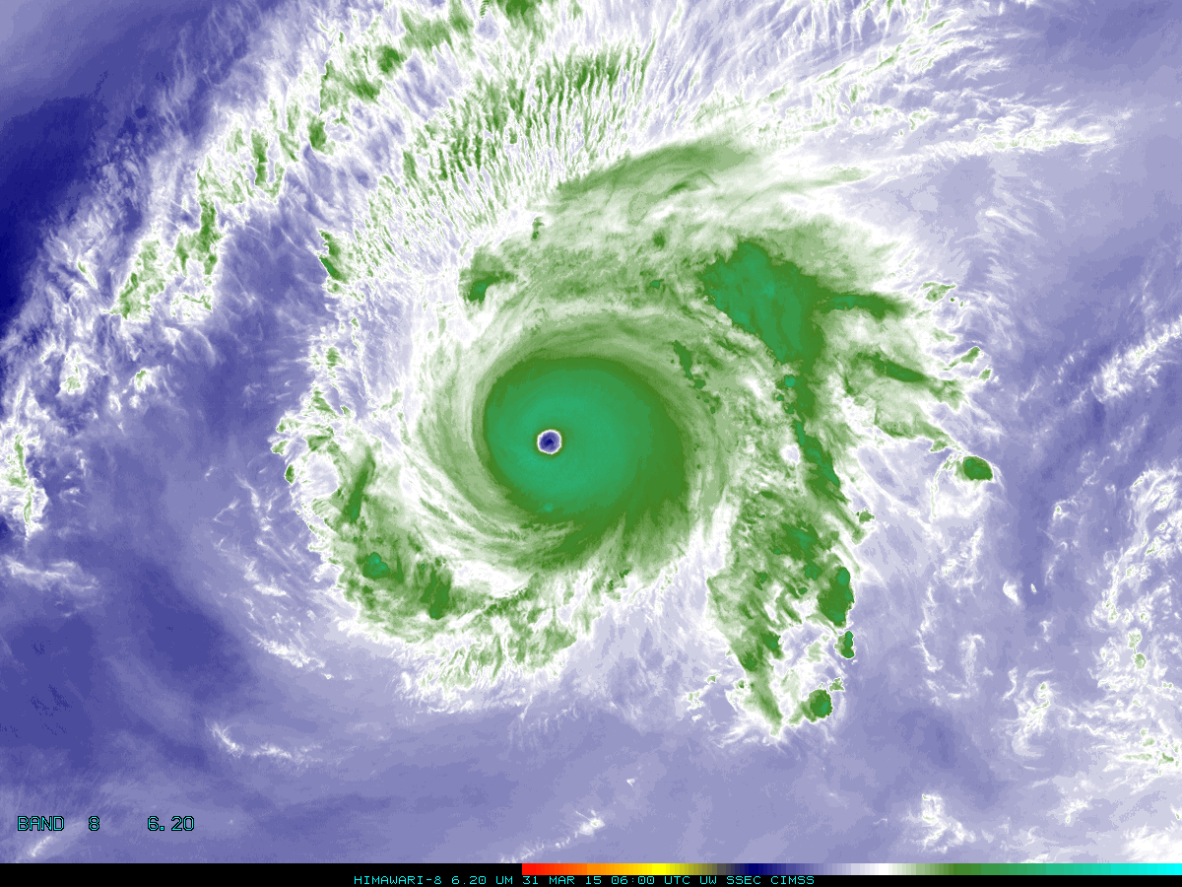

Above: The Advanced Himawari Imager (AHI) 6.2 μm for Typhoon Maysak from March 31, 2015 at 06 UTC. Credit: CIMSS and JMA.

In a nutshell

GOES-R ABI Band 8 (approximately 6.2 μm central, 5.8 μm to 6.6 μm)

Also similar MODIS Band 27, SEVIRI Band 5, MTSAT Band 4, AHI Band 8

Available on current GOES (Imager and Sounder)

Nickname: “Upper-level water vapor” infrared band

Availability: Both Day and Night

Primary purpose: Atmospheric feature detection

Uses similar to: ABI/AHI Bands 9/10
“Core” front text and image
There are three mid-level water vapor bands on the ABI. The 6.2 micrometer “water vapor” band will be used for upper-level tropospheric water vapor tracking, jet stream identification (e.g., location of clear slots), hurricane track forecasting, mid-latitude storm forecasting, severe weather analysis, upper mid-level moisture estimation (for the legacy vertical moisture profiles) and turbulence detection. This band can be used to estimate atmospheric motion vectors. In addition, the radiances from this and other bands will be used directly in Numerical Weather Prediction (NWP) models. This water vapor band is the most similar to those on heritage GOES imagers, although current GOES Water Vapor band centered at 6.5 μm falls between the ABI band 6.2 and 7.0 μm. Source: Schmit et al., 2005 in BAMS, and the ABI Weather Event Simulator (WES) Guide by CIMSS.

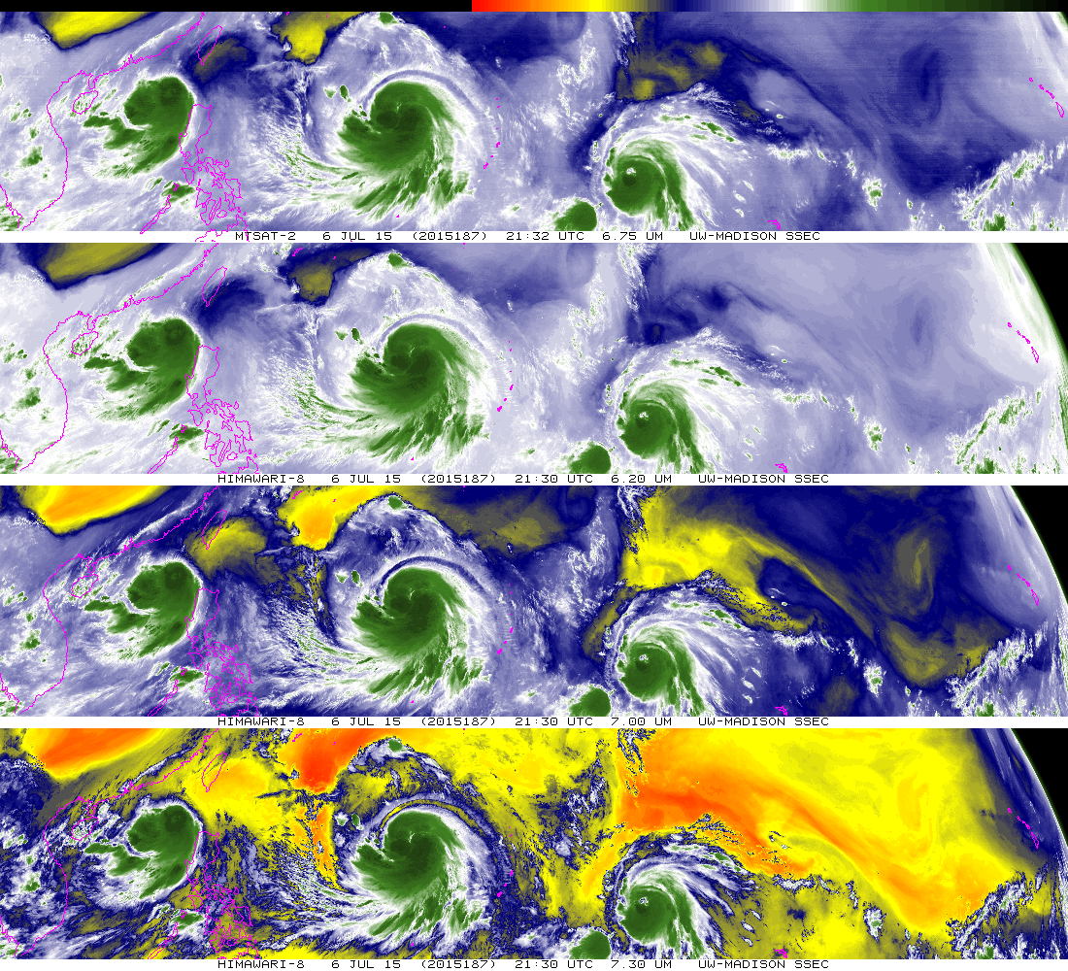
The lowest three panels should the three water vapor bands of JMA’s AHI: 6.2, 7.0, and 7.3 μm, respectively from top to bottom. Similar brightness temperatures are observed in cloudy regions (cold, or green colors), while the three levels can be seen in the clear-sky, with the 7.3 μm reporting the warmest temperatures. Similar to the ABI, each of these water vapor bands are 2 km spatial resolution (at the sub-point). The top panel shows the corresponding water vapor image from MTSAT. These images are from July 6, 2015 at approximately 2130 UTC and each satellite is shown in its native projection. This image was made in McIDAS-X. Credit: SSEC and ASPB.
Did You Know?

Europe was the first to put a water vapor band on a geostationary imager, in 1977. It was soon followed by the VISSR on GOES-4 (1980). The spatial resolution of this VISSR (Visible-Infrared Spin-Scan Radiometer) band was approximately 14 km, meaning the GOES-R ABI water vapor bands have a spatial resolution improvement of almost 50 times. Of course there have been other improvements with the ABI as well, such as images at least every 5 minutes (over the Contiguous U.S.); compared to 30 min images with GOES-4.

Tim’s Topics

- Use same photo as currently, although not that one that too zoomed in. :)

The current GOES imager has an infrared band centered at 6.5 μm, while earlier generation of GOES imagers had a spectral band centered at 6.7 μm (which was much spectrally narrower). Due to the strong absorption of water vapor at this wavelength, this and similar bands in the spectral region are rightly called water vapor bands. Yet, the bands also have a strong temperature dependence. So ideally, these bands would be called “infrared bands with dependencies on both temperature and water vapor”, but this is too long for a “nickname”. It is important to remember that a time tendency of warming for a given water vapor image pixel may be indicative of drier air, warmer air, or a combination of both.

Tim Schmit is a research meteorologist with NOAA NESDIS in Madison, Wisconsin.
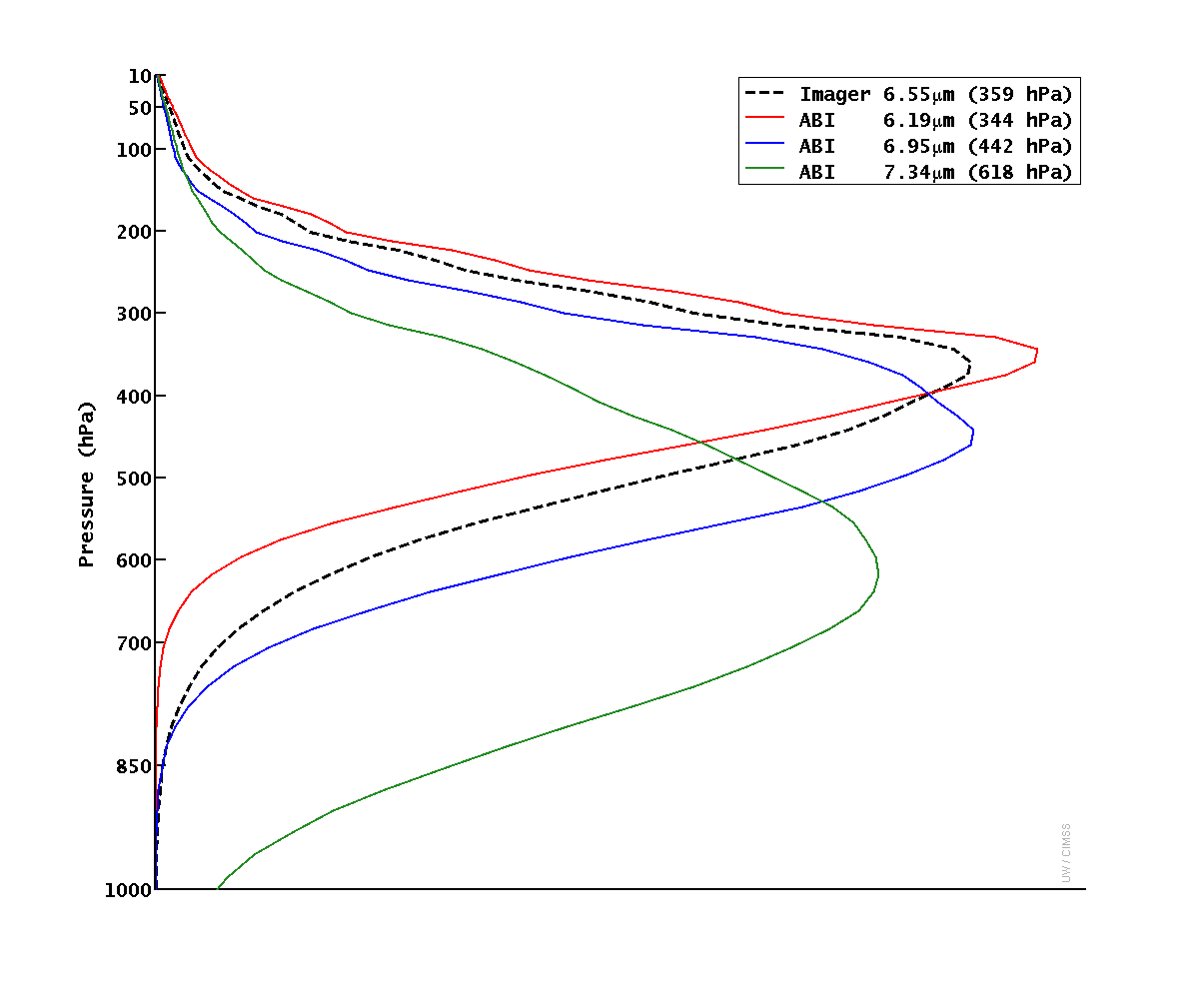
Caption: The weighting function (or contribution function) represents the layer of the atmosphere where the radiation sensed by the ABI originated. The above image demonstrates the one mid-level water vapor on today’s GOES imagers (dashed line) and the three mid-level water vapor bands on the ABI (solid lines). These are clear-sky calculated brightness temperature and hence do not include the presence of clouds. For the U.S. standard atmosphere, the three ABI water vapor bands have a level of peak contribution of approximately 340, 440 and 620 hPa, respectively. This corresponds to 360 hPa for today’s imager water vapor band. Credit: CIMSS.

Carven’s Corner

- Same picture.

Meteorologists know that an accurate three-dimensional representation of the atmosphere is necessary in order to produce the best forecast. The GOES-R ABI offers some added value to the field in this area. Unlike the GOES-13/15 imagers, there are now multiple water vapor channels on the ABI. These water vapor channels will provide an opportunity to track atmospheric features on layers that depend on the temperature and concentration of water vapor in the troposphere. That brightness temperature is not solely representative of any one level, but instead a weighted mean across several adjacent “levels”. A hyperspectral sounder, a possibility for the future, may be able to provide a depiction of water vapor in the lower levels of the atmosphere – near or within the boundary layer.

Carven Scott is the ESSD Chief in NWS Alaska Region and a former SOO.

ABI Band Table

ABI Band | Approximate Central  Wavelength (µm) | Band “Nickname” | Type | Nominal sub satellite pixel spacing (km)
8 | 6.2 | Upper-level water vapor | IR (with absorption due to water vapor) | 2
9 | 6.9 | Mid-level water vapor | IR (with absorption due to water vapor) | 2
10 | 7.3 | Low-level water vapor | IR (with absorption due to water vapor) | 2

ABI Band Product Table (same general layout)

Use band 8 (from excel file, separated by tab)

Bottom of back page (update date)

Further reading

GOES-R Overview: http://goes-r.gov

ABI Bands Quick Information Guides: http://www.goes-r.gov/education/ABI-bands-quick-info.html

ABI Weighting Function page: http://cimss.ssec.wisc.edu/goes/wf/ABI/

CIMSS Satellite Blog: http://cimss.ssec.wisc.edu/goes/blog/archives/17893

GOES-R COMET training: http://www.goes-r.gov/users/training/comet.html
GOES-R acronyms: http://www.goes-r.gov/resources/acronyms.html

