GOES-R ABI Fact Sheet Band 9 (The “mid-level water vapor” infrared band)
The “need to know” Advanced Baseline Imager reference guide for the NWS forecaster

Front page – Maintain general layout

No changes needed to header banner (GOES-R satellite); title as above
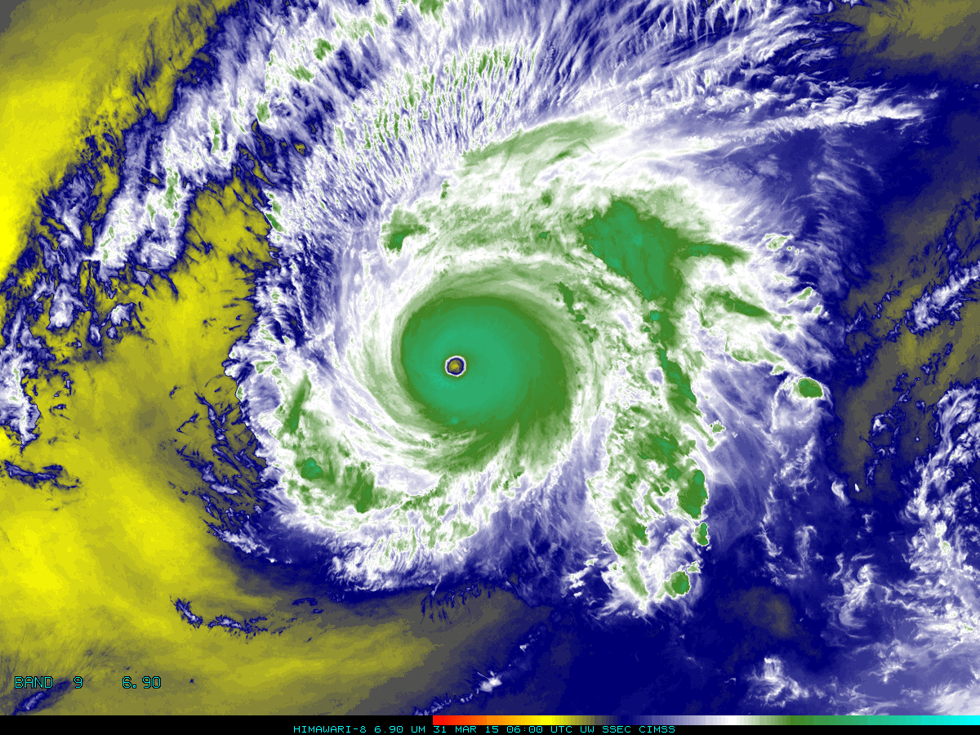

Above: The Advanced Himawari Imager (AHI) 6.9 μm for Typhoon Maysak from March 31, 2015 at 06 UTC. Credit: CIMSS and JMA.

In a nutshell

GOES-R ABI Band 9 (approximately 6.9 μm central, 6.7 μm to 7.1 μm)

Also similar to AHI Band 9

Available on current GOES Sounder (Band 11)

Nickname: “Mid-level water vapor” infrared band

Availability: Both Day and Night

Primary purpose: Atmospheric feature detection

Uses similar to: ABI/AHI Bands 8/9
“Core” front text and image
This 6.9 µm band is one of the three mid-tropospheric water vapor bands on the ABI. This “water vapor” band will be used for mid and upper-level tropospheric water vapor tracking, jet stream identification, hurricane track forecasting, mid-latitude storm forecasting, severe weather analysis, and mid-level moisture estimation (for the legacy vertical moisture profiles). This band can be used to estimate atmospheric motion vectors. In addition, the radiance from this, and other bands, will be used directly in numerical weather prediction (NWP). This water vapor band is similar a band on the GOES Sounders, although those bands are spectrally narrower. The heritage GOES imager water vapor band falls “between” this band and the 6.2 μm. Source: Schmit et al., 2005 in BAMS, and the ABI Weather Event Simulator (WES) Guide by CIMSS.

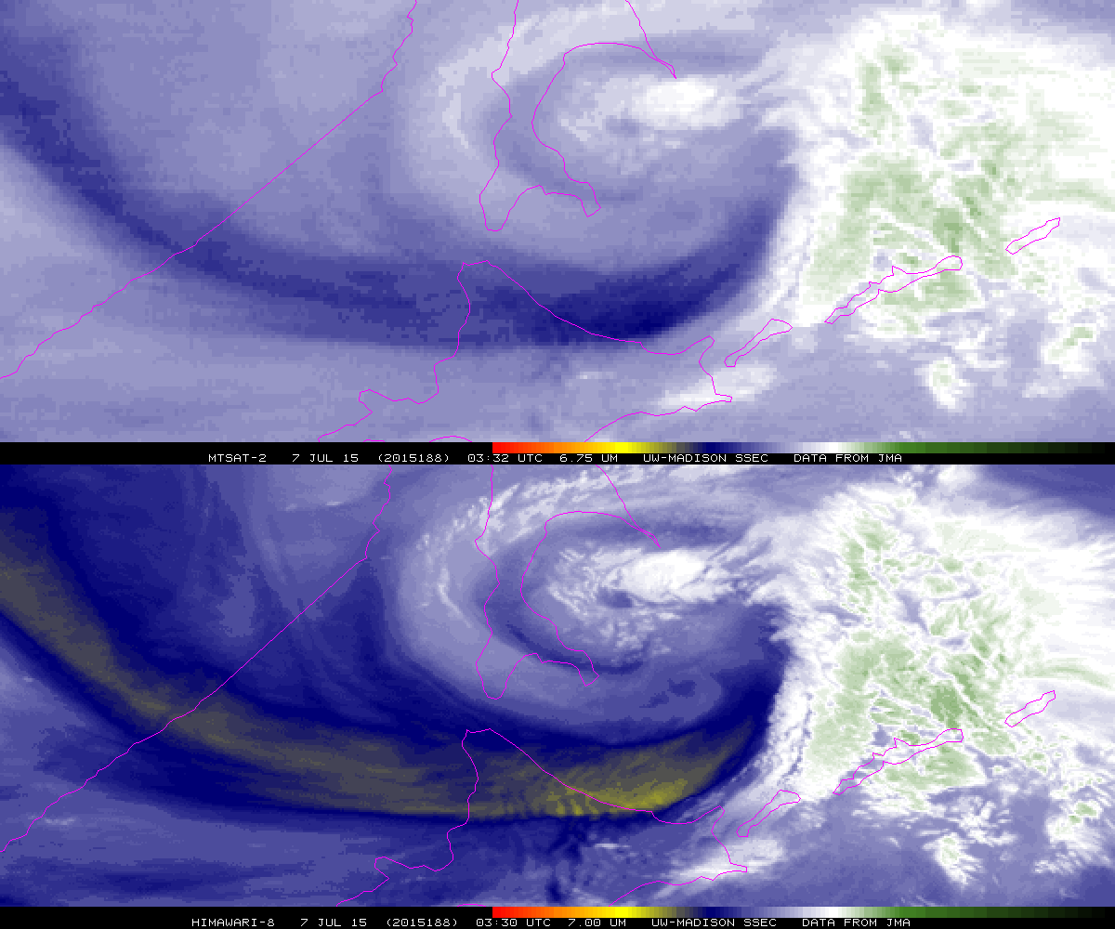
The top panel shows the MTSAT vapor band, while the lower panel shows JMA’s AHI water vapor band centered at 7.0 μm. There is improved spatial resolution from the AHI, providing evidence of waves over northern Japan that are not evident in the MTSAT image. Both images are from July 7, 2015 at approximately 0330 UTC, and each are shown in native projection. This image was made in McIDAS-X. Credit: SSEC and ASPB.
Did You Know?

A GOES image is not scanned all at the same exact time, but is constructed over a small time range. A portion of the earth is scanned as a telescope mirror sweeps back and forth. The IR Imager on GOES-13 to GOES-15 has two detectors building an image; it takes 25 minutes to scan a full disk. The ABI on GOES-R has more than 200 IR detectors monitoring radiation as the detector mirror sweeps across different sectors. It takes only 5 minutes for ABI to scan a full disk in a dedicated full disk mode. In ABI's agile “flex mode”, the ABI scans a full disk (every 15 minutes), the Contiguous U.S. (every 5 minutes), and a 1000 km x 1000 km area, at the satellite sub-point, meso-scale sector (every 30 sec for one regional sector or one minute to capture two geographically separated sectors).

Tim’s Topics

- Use same photo as currently, although not that one that too zoomed in. :)

The improved spatial resolution on water vapor bands of the AHI and ABI and other advanced imagers are not only to better monitor features that we observe with today’s imager, but also to depict finer scale features, such as waves. These waves might be due to flow over mountains or convection. The additional spectral bands, with the finer (nominally 2km) spatial resolutions allows for monitoring either mountain waves or Clear Air Turbulence (CAT). While the satellite cannot “see” turbulence, it can monitor “interest fields” that may be associated.

Tim Schmit is a research meteorologist with NOAA NESDIS in Madison, Wisconsin.

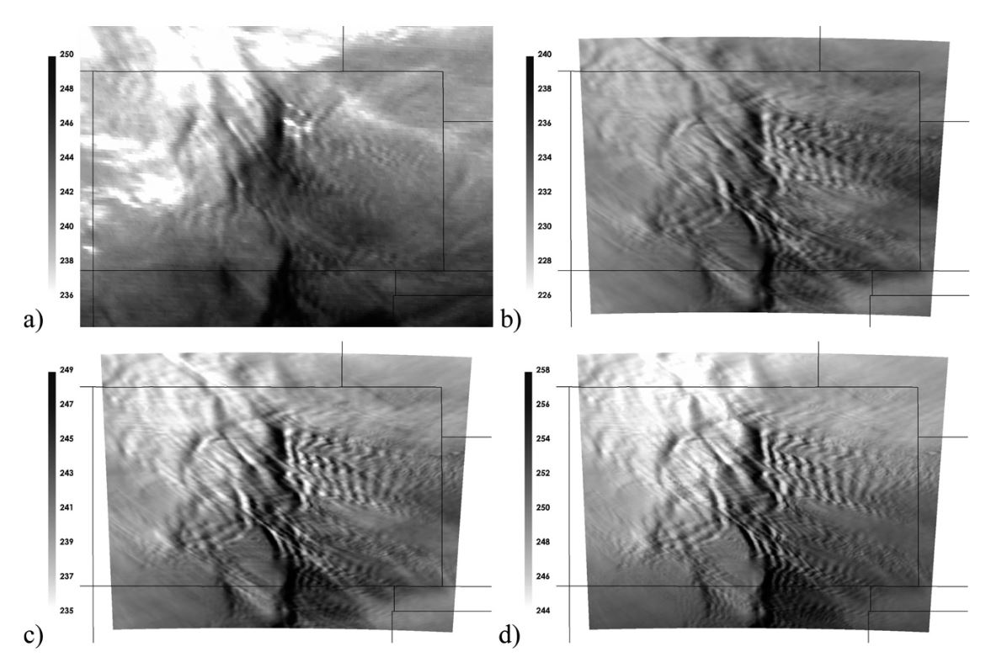
Caption: (a) GOES-12 Imager 4-km 6.5 μm WV band observations at 2002 UTC. (b)–(d) Synthetic 2 km resolution imagery at 2000 UTC for the three GOES-R ABI WV bands: (b) band 8 (6.2 μm), (c) band 9 (7.0 μm), and (d) band 10 (7.3 μm). The grayscale enhancement is fixed to the warmest temperature in each image and is applied over a 14 K range to make the wave features apparent in all spectral bands. Credit: Feltz et al, 2009 (AMS).

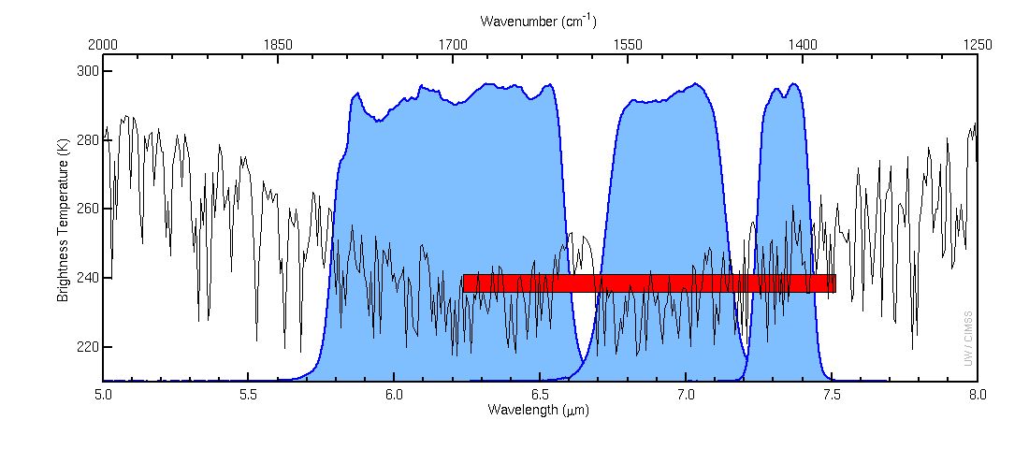
Caption: The (solid blue) curves represent the instrument response functions for the three ABI water vapor bands (8, 9 and 10); while the red box represents the main spectral region of the GOES-15 series imager water vapor band. The black line represents a high spectral resolution earth emitted spectra. There is cooling due to water vapor absorption. Credit: ASPB and CIMSS.

Ward’s Words

- Same picture.

For meteorologists who may be monitoring features in water vapor imagery emerging from the edge of the full disk, consider the differences between this band and Band 8. The brightness temperatures of Band 9 will increase significantly as a constant feature moves from the limb toward the center portion of the image – more so than Band 8, though the behavior is similar. This difference also suggests that for dry tropospheres (in terms of specific humidity), Band 9 is a better choice for seeing lower and mid-level features than Band 8, despite similarities over the tropics and in warm and moist environments.

Bill “Hima-Ward-i” Ward is the ESSD Chief in NWS Pacific Region and a former Guam forecaster.

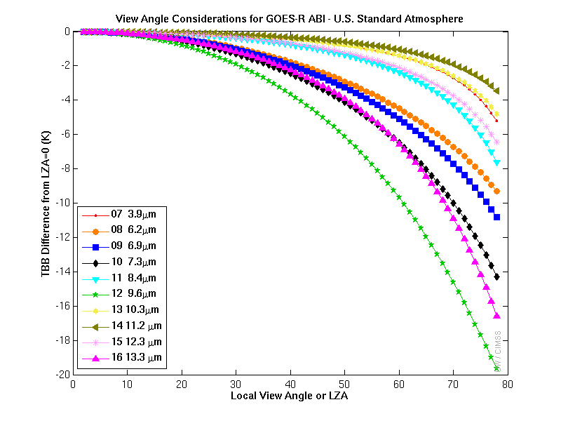
Caption: As the zenith (or view) angle increases away from nadir, in general the observed brightness temperature decreases, due to the increased path length. All the ABI IR bands are shown. Note the ozone band (9.6 μm), followed by the CO₂ band (13.3 μm) cools the most, followed by the water vapor bands. The U.S. standard atmosphere was used for these clear-sky calculations. Credit: CIMSS.

ABI Band Product Table (same general layout)

Use band 9 (from excel file, separated by tab)

Bottom of back page (update date)

Further reading

ABI Bands Quick Information Guides: http://www.goes-r.gov/education/ABI-bands-quick-info.html

ABI Weighting Function page: http://cimss.ssec.wisc.edu/goes/wf/ABI/

CIMSS Satellite Blog: http://cimss.ssec.wisc.edu/goes/blog/archives/category/himawari-8

Mountain Wave turbulence: http://journals.ametsoc.org/doi/abs/10.1175/2008WAF2222127.1

VISIT on GOES Sounder: http://cimss.ssec.wisc.edu/goes/visit/sounder.html

GOES-R COMET training: http://www.goes-r.gov/users/training/comet.html
GOES-R acronyms: http://www.goes-r.gov/resources/acronyms.html

