GOES-R ABI Fact Sheet Band 10 (The “lower-level water vapor” infrared band)
The “need to know” Advanced Baseline Imager reference guide for the NWS forecaster

Front page – Maintain general layout

No changes needed to header banner (GOES-R satellite); title as above
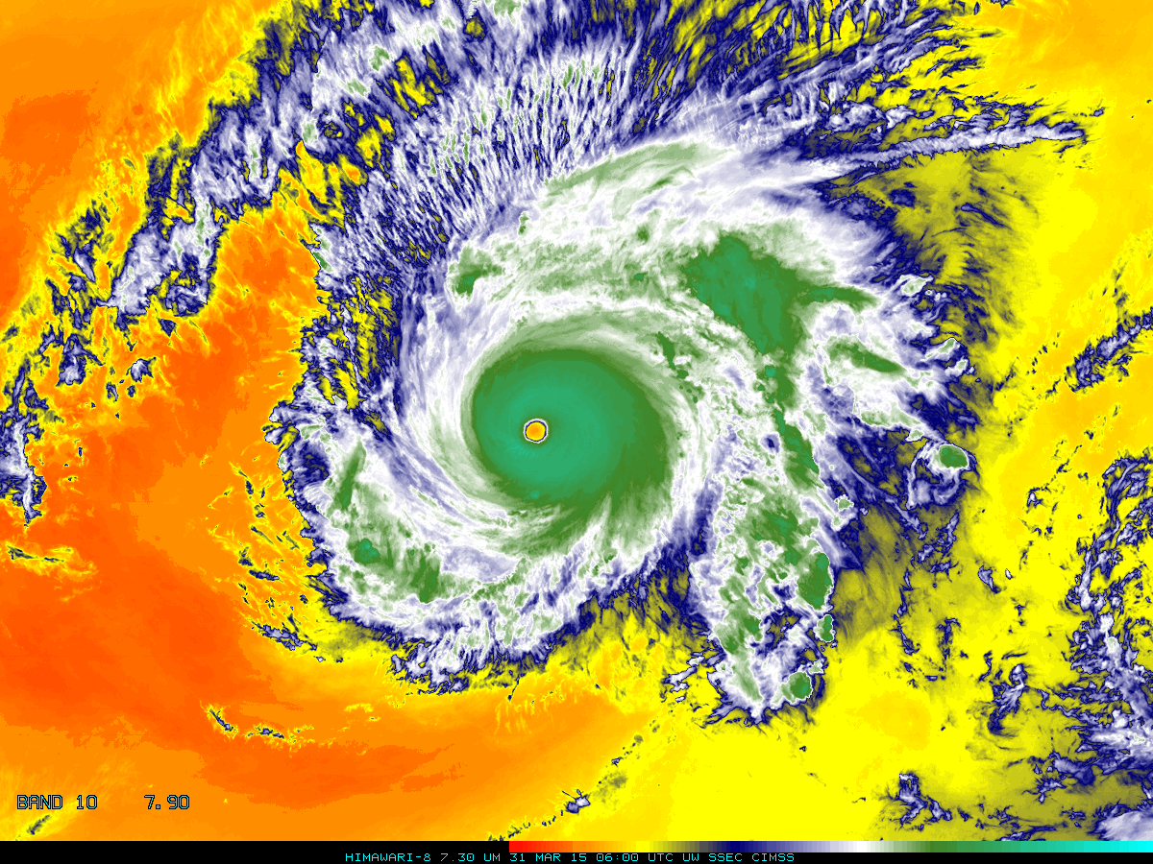

Above: The Advanced Himawari Imager (AHI) 7.3 μm for Typhoon Maysak from March 31, 2015 at 06 UTC. Credit: CIMSS and JMA.

In a nutshell

GOES-R ABI Band 10 (approximately 7.3 μm central, 7.2 μm to 7.4 μm)

Similar to MODIS Band 28, SEVIRI Band 6, AHI Band 10

Available on current GOES Sounder

Nickname: “Lower-level water vapor” infrared band

Availability: Both Day and Night

Primary purpose: Atmospheric feature detection

Uses similar to: ABI/AHI Bands 8/9
“Core” front text and image
The 7.3 µm band is one of the three mid-tropospheric water vapor bands on the ABI. It reveals information about lower mid-level atmospheric flow (depending on the amount of moisture in the upper troposphere) and can help identify jet streaks. It has been proven to be useful, under certain conditions, in identifying and tracking volcanic plumes due to upper-level sulfur dioxide absorption. Vertical moisture information can be gained from comparison of measurements in all three water vapor bands as is done with current GOES sounder bands. This water vapor band is similar a band on the GOES Sounders, although those bands are spectrally narrower. The heritage GOES imager water vapor band falls “between” this band and the 6.2 μm. Source: Schmit et al., 2005 in BAMS, and the ABI Weather Event Simulator (WES) Guide by CIMSS.

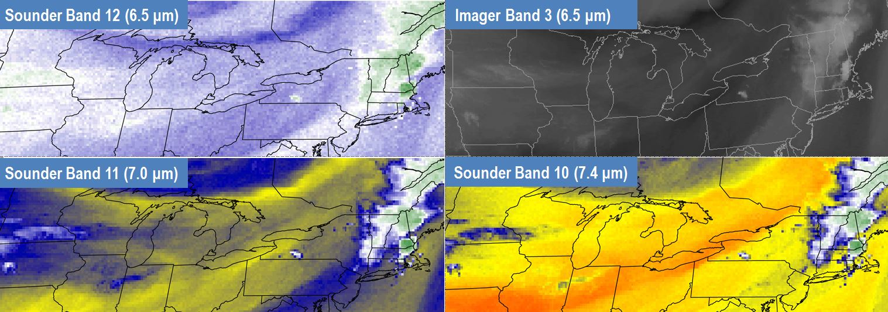
The three water vapor bands on the GOES Sounder are shown above, as well as the GOES Imager water vapor band, in this example from June 1, 2011. Additional information is available from the sounder, compared to the imager alone. This image was made in McIDAS-X. Credit: Christopher Gitro, NWS Pleasant Hill, Missouri.
Did You Know?

Significant effort is placed on assuring the spacecraft delivers the imagery we expect without an early-life failure. There are many redundant components on the ABI instrument. In addition, the instrument and spacecraft are put through many tests before launch. These tests include component level testing, instrument testing (vibration, acoustics, putting the instrument in a vacuum chamber, heating the instrument to extreme temperatures, etc.). In addition, many of these tests are checked after the instrument is integrated on the spacecraft, before launch. All of these tests, along with the corresponding reviews, provide confidence that the ABI will work on-orbit over the long haul.

Tim’s Topics

- Use same photo as currently, although not that one that too zoomed in. :)

When this water vapor band was first proposed on the ABI, it was to be centered at 7.4 μm. This is fine for the water vapor applications, but is sub-optimal for aviation applications, such as upper-level SO₂ associated with volcanoes. Several in the aviation community, including Gary Ellrod, then of NOAA NESDIS, decided to move the band center to 7.34 μm to better capture absorption due to SO₂. Thus, monitoring of some upper level SO2 will be possible from the ABI. Knowing the location of SO₂ plumes can be very important for many applications, including aviation, health, and economic impacts. The rapid refresh and good spatial resolutions, along with some of the new spectral bands mean the monitoring of aviation hazards from the ABI will be greatly improved over the heritage imager.
Tim Schmit is a research meteorologist with NOAA NESDIS in Madison, Wisconsin.

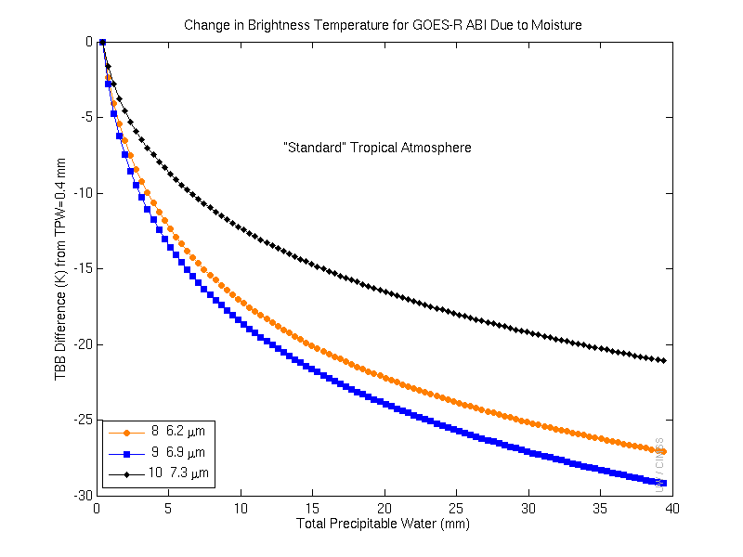
Calculations demonstrate, for the clear-sky, how the brightness temperatures change with atmospheric moisture for the ABI water vapor bands. With the same temperature profile, a much colder brightness temperature is achievable with more total moisture. In general, more moisture causes more cooling (as water vapor absorption occurs higher in the troposphere). Credit: ASPB and CIMSS.

Chris’ Corner

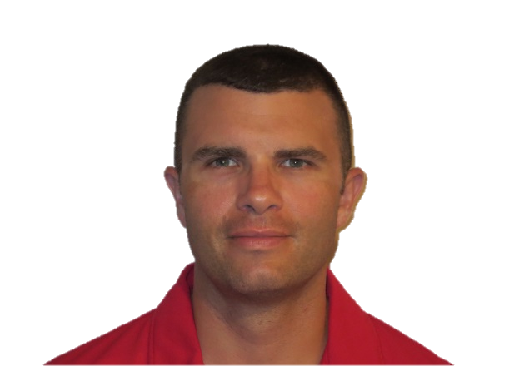
(frame and size appropriately for fact sheet)

With the advent of three water vapor bands on the ABI, monitoring atmospheric water vapor in the GOES-R era will be enhanced. These bands will sample upper-level, midlevel, and low-level water vapor and provide operational meteorologists the opportunity to monitor the evolution of atmospheric features in these levels. These bands will also allow for improved baseline products such as Atmospheric Motion Winds (AMVs) that contribute to numerical weather prediction models.

The arrival of the 7.3 µm band may have significant impacts on forecasting convection because atmospheric features that are difficult to analyze using the 7.0 or 6.2 µm water vapor bands may be more apparent in the 7.3 µm band. For example, the 7.3 µm band will allow forecasters to track features that have been associated with severe weather such as elevated mixed layers, elevated cold fronts, and low-level boundaries at high temporal and spatial resolution.

Christopher M. Gitro is a senior meteorologist for the National Weather Service at the field office in Pleasant Hill, Missouri.

ABI Band Product Table (same general layout)

Use band 10 (from excel file, separated by tab)

Bottom of back page (update date)

Further reading

ABI Bands Quick Information Guides: http://www.goes-r.gov/education/ABI-bands-quick-info.html

Real-time Weighting Function page: http://cimss.ssec.wisc.edu/goes/wf/

CIMSS Satellite Blog: http://cimss.ssec.wisc.edu/goes/blog/archives/category/himawari-8

VISIT on GOES WV: http://rammb.cira.colostate.edu/training/visit/wv_svr_wx

GOES-R SO₂: http://www.goes-r.gov/products/opt2-so2-detection.html
GOES-R COMET training: http://www.goes-r.gov/users/training/comet.html
GOES-R acronyms: http://www.goes-r.gov/resources/acronyms.html

