GOES-R ABI Fact Sheet Band 3 (The “Vegetation” visible band)
The “need to know” Advanced Baseline Imager reference guide for the NWS forecaster

Front page – Maintain general layout

No changes needed to header banner (GOES-R satellite); title as above

Replace simulated hurricane image with band 3 (see below).
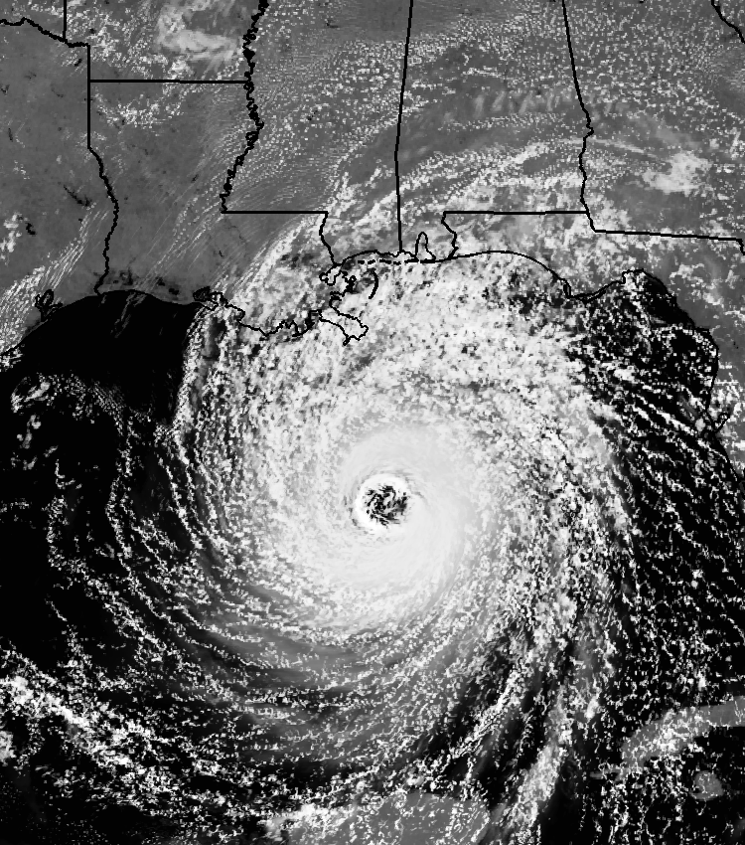

Caption: Above: Simulated image of ABI band 3 (0.86 μm) for Hurricane Katrina. This image was simulated via a combination of high spatial resolution numerical model runs and advanced “forward” radiative transfer models. (Credit: CIMSS)

In a nutshell

GOES-R ABI Band 3 (approximately: 0.86 μm central, 0.85 μm to 0.88 μm)

Also similar to the AVHRR band 2, Suomi NPP VIIRS Band M7, EUMETSAT SERVIRI band 2 and Himawari-8/9 AHI Band 4.

New for GOES-R Series, not available on current GOES

Nickname: “Vegetation” (visible) band

Availability: Daytime only

Primary purpose: Vegetation

Uses similar to: None.
“Core” front text and image
The 0.86 μm band (a near-infrared or “reflective” band), along with the 0.64 μm (“red”) ABI
band 2, will be used for detecting daytime clouds, fog, and aerosols, and calculating a
normalized difference vegetation index (NDVI), hence its nickname the “vegetation” (or “veggie” band). This band can help in determining vegetation, via the vegetation index and green vegetation fraction products, although these are not baseline. The current GOES lone visible channel does not as effectively delineate burn scars. Thus, this ABI band has potential for detecting forest regrowth patterns, etc. Also, given that vegetated land, in general, shows up brighter in this band, it can be used for monitoring Image Navigation and Registration (INR). This band is also useful to simulate a “green” band needed for a natural color image from the ABI. Source: Schmit et al., 2005 in BAMS, Miller et al. 2012 and the ABI Weather Event Simulator (WES) Guide by CIMSS.

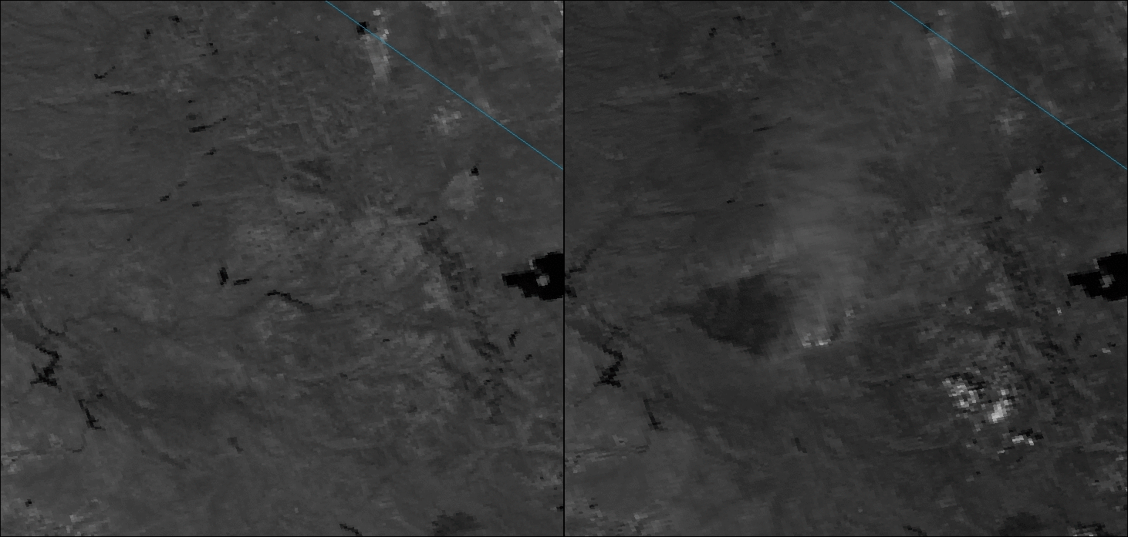
NASA’s VIIRS M7 band (0.865 μm) is shown for two times. On the left is before (August 13, 2013) and on the right is after (August 30, 2013) the California Rim Fire. Note the smoke plume and pyrocumulus along the periphery of the dark burn scar near the center of the image on the right, and the large burn scar just to the west of the smoke plume. Credit: NASA and CIMSS.
Did You Know?

The spectral width of the ABI “vegetation” band is narrower than that on heritage instruments such as AVHRR. This means that the ABI band does not include a water vapor absorption feature that complicates the estimating of the surface features. Stated another way, if the NDVI changes in the GOES-R era, it is more likely due to vegetation changes, and not variable atmospheric water vapor.

Tim’s Topics

- Use same photo as currently, although not that one that too zoomed in.:)

Each of the spectral bands on the ABI have “champion”. This is the person who might have suggested it be included on the ABI, to better fulfill the various requirements. Or this might have been a band on the first satellites, and hence the champion might be Vern Suomi. The champion for the 0.86 μm ABI band was the late Nagaraja Rao, of NOAA NESDIS research office. In his email from late 1999, he stated “I believe we can increase the usefulness of the ABI very appreciably if we replace the proposed very broad visible channel with two channels in the visible and near-infrared”. This was the beginning of the band 3 (0.86 μm) on the ABI. This idea was further bolstered when it was approved by the NOAA research council.
The 0.86 μm on the ABI has a sub-point spatial resolution of 1 km. This is nominally the spatial resolution of today’s GOES Imager visible band 1.

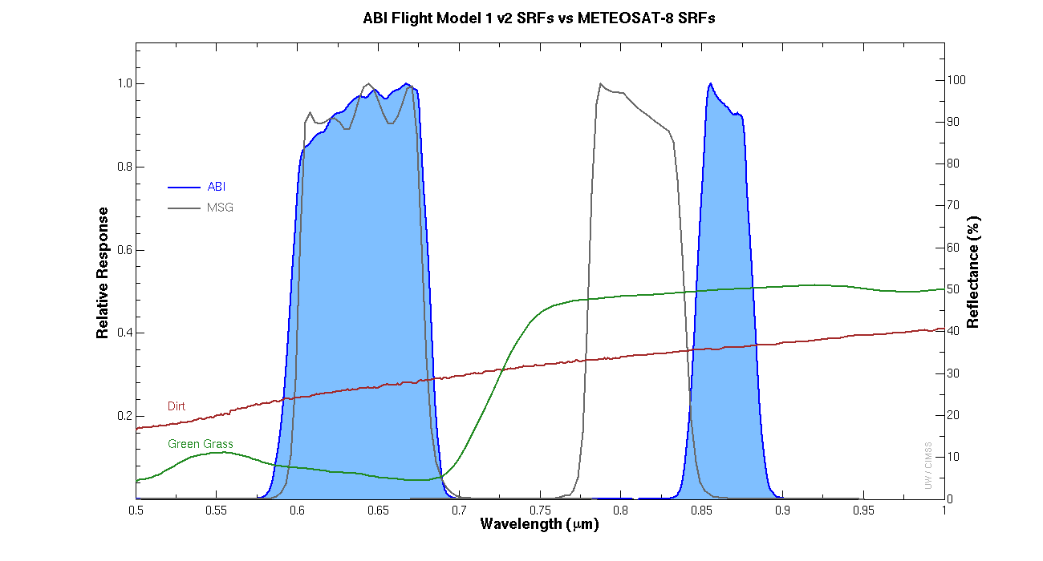

Caption: ABI (blue shaded curves) and SEVIRI (gray curves) spectral response functions. Note that the SEVIVI has a “vegetation” band, although with a different spectral center. Also plotted are spectral curves for dirt and grass, note the transition between 0.70 and 0.75 micrometers. Credit CIMSS, EUMETSAT and the ASTER spectral library.

[Note that the top legend of the figure could be cropped off!]

Tim Schmit is a research meteorologist with NOAA NESDIS in Madison, Wisconsin.

Ward’s Words

- Same picture.

While the vegetation band has a legacy on our polar-orbiting satellites, it was not until some recent imagery from the new Himawari satellite that I realized the potential of this band from the geostationary orbit. Due to the high reflectance of vegetative surfaces and relative low reflectance of water in this near infrared band, the contrast between land and water is extremely sharp, especially when coupled with the 1 km spatial resolution at nadir.

In the Pacific Basin, the sharp contrast will make it easy to identify small islands and atolls. Another benefit of this contrast is the ability to monitor coastal inundation and other flooding, especially when viewed in a time animation. In the future, it is possible that this band would contribute to a flood/standing water product. The enhanced reflectance contrast, while maintaining the high reflectance from clouds and snow similar to visible imagery, will likely make the vegetation band a potential replacement to the visible band as a quick reference for surface and land features amongst forecasters.

Update spectral bands plot and caption.

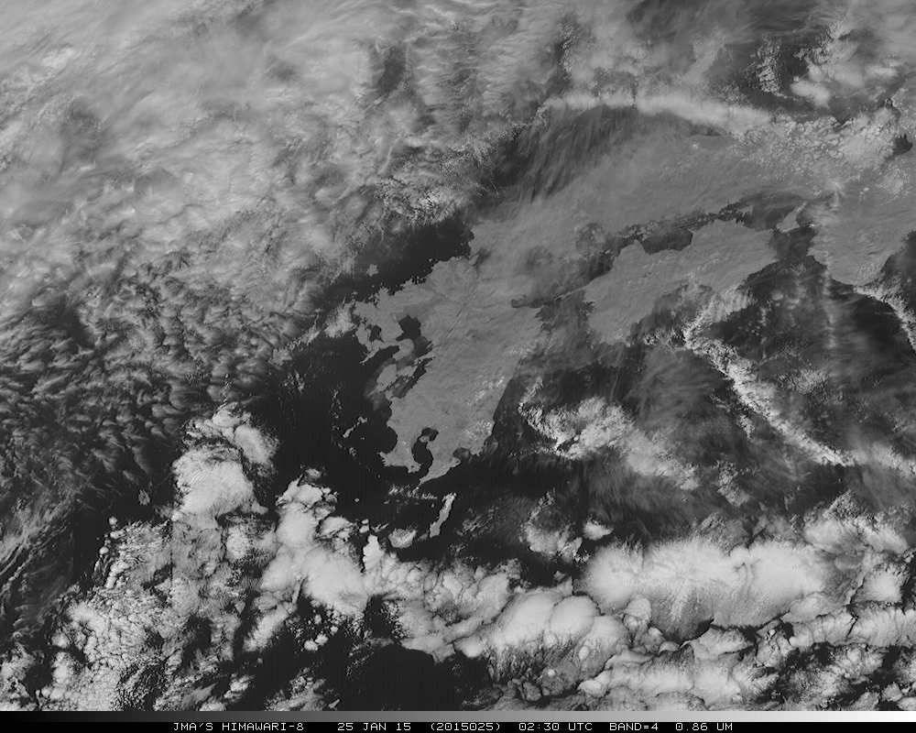

Japan Meteorological Agency (JMA) Advanced Himawari Imager (AHI) 0.86 micrometer image, centered at approximately 32N, 131 E, showing both clouds and land features. The image is from January 25, 2015 and was displayed in McIDAS-X.

Bill “Hima-Ward-i” Ward is the ESSD Chief in NWS Pacific Region and a former Guam forecaster.

ABI Band Table

ABI Band | Approximate Central  Wavelength (µm) | Band “Nickname” | Type | Nominal sub satellite pixel spacing (km)
2 | 0.64 | “Red” band | Visible | 0.5
3 | 0.86 | “Vegetation” band | Near-IR | 1

ABI Band Product Table (same general layout)

Use band 3 (from excel file, separated by tab)

Bottom of back page (update date)

Further reading

GOES-R Overview: http://goes-r.gov

ABI Bands Quick Information Guides: http://www.goes-r.gov/education/ABI-bands-quick-info.html

Vegetation information: http://www.goes-r.gov/products/opt2-vegetation-index.html

Flood standing water: http://www.goes-r.gov/products/opt2-flood-standing-water.html

CIMSS blog on the CA Rim Fire: http://cimss.ssec.wisc.edu/goes/blog/archives/13785

GOES-R COMET training: http://www.goes-r.gov/users/training/comet.html
GOES-R acronyms: http://www.goes-r.gov/resources/acronyms.html

