GOES-R ABI Fact Sheet Band 5 (The “Snow/Ice” near-infrared band)
The “need to know” Advanced Baseline Imager reference guide for the NWS forecaster

Front page – Maintain general layout

No changes needed to header banner (GOES-R satellite); title as above

Replace simulated hurricane image with band (see below).
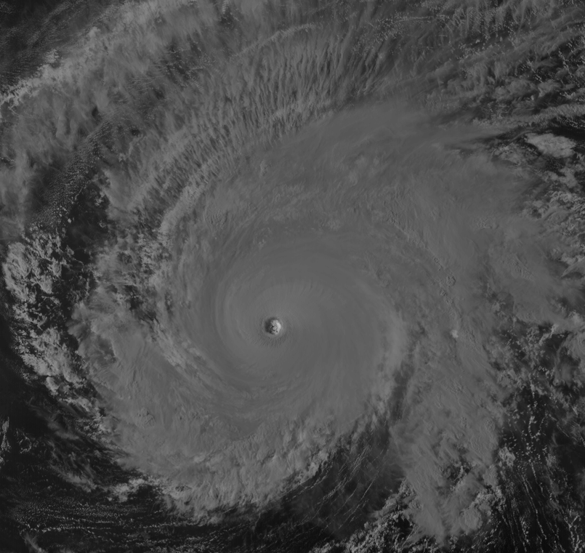

Above: The Advanced Himawari Imager (AHI) 1.6 μm image for Typhoon Maysak from March 31, 2015 at 6 UTC. Glaciated clouds appear dark in this band, due to less solar reflection. (Credit: CIMSS)

In a nutshell

GOES-R ABI Band 5 (approximately 1.61 μm central, 1.59 μm to 1.63 μm)

Similar to Suomi NPP VIIRS Bands I3 and M10, Landsat Band 6, MODIS Band 6, Meteosat Second Generation (MSG) Band 3, Himawari-8/9 AHI Band 5, and AVHRR Band 3A

New for GOES-R Series, not available on current GOES

Nickname: “Snow/Ice” (near-infrared) band

Availability: Daytime only for snow and cloud applications

Primary purpose: Snow and ice discrimination, cloud top phase

Uses similar to: GOES-R ABI Band 6 (2.3 μm), for night-time fire locations
“Core” front text and image
In conjunction with other bands, the 1.6 µm, or “snow/ice” band will be used for daytime cloud, snow, and ice discrimination, total cloud cover estimation, cloud-top phase, and smoke detection from fires with low burn rates. The 1.6 µm band takes advantage of the relatively large difference between the imaginary refraction components of water and ice. This makes daytime water/ice cloud delineation possible with this band, which will be very useful for aircraft routing. This band on MODIS and VIIRS has also been used to highlight areas that previously experienced freezing rain, even when on top of snow. At night, in lieu of solar reflection, radiating fires might be particularly noticeable against the dark background. Source: Schmit et al., 2005 in BAMS, and the ABI Weather Event Simulator (WES) Guide by CIMSS.

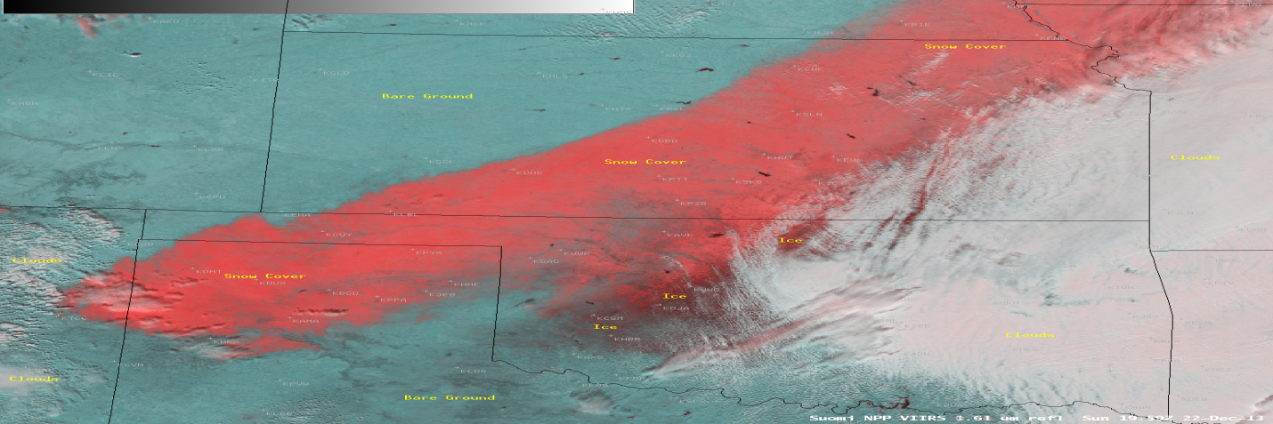
This Suomi NPP VIIRS false-color snow/ice-vs-cloud RGB image valid on December 22, 2013, at 19:59 UTC combines the visible band (red) and the snow/ice band (green and blue). Red shades indicate features that are more reflective in the visible band, whereas cyan areas are more reflective in the 1.6 μm band. Credit: NASA and SSEC.

Did You Know?

When generating derived (Level 2) products, such as cloud heights, each of the products directly uses a number of the ABI bands. Yet, many products may use other derived products as inputs, i.e., prerequisite products. For example, the derived product such as Total Precipitable Water (vapor) uses the cloud mask, which uses the 1.37 μm band. Due to this product precedence, more bands are used in total, than may be listed in a products-by-band table.

Tim’s Topics

- Use same photo as currently

The band on the ABI fulfills the NWS requirement related to snow detection from the geostationary orbit. A similar band was on the Landsat Thematic Mapper satellite and this band is also the third generation of AVHRR.
The 1.6 μm band strongly absorbs snow and ice surfaces. It is this absorption that allows the snow or ice to stand out, compared to a 0.64 μm where snow appears bright, but not substantially different from the water cloud. The GOES-R Cloud Mask algorithm uses, as one of its inputs, information from the 1.6 μm band. According to Andrew Heidinger, NOAA NESDIS STAR, “the near-IR channels, particularly the 1.6 μm reflectance are useful in discriminating between snow and clouds, as snow has very low 1.6 μm reflectance, while the 1.6 μm reflectance of clouds remains high.”

The 1.6 μm on the ABI has a sub-point spatial resolution of 1 km. This is nominally the spatial resolution of ABI’s bands 1 (0.47 μm) and 3 (0.86 μm).

Tim Schmit is a research meteorologist with NOAA NESDIS in Madison, Wisconsin.

Ward’s Words

- Same picture.

The GOES-R Series presents the first opportunity for operational meteorologists in the Western Hemisphere to observe the Americas from the geostationary orbit in the near-infrared. Near-infrared bands are similar to the visible bands in that they predominantly capture reflected solar energy. However, those near-infrared bands close to the shortwave infrared window at around 4 μm can detect heat from fires and other terrestrial sources, including the 1.6 μm band. This capability will be particularly beneficial at night where there are few other sources for radiation in the near-infrared.

Beyond that, the 1.6 μm band can help forecasters discriminate between ice- and snow-covered ground, as well as ice and water cloud. Among other applications, time animations of this band will help to determine whether ice from a recent freezing rain event is melting.

Bill “Hima-Ward-i” Ward is the ESSD Chief in NWS Pacific Region and a former Guam forecaster.

Caption: AHI images over Australia on March 23, 2015 of bands 3.9 μm (left) 1.6 μm (right) showing a fire. The AHI 1.6 μm is nominally 2 km spatial resolution, while on the ABI the band will be 1 km. Credit: CIMSS.

ABI Band Table
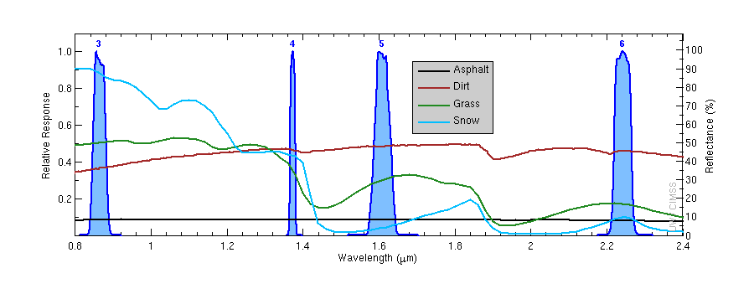
Caption: The ABI (blue shaded curve) spectral response functions for the ABI near-infrared bands, along with three high-spectral resolution curves. The plot of snow (“light blue solid line”) demonstrates how the 1.6 μm band (5) is not reflective and the 0.86 and the visible bands. Credit CIMSS, ASTER spectral library.
ABI Band | Approximate Central  Wavelength (µm) | Band “Nickname” | Type | Nominal sub satellite pixel spacing (km)
5 | 1.6 | “Snow” band | Near-IR | 1
6 | 2.3 | “Cloud-top phase” band | Near-IR | 2

ABI Band Product Table (same general layout)
Use band 5 (from excel file, separated by tab)

Bottom of back page (update date)

Further reading

ABI Bands Quick Information Guides: http://www.goes-r.gov/education/ABI-bands-quick-info.html

Landsat Bands: http://landsat.gsfc.nasa.gov/?page_id=5377

CIMSS Blog: http://cimss.ssec.wisc.edu/goes/blog/archives/14635

Cloud Mask ATBD: http://www.star.nesdis.noaa.gov/goesr/docs/ATBD/Cloud_Mask.pdf

GOES-R COMET training: http://www.goes-r.gov/users/training/comet.html
GOES-R acronyms: http://www.goes-r.gov/resources/acronyms.html

