GOES-R ABI Fact Sheet Band 12 (“ozone” infrared band)
The “need to know” Advanced Baseline Imager reference guide for the NWS forecaster

Front page – Maintain general layout

No changes needed to header banner (GOES-R satellite); title as above
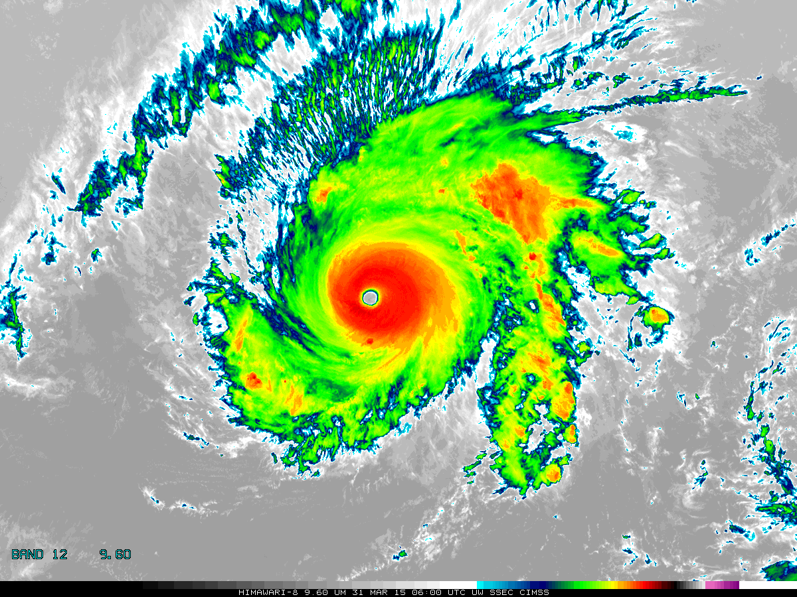

[Please crop out the colorbar.]

Above: The Advanced Himawari Imager (AHI) 9.6 μm ozone band image for Typhoon Maysak from March 31, 2015 at 06 UTC. Credit: CIMSS and JMA.

In a nutshell

GOES-R ABI Band 12 (approximately 9.6 μm central, 9.4 μm to 9.8 μm)

Similar to MODIS Band 30, SEVIRI Band 8, AHI Band 12

Available on current GOES sounder

Nickname: “Ozone” infrared band

Availability: Both day and night

Primary purpose: Total column ozone

Uses similar to: None
“Core” front text and image
The “ozone” band at 9.6 μm will provide information both day and night about the dynamics of the atmosphere near the tropopause with both high spatial and temporal resolutions. For clear (cloud-free) scenes of view, this band is cooler than the IR window bands because of absorption due to ozone. A high temporal and spatial ozone product derived from the 9.6 μm band may give some indications to clear-air turbulence in certain situations associated with tropopause folding. A similar band is available on today’s geostationary sounders. Product generation will be key for estimating the ozone signature; stated another way, this band alone does not provide total column ozone. This band/product can also be compared to upper-level potential vorticity. Band 12 is part of the “air mass” red-green-blue (RGB) composite and the non-baseline total column ozone product. Source: Schmit et al., 2005 in BAMS, and the ABI Weather Event Simulator (WES) Guide by CIMSS.

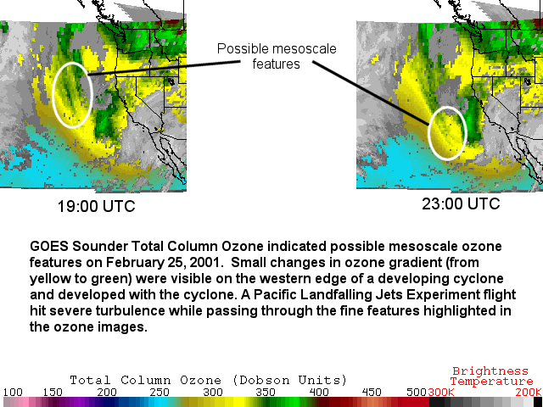

The GOES Sounder Total Column Ozone product depicted mesoscale ozone features on February 25, 2001. Small changes in ozone gradient (from yellow to green) were visible on the western edge of a developing cyclone, which propagated eastward with the cyclone. A Pacific Landfalling Jets Experiment flight encountered severe turbulence while passing though the fine features highlighted in the ozone images. These gradients are not visible in Band 12 images. Credit: CIMSS.
[Note that the above is two (2) cropped images.]

Did You Know?

While the future capability product is called total column ozone, there is very limited sensitivity to surface levels of ozone, especially when using a spectrally broad band. When the ABI was first being designed, there was a high-spectral resolution infrared sensor (the ABS: Advanced Baseline Sounder) on the GOES-R series. The advanced geostationary sounder, later called the Hyperspectral Environmental Suite (HES) was removed in 2006, predominately because of budgetary issues.

Tim’s Topics

- Use same photo as currently

The ozone band on the ABI was added in the early formulation stages, suggested by those in both NOAA and NASA. The thermal infrared ozone channel on ABI can provide information about turbulence and wind shear near the tropopause that is important to aviation. It was stated in 2003 by Art Neuendorffer, then of NOAA NESDIS, that the “channel [spectral width] allows for a strong quasi-linear signal over a broad range of ozone values (and secant angles) while being relatively insensitive to variations in filter function”. This band was based on Europe's Meteosat Second Generation (MSG) SEVIRI and the current GOES sounders, first launched in 2002 and 1994, respectively.

Tim Schmit is a research meteorologist with NOAA NESDIS in Madison, Wisconsin.

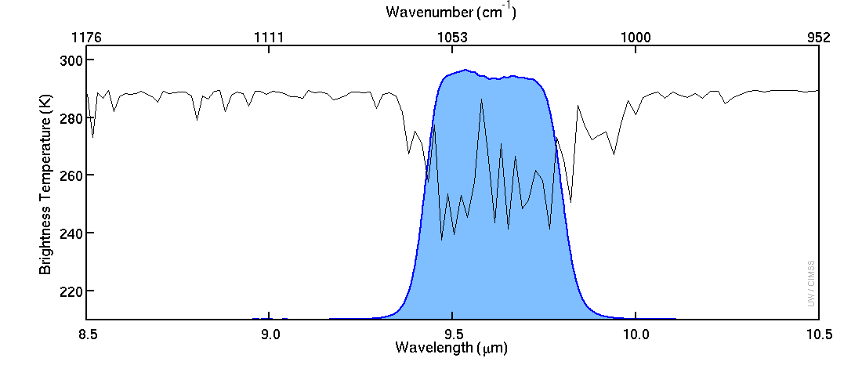
Caption: The solid blue curve represents the instrument response functions for the ABI ozone band (12). The black line represents a high spectral resolution Earth-emitted radiation spectrum. There is cooling due to ozone absorption within the ozone band wavelengths. Credit: CIMSS.

Carven’s Corner

- Same picture.

Beyond ozone, water vapor absorption also occurs in this band. This makes Band 12 somewhat complicated to use, because the horizontal distribution of ozone and water vapor varies across the globe (there is an ozone hole in the southern hemisphere). The brightness temperature will generally increase with less water vapor, less ozone, or an increase in air temperature in the layer where water vapor or ozone resides.

Compared to other bands, Band 12 will show cloud top temperatures at the tropopause in tropical environments with temperatures somewhat higher than other bands. This is because temperatures increase with height in the stratosphere, where the majority of ozone resides. This ozone partially obscures the cloud (and entire troposphere) in this spectral range.

In lieu of Band 12, a difference between two water vapor channels, Band 8 and Band 10, is effective at locating stratospheric intrusions that may better depict the evolution of extratropical cyclones.

Carven Scott is the ESSD Chief in NWS Alaska Region and a former SOO.

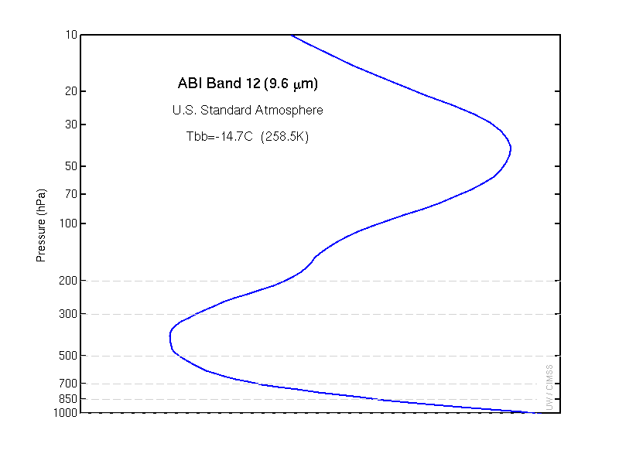
The weighting function (or contribution function) represents the layer(s) of the atmosphere where the radiation sensed by the instrument originated. The plot above shows the weighting function of the ozone band on the ABI. The clear-sky calculated brightness temperature does not include the presence of clouds. The weighting function peaks both in the stratosphere and near the surface. Credit: CIMSS.

ABI Band | Approximate Central  Wavelength (µm) | Band “Nickname” | Type | Nominal sub satellite pixel spacing (km)
12 | 9.6 | Ozone | IR | 2

ABI Band Product Table (same general layout)

Use Band 12 (from Excel file, separated by tab)

Bottom of back page (update date)

Further reading

ABI Bands Quick Information Guides: http://www.goes-r.gov/education/ABI-bands-quick-info.html

GOES Sounder Total Column Ozone: http://cimss.ssec.wisc.edu/goes/rt/viewdata.php?product=o3_us

CIMSS Satellite Blog Post: http://cimss.ssec.wisc.edu/goes/blog/archives/16395

CIMSS Satellite Blog Post: http://cimss.ssec.wisc.edu/goes/blog/archives/15047

CIMSS Satellite Blog Post: http://cimss.ssec.wisc.edu/goes/blog/archives/17223

EUMETSAT: http://oiswww.eumetsat.org/IPPS/html/MSG/RGB/AIRMASS/

GOES-R COMET training: http://www.goes-r.gov/users/training/comet.html

AHI Weighting Functions: http://cimss.ssec.wisc.edu/goes/wf/AHI/

GOES-R acronyms: http://www.goes-r.gov/resources/acronyms.html

