GOES-R ABI Fact Sheet Band 13 (“clean” longwave infrared window band)
The “need to know” Advanced Baseline Imager reference guide for the NWS forecaster

Front page – Maintain general layout

No changes needed to header banner (GOES-R satellite); title as above
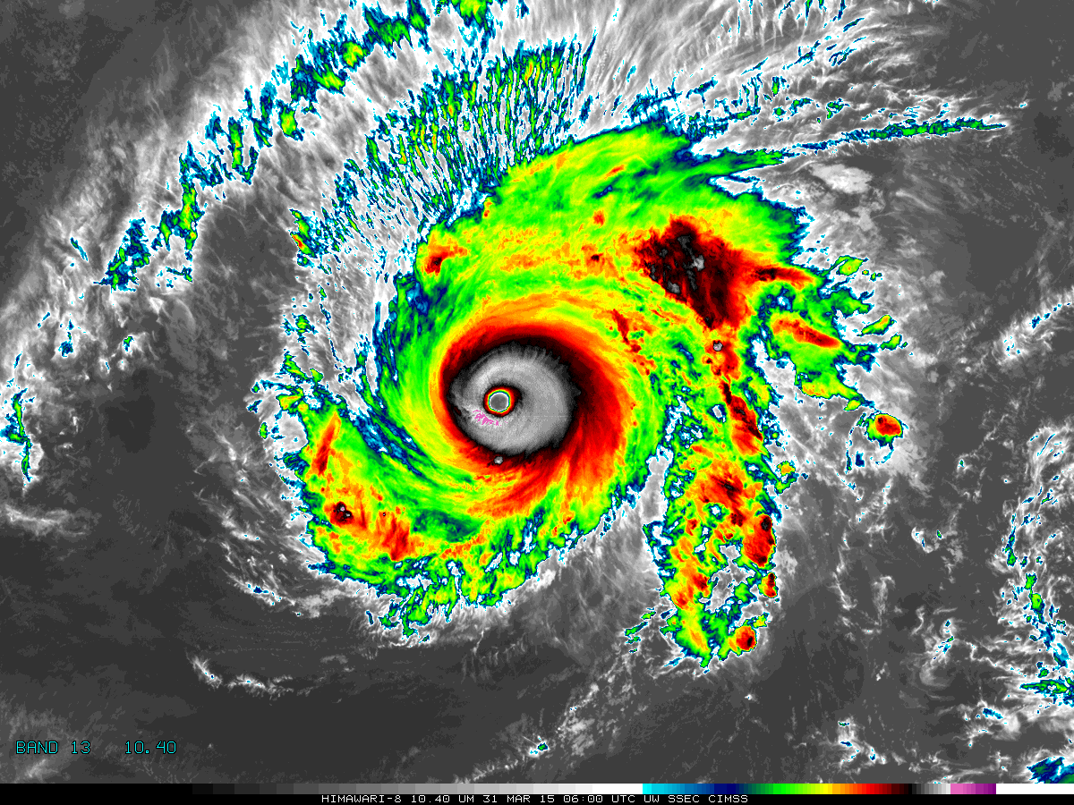

[Please crop out the colorbar.]

Above: The Advanced Himawari Imager (AHI) 10.4 μm band image for Typhoon Maysak from March 31, 2015, at 6 UTC. Credit: CIMSS and JMA

In a nutshell

GOES-R ABI Band 13 (approximately 10.3 μm central, 10.2 μm to 10.5 μm)

Also similar to AHI Band 13

Not available on current GOES sounder nor imager

Nickname: “Clean” longwave infrared window band

Availability: Both day and night

Primary purpose: Clouds

Uses similar to: GOES-R ABI Bands 11, 14, and 15
“Core” front text and image
The 10.3 µm atmospheric “clean” infrared window band is less sensitive than other infrared window channels to water vapor and, hence, improves atmospheric moisture corrections, cloud particle size estimation, and surface property characterization in derived products. The 10.3 µm band does have a very small sensitivity to ozone, while the 11.2 µm longwave window does not. In general, the 10.3 µm band may be used much like the traditional infrared window band. Typically, this band is slightly warmer than the traditional longwave window due to less moisture absorption in the lower troposphere. Source: Schmit et al., 2005 in BAMS, the ABI Weather Event Simulator (WES) Guide, Lindsey et al., 2012

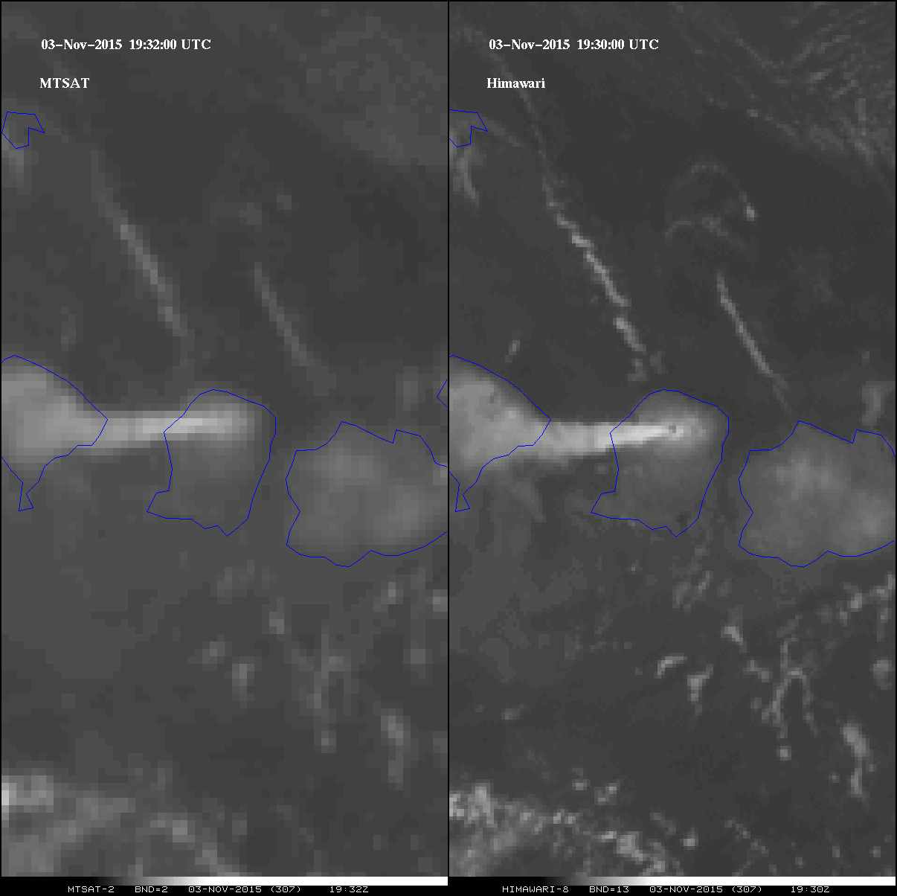

The left panel shows the MTSAT infrared window band, while the right panel is of the JMA’s AHI longwave window centered at 10.4 µm. There is improved spatial resolution from the AHI, approximately by a factor of four. Both images are from November 3, 2015, at approximately 19:30 UTC, and each are shown in their native projection. This case is of the Mount Rinjani volcano in Indonesia. While the MTSAT does show the plume (in the center of the image), the Himawari data (from JMA) depicts the plume more clearly and uniquely shows the hot spot associated with this event. This image was made in McIDAS-X. Warmer brightness temperatures (K) are denoted as darker shades of gray, while the colder values are denoted as white. Credit: SSEC and ASPB

Did You Know?

Should the 10.3 μm or 11.2 μm band be the “default” atmospheric longwave IR window band?

According to Lindsey et al.: “Since the 10.3 μm band is cleaner than the 11.2 μm band, we recommend that forecasters default to the 10.3 μm band when simply looking at a window IR for estimates of radiating temperatures or subjective cloud identification and classification. But when a more detailed physical retrieval is being designed, characteristics of both bands need to be carefully considered. That said, … all bands from the ABI… are planned to be available for use by forecasters and others.”

Tim’s Topics

- Use same photo as currently

During the early formulation phase of the ABI, during the late 1990s, this spectral band was not at first included. In fact, originally the ABI was only eight spectral bands. Dr. Paul Menzel suggested this band based on his experience with a similar band from a research sensor, the MAS (MODIS Airborne Sensor) on the NASA ER-2 high-altitude research aircraft. The data revealed the utility of this clean longwave infrared window for seeing through some clouds to ice (when differenced with a 8.6 μm band). The NOAA research council added the 10.3 μm band to the suite of ABI bands as a result. Several other international geostationary images now have, or will, have this spectral band.

Tim Schmit is a research meteorologist with NOAA NESDIS in Madison, Wisconsin.

Ward’s Words

- Use same photo as currently

Though the weighting functions peak at the surface, longwave infrared window bands brightness temperatures are not necessarily representative of the two-meter shelter temperature, particularly during the day and over land, when certain land surfaces can warm substantially compared to the air temperature. Because of the water vapor absorption in infrared windows bands, they do not provide a great estimate of the “skin” temperature. There are baseline products that can exist to provide this information, though users can also estimate some quantities. For example, sea surface temperature is approximately twice the ABI Band 14 brightness temperature less than the ABI Band 15 brightness temperature based on regression algorithms developed with polar-orbiting satellite imagers.

Bill “Hima-Ward-i” Ward is the ESSD Chief in NWS Pacific Region and a former Guam forecaster.

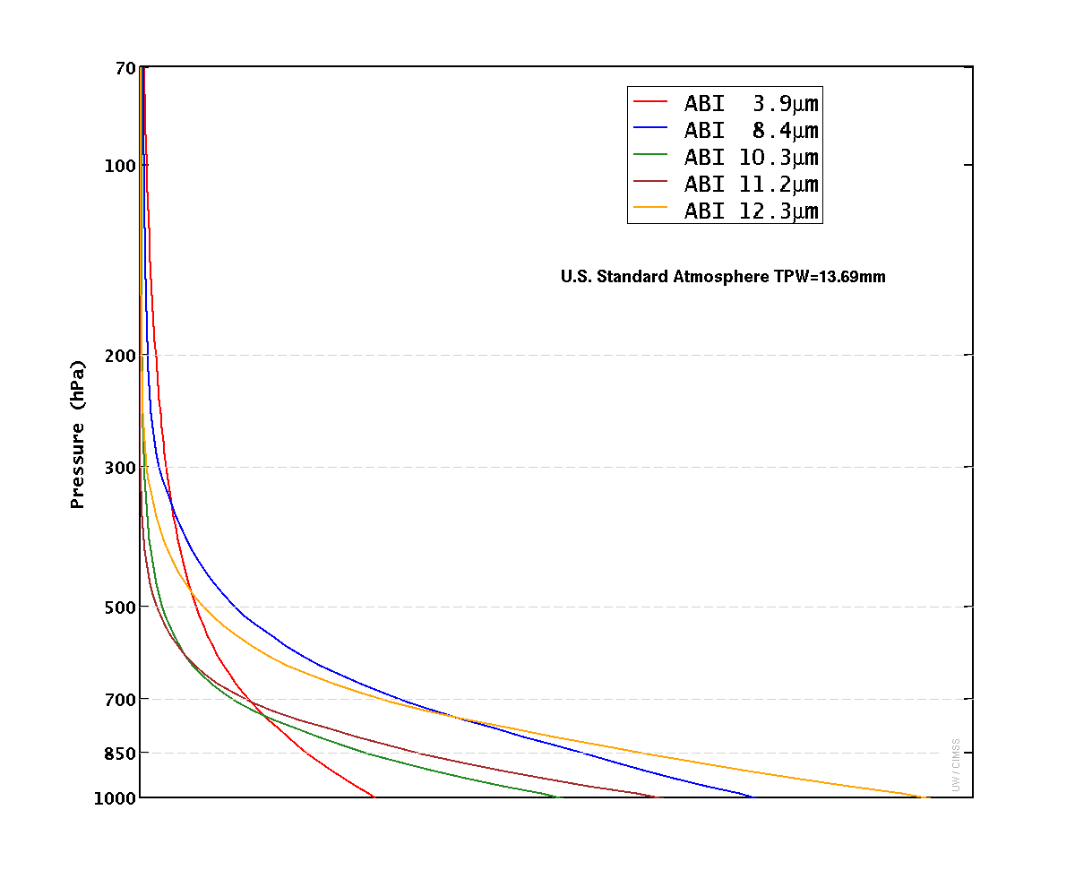
Caption: The clear-sky weighting function (or contribution function) represents the layer of the atmosphere where the satellite-sensed radiation originates. The figure depicts the weighting functions for United States standard atmosphere scenes without the presence of clouds for window bands on the ABI. All of these weighting functions peak at the surface, suggesting that the surface temperature and emissivity dominate the brightness temperature in cloud-free scenes. Credit: CIMSS

ABI Band | Approximate Central  Wavelength (µm) | Band “Nickname” | Type | Nominal sub satellite pixel spacing (km)
13 | 10.3 | “Clean” longwave window | IR | 2
14 | 11.2 | Longwave window | IR | 2
15 | 12.3 | “Dirty” longwave window” | IR | 2

ABI Band Product Table (same general layout)

Use band 13 (from excel file, separated by tab)

Bottom of back page (update date)

Further reading

ABI Bands Quick Information Guides: http://www.goes-r.gov/education/ABI-bands-quick-info.html

J. Appl. Remote Sensing: http://spie.org/Publications/Journal/10.1117/1.JRS.6.063598

MAS: http://mas.arc.nasa.gov/reference/mas.pdf

ABI Weighting Function page: http://cimss.ssec.wisc.edu/goes/wf/ABI/

CIMSS Satellite Blog: http://cimss.ssec.wisc.edu/goes/blog/archives/20096

CIMSS Satellite Blog: http://cimss.ssec.wisc.edu/goes/blog/archives/19897

GOES-R COMET training: http://www.goes-r.gov/users/training/comet.html

GOES-R acronyms: http://www.goes-r.gov/resources/acronyms.html

