Madison, Wis., hosts NWA annual meeting, brings membership together

This year’s National Weather Association annual meeting was another success. We welcomed approximately 425 attendees to this year’s meeting in Madison, Wisconsin, the birthplace of satellite meteorology and home to the University of Wisconsin. The theme was “Synthesizing Weather Information for Society: From Observations to Action across our Communities”. The meeting was held in the iconic Monona Terrace, with an overlook of Lake Monona. Though not all of our oral presenters could join us, the program committee and session chairs did an amazing job of accommodating remote presenters and last-minute changes to the schedule.

There are many beginnings to an annual NWA conference. To some it’s the vendor booth opening, or the start of the student or broadcaster sessions; while to others it’s the keynote address on Monday morning (or the first time they are asked to buy a raffle ticket). For others the heart of the NWA conference is the poster session. This year there were two poster sessions (in addition to the one associated with the student session) with over 100 posters. While many poster presenters from National Weather Service (NWS) were missed, the poster session offered a chance for one-on-one exchanges on a host of topics with a broad range of meteorologists and meteorology students. New this year was one-page poster introductions just before the beginning of each session. This allowed all to get a glimpse of the scope of topics offered within each poster session, and allowed attendees to easily find those posters which best caught their attention.

The keynote speakers for this year’s meeting brought many talents from all facets of the meteorological enterprise. We had the great pleasure of jumpstarting the general sessions with Tom Skilling (WGN-TV in Chicago, IL), who spoke about the evolution of meteorology over the past 45 years of his career. Also early in the meeting, University of Wisconsin alumnus Dr. Louis Uccellini (Director of the National Weather Service’s National Centers for Environmental Prediction and President of the American Meteorological Society) addressed the attendees about the current state and future of environmental prediction. Additionally, we were very happy to host Dr. Kathryn Sullivan (Assistant Secretary of Commerce for Environmental Observation and Prediction, Deputy Administrator of NOAA, and Acting Chief Scientist) and Laura Furgione (NOAA Acting Assistant Administrator for Weather Services and Acting Director of the National Weather Service), who talked about their vision for a Weather-Ready Nation and how the NWS has progressed in this endeavor over the past year. Last, but certainly not least, Jon Davis (Chesapeake Energy, Chicago, IL) spoke about the all-too-important link between meteorology and the energy and agriculture ventures.

One of the new and highly praised events to take place as part of this year’s meeting was the women’s luncheon on Tuesday. Approximately 60 women participated in small roundtable discussions over lunch. Each table had a mixture of women at different stages in their careers. Conversations about balancing work and family life, stories of the unexpected places careers have gone, and laughter about common experiences in a male-dominated profession rang through the Hilton. Women from all branches of meteorology and levels of experience got a chance to discuss women’s career-oriented issues while enhancing a support network. Great connections were made, evinced by business cards passed around and new acquaintances continuing their conversations all the way back to the convention center. Our overwhelmingly positive response will hopefully keep the lunch on the conference schedule for years to come…and maybe all the guys who were asking to attend will eventually be allowed to join in on the fun!

The Weather-Ready Nation (WRN) session on Tuesday afternoon concluded with a Town Hall Meeting on “Decision Maker’s Perspective – Assessing Weather Impacts.” This provided an opportunity for the Weather Enterprise to hear first-hand from various users of weather information. There were nine panelists representing a spectrum of organizations, and each had an opportunity to respond to a given scenario such as an approaching winter storm (or severe weather). They were asked about ideal lead time, how meteorologists might convey forecast uncertainty, and what amounts/types of precipitation may impact their operations. People in attendance learned about different requirements and thresholds involved in their strategic planning in support of the organization’s mission during active weather. The meeting concluded with the panelists answering questions geared toward the WRN.

Another highlight of the annual meeting was courtesy of the NWA Social Media Committee, which provided three social media boot camps. Tiffany Sunday and Tim Brice spearheaded the sessions. Renee Willet, who oversees the Weather Channel social media activities was a guest speaker in the student and broadcaster sessions. The sessions were well received and many have offered ideas for a future boot camp. Many broadcasters expressed that their industry is rapidly changing and that the “second screen” and social media is becoming more and more a key component to gathering and relaying information. Attendees even used social media for their praise. A tweet from @northflamsnwa commented that the social media boot camps “really opened my eyes.”

On Thursday, the last day of the conference, we opened with speaker Shevy Greene from Raytheon and a panel discussion about the Advanced Weather Interactive Processing System (AWIPS), which proved engaging for the audience. There were a number of questions and concerns from the audience about how the primary weather visualization software tool used at NWS forecast offices across the country will be deployed and seamlessly integrated into daily operations.

If you were unable to make it to Madison, most of the presentations are available at: http://www.nwas.org/meetings/nwa2012/agenda. Please consider joining us in Charleston, South Carolina, for the next annual meeting, October 12 through 17, 2013. Let us not forget the countless number of volunteers within the NWA who help make our annual meetings great!

Jordan Gerth
NWA 2012 Program Committee Chair
with contributions from
Lee Cronce, Gary Wade, Tim Schmit, Jeff Craven, Diane Cooper, and Christina Crowe
Members of the Program Committee
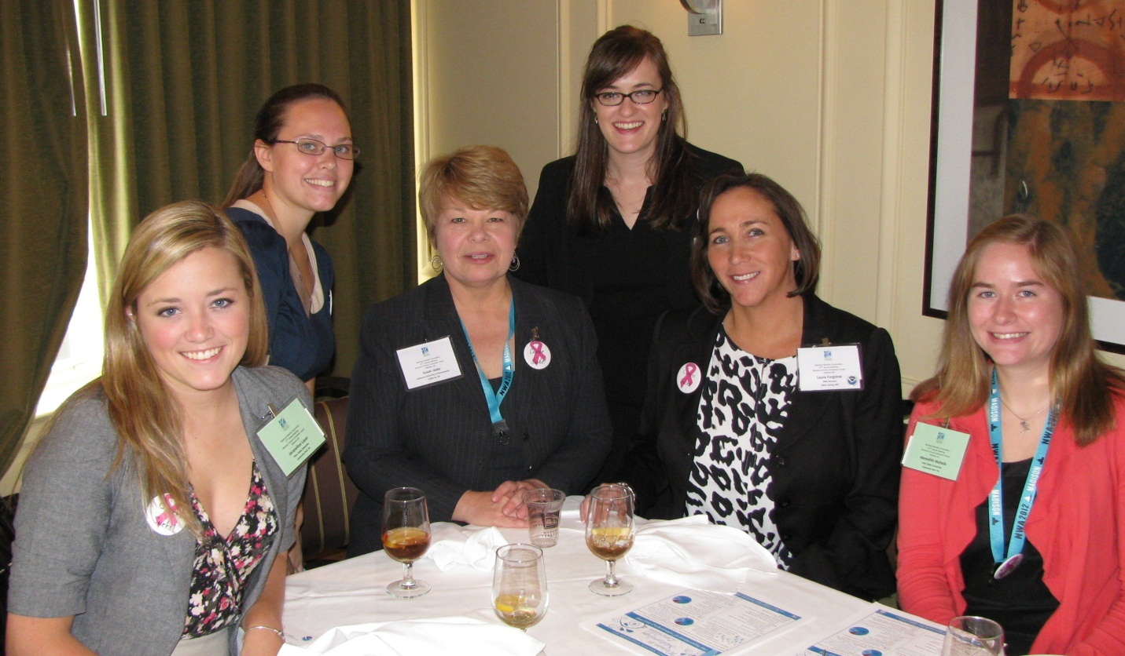
Mary Sharkey, Susan Jasko, Christina Crowe, and Laura Furgione are flanked by two students at the women’s luncheon.

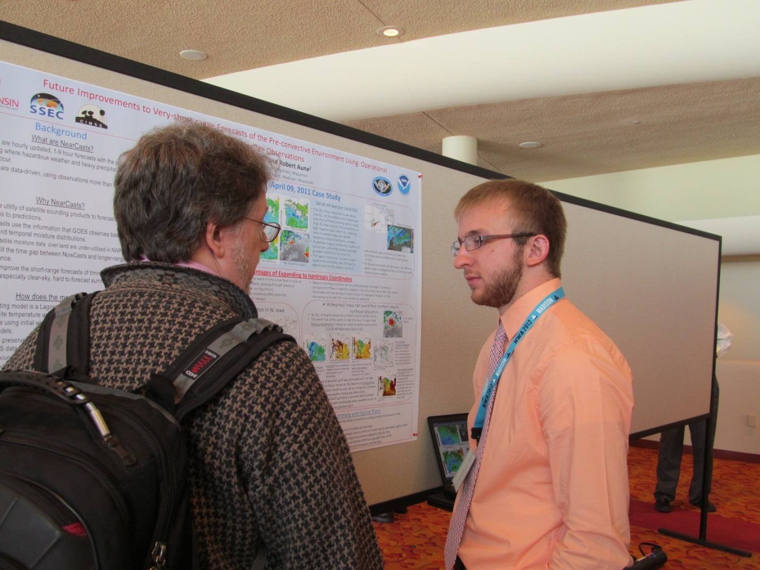
Dr. John Knox, University of Georgia, talks with Bill Line about his research topic. Bill Line is a graduate student at the University of Wisconsin.

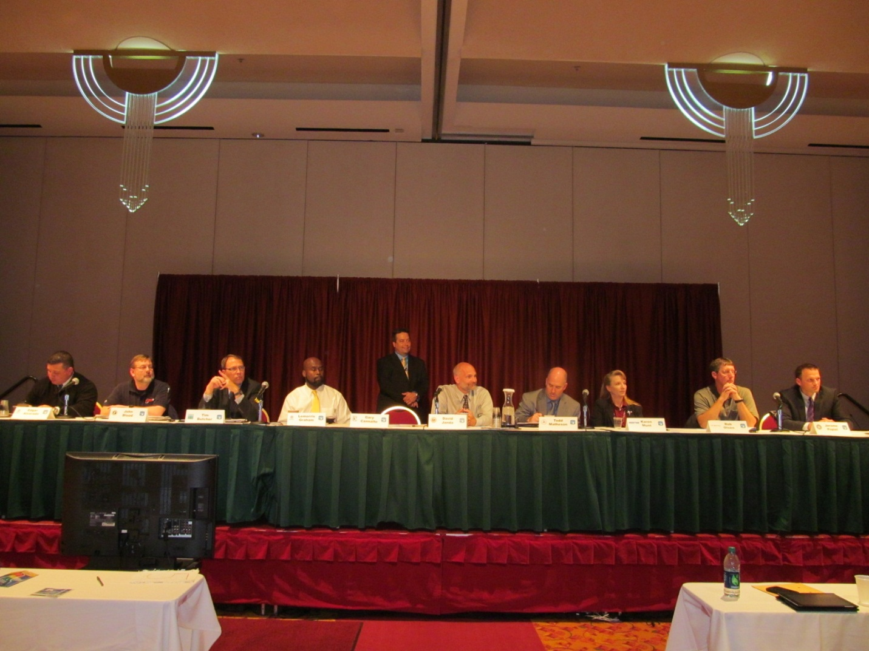
The Weather-Ready Nation panel brought together local, state, and federal decision-makers.

