CITY OF MUNSON, WISCONSIN

Intern Name:_____________________________________ Date:__________________

Supervisor: Dr. Carol Snow

SNOWFALL PREDICTION REPORT

I. Introduction

As part of the city’s budget planning process, Mayor Matthew Wade requested information regarding snowfall predictions for the next ten years, so that the city planner could help advise the council projected snow removal costs. Dr. Carol Snow and I conducted the research and determined that for the next ten years, the data suggests some difficulty in predicting snowfall totals and frequency. We advised the mayor and city planner to continue using current average snowfall amounts for budget-planning proceedings.

With this information, the mayor and city planner requested information regarding overall precipitation amounts and frequency for the next thirty to fifty years, including how long winters will last on average during that time frame. The city’s sewer and drainage infrastructure could be in need of an upgrade if more precipitation and/or snowmelt are expected. This report summarizes preliminary findings and data the Munson science staff will need moving forward.

II. Preliminary Research

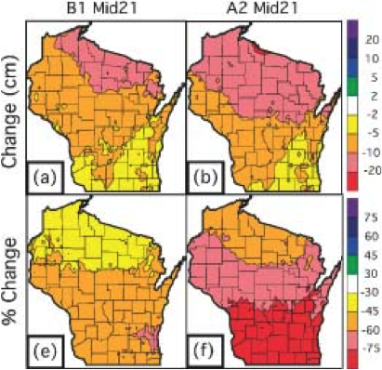
The figure to the right is from a peer-reviewed paper in the Journal of Climatology regarding snowfall for Wisconsin. The maps display a change in snowfall depth by the mid-21st century, as compared to the current climatological average, based on two different climate model scenarios. Based on this figure, we can conclude the following about snowfall in Dane County by the mid-21st century: [write conclusions here, 5 POINTS]

III. Future Research

This section lists other data we will need to collect in order to address the mayor and city planner’s concerns regarding winter length, storm frequency, and precipitation amounts and frequency for the next thirty to fifty years. [What data do you think you would need in order to address the mayor’s concerns, especially with regard to the city’s sewer/drainage infrastructure?, 5 POINTS]

